Submission: 29-04-2021

Accepted: 18-08-2021

Published: 15-11-2021

Journal of Ophthalmology Cases & Hypotheses

UNUSUAL TREATMENT OPTION FOR PANUVEITIS

Aliyeva A.C. MD

(Corresponding Author)

HAT Medicine Clinic, Baku, Azerbaijan

Hajiyev R.V. MD PhD

HAT Medicine Clinic, Baku, Azerbaijan

Abstract

Purpose: The purpose of this study is to report an unusual treatment option for panuveitis.

Methods: This study included ophthalmologic examination, optical coherence tomography investigation, laboratory table of inflammatory and infectious diseases, X-ray investigation and review of the relevant literature.

Results: A 53-year-old woman who had been unsuccessfully treated to date with a diagnosis of uveitis came to our clinic. After a complete examination, the patient was diagnosed with bilateral idiopathic panuveitis. We used a sequential combination of systemic antibiotics and dexamethasone as a treatment option. After a week of treatment, the patient had a noticeable clinical improvement, which was stable.

Conclusion: We have assumptions that the dysbiosis of the microbiota of the body, as a result of the interaction between the microbiota and foreign agents, could lead to such a manifestation, for example, as panuveitis. We assume that the antibiotics acted directly on this link in the pathogenesis. In the future, it will be possible to discover new mechanisms that can be used to treat patients with idiopathic uveitis.

Keywords: Panuveitis, microbiota, macular edema.

Access this article online
Quick Response Code: | Website:
 | https://ophthalmolcases.com/index.php/ hat
 | DOI:
 | 10.30546/2788-516X.2021.2.2.5

Introduction

Uveitis are a large group of inflammatory diseases of the uvea. Multiple infectious or autoimmune disease are responsible for ocular inflammation. They can be caused by approximately 30 inflammatory disorders and lead to a visual loss in people of working age^{1,2}. The incidence varies from 14 to 28/100,000 habitants. About 7-69% (average 20%) of them are panuveitis³. The patient's treatment method is determined, depending on the etiological factor. But etiology can not be established in more than 30% cases⁴. In such cases we can use unusual treatment option.

We would like to present a patient suffering from panuveitis, who had been treated for 2 years in different clinics, including clinics in İran.

Case report

We present the case of a 53-year-old woman who came to our clinic complaining of decreased vision and photophobia. The patient had been treated for 2 years in different clinics, including clinics in Iran. In Iran, with a diagnosis of uveitis, the patient was treated with oral prednisone, azathioprine and topical betamethasone. There was no effect, and her vision gradually deteriorated. On examination, her best corrected visual acuity (BCVA) was 20/200 in both eyes. Intraocular pressure was 11 mmHg in right eye (RE) and 17 mmHg in the left eye (LE).

Examination of the anterior segment with the slit lamp revealed mild hyperemia of the conjunctiva, solitary white keratic precipitates, posterior synechiae, pigment deposits on the anterior lens capsule, irregular pupil (Figure 1).

₅ Journal of Ophthalmology Cases & Hypotheses
Volume 2, Number 2, 2021. 5-8

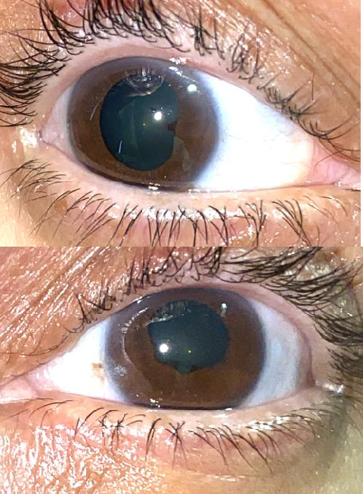

Figure 1. Anterior segment of the RE and LE respectively.

The pupillary light reflexes were abnormal, and an afferent pupillary defect (APD) was observed in both eyes. Examination of the posterior pole revealed opacity and granular destruction of the vitreous body. Spectral domain optical coherence tomography (SD-OCT) were performed (Figure 2, 3).
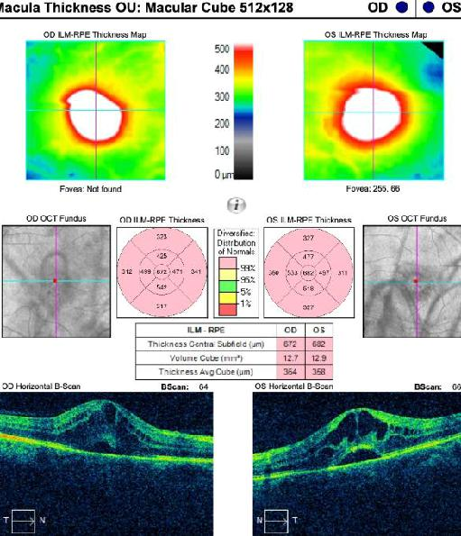

Figure 2. SD-OCT of both eyes showed cystoid macular edema with diffuse retinal thickening.

Figure 3. SD-OCT of the RE and LE respectively.
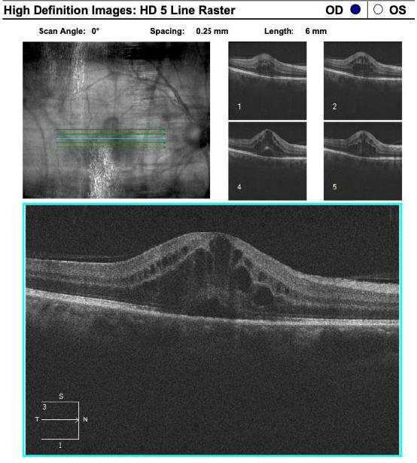
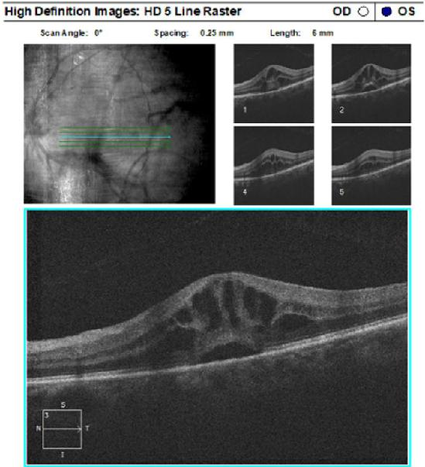

Due to vitreous opacity, the fundus of the eyes was not visible. We had a picture of the fundus that was taken over a year ago in Iran. At that time, the fundus was visible
(Figure 4).

6

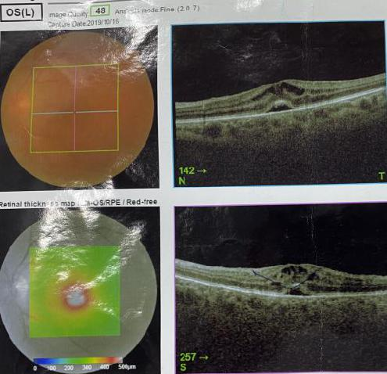

Figure 4. Fundus photo and OCT of the LE.

The patient was not aware of any systemic diseases. A complete laboratory table of inflammatory and infectious diseases was given. Chest and sacroiliac joint X-ray were also performed. The results were unremarkable.

The patient was diagnosed with bilateral idiopathic panuveitis. She was treated for the first three days with intravenous ceftriaxone, topical dexamethasone (six times/day) and mydriatics (twice/day). After 4 days, a dexamethasone sodium phosphate injection was administered intravenously at 1 mg/day. After one week of treatment, the patient showed remarkable clinical improvement. The RE VA was 20/100 and the LE VA was 20/80. The vitreous became clear and the fundus was visible. On OCT, cystic macular edema in both eyes also disappeared. (Figures 5, 6).
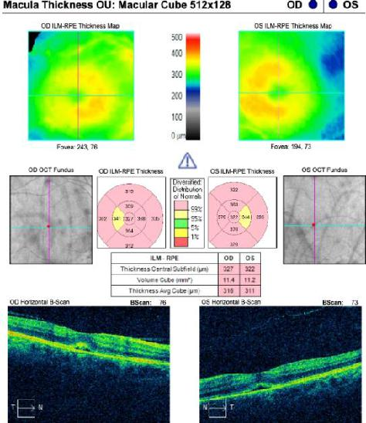

Figure 5. OCT of the both eyes. Cystic macular edema also disappeared.

Figure 6. Fundus photo of both eye RE and LE respectively.
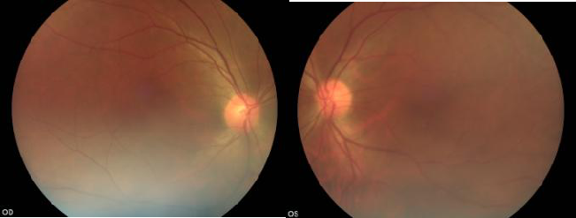

Discussion

Uveitis is the inflammation of the uvea. In 2005, the Working Group on the Standardization of Uveitis Nomenclature (SUN) standardized the classification of uveitis based on clinical data⁵. Priority was given to the anatomical classification of uveitis, which was compiled by the International Uveitis Research Group (IUSG) ⁶. Uveitis is classified anatomically into anterior uveitis, intermediate uveitis, posterior uveitis, and panuveitic forms. Panuveitis is the inflammation of all layers of the uvea, as shown in our patient. The patient had posterior synechiae on the lens (anterior uveitis), opacity of the vitreous humour (intermediate uveitis) and signs of posterior uveitis observed on OCT. Panuveitis is generalized inflammation of the uvea that is also involved in the process of retinal and vitreous humour ⁷.

The differential diagnosis of panuveitis includes infectious and autoimmune aetiologies. The choice of a patient's treatment method directly depends on the aetiology; therefore, it is very important to determine the aetiology as soon as possible. For these purposes, we checked the patient first for infectious diseases such as syphilis and tuberculosis and for autoimmune or systemic diseases such as Vogt-Koyanagi-Harada syndrome, Behchet disease, and sarcoidosis.

The unsuccessful treatment with oral prednisone, azathioprine and topical betamethasone in Iran did not favour systemic diseases. Additionally, based on anamnestic, clinical and laboratory findings, no infectious, systemic, neoplastic or other aetiology was identified.

Since it was not possible to determine the aetiology, we decided to take a nonstandard treatment approach. In addition, as it turned out, we succeeded. First, the patient received an intravenous antibiotic and then intravenous dexamethasone. In this case, the sequential combination of antibiotics and dexamethasone played a role.

We have assumptions that the dysbiosis of the microbiota of the body, as a result of the interaction between the microbiota and foreign agents, could lead to such a manifestation, for example, panuveitis. We assume that the antibiotics acted directly on this link in the pathogenesis. In the future, it will be possible to discover new mechanisms that can be used to treat patients with idiopathic uveitis.
7

We assume that the pathogenesis of posterior uveitis and retinal diseases was based on a disturbance in the microbiota of the genitourinary tract. This conclusion is made based on the fact that in our practice, the onset of diseases often occurs after acute urogenital diseases. Similar cases have been found in the literature⁸.

The effect of the sequential use of ceftriaxone and dexamethasone is that first, we tried to weaken the human microbiota with an antibiotic, and then we balanced the microbial population and the antibody population with corticosteroids. This is just speculation and further research is needed.

Conflict of interests

The author declares that there is no conflict of interests.

Data availability statement

The data that support the findings of this study are available from the corresponding author upon reasonable request.

Funding

None.

Study association

This study is not associated with any thesis or dissertation work.

References and notes:

- Durrani OM, Meads CA, Murray PI. Uveitis: a potentially blinding disease. Ophthalmologica 2004;218(4):223–236.

- Rothova A, Suttorp-van Schulten MS, Frits Treffers W, Kijlstra A. Causes and frequency of blindness in patients with intraocular inflammatory disease. Br J Ophthalmol 1996; 80(4):332– 336. doi: 10.1136/bjo.80.4.332

- Guex-Crosier Y. Epidemiology of uveitis. Rev Prat 1999;49(18):1989-94. PMID: 10626483

- Biswas J. Epidemiology and pathogenesis of uveitis: A review. IJIR 2017;1(1):R1 DOI: 10.15305/ijir/v1i1/249

- Jabs DA, Nussenblatt RB, Rosenbaum JT Standardization of Uveitis Nomenclature (SUN) Working Group. Standardization of uveitis nomenclature for reporting clinical data. Results of the First International Workshop. Am J Ophthalmol 2005;140(3):509–16. doi: 10.1016/j.ajo.2005.03.057.

- Madow B, Galor A, Feuer WJ, Altaweel MM, Davis JL. Validation of a photographic vitreous haze grading technique for clinical trials in uveitis. Am J Ophthalmol 2011;

152(2):170-176.e1. doi: 10.1016/j.ajo.2005.03.057.doi: 10.1016/j.ajo.2011.01.058

- Reema Bansal, Vishali Gupta, and Amod Gupta. Current approach in the diagnosis and management of panuveitis. Indian J Ophthalmol 2010;58(1):11-9 doi: 10.4103/0301-4738.58468.

- Shchadnykh M. Punctate inner choroidopathy and spontaneous abortion of the pregnancy. Ophthalmology Cases

and Hypotheses 2020;1(1):5-8. DOI: 10.30546/2788-516X.2020.1.1.5

How to cite this article: Aliyeva A.C., Hajiyev

R.V. Unusual treatment option for panuvetits.

Ophthalmology Cases & Hypotheses. 2021;02(02):5-8.

Copyright ©2021. All rights reserved. | 8

