Submission: 09-12-2021
Accepted: 18-03-2022
Published: 22-07-2022
Journal of Ophthalmology Cases & Hypotheses

DIFFERENTIAL DIAGNOSIS OF GRAVES’ ORBITOPATHY AND NON-HODGKIN'S LYMPHOMA OF THE ORBIT: A CASE REPORT

Grishina E.E. MD, PhD.
Moscow Regional Research and Clinical Institute (“MONIKI”), Moscow,
Russian Federation
: https://orcid.org/: 0000-0003-2668-9136
Izotova E.N. MD
Moscow Regional Research and Clinical Institute (“MONIKI”), Moscow, Russian Federation
: https://orcid.org/: 0000-0002-2340-1902

Abstract

Purpose: The purpose of this study is to report, how Non- Hodgkin's lymphoma of the orbits can be easily confuse d with othe r diseases of the eye, causing difficultie s in diagnosis and leading to delayed initiation of treatme nt. A clinical case of a patie nt with bilateral orbital lymphoma with a predominant lesion of the extraocular muscles, occurring unde r the guise of Graves' orbitopathy is prese nte d.
Methods: this study include d ante rior segment assessment using a slit lamp, fundus examination, autore fractome try, exophthalmome try. For the final diagnosis, an orbitotomy was performed with a biopsy of the affe cted levator and surrounding tissues.
Results: Histological and immunohistoche mical studies confirme d the diagnosis of MALT lymphoma in both orbits. The patie nt received anticancer treatment and has been in remission for a year.
Conclusion: bilateral non-Hodgkin lymphoma of the orbits is rare, may pretend to be Graves' orbitopathy and be the cause of inade quate treatme nt. In such cases, a biopsy of the affe cted extraocular muscles is required to clarify the diagnosis and determine the morphological subtype of non-Hodgkin's lymphoma

Keywords: Graves' orbitopathy, bilateral non-Hodgkin's orbital lymphoma, MALT lymphoma, differential diagnosis.

Qu ick Resp on s e C od e: | Website:  https://ophthalmolcases.com/index. php/hat
DOI:
10.30546/2788-516X.2022.3.1.1

Introduction

Exophthalmos is one of the main clinical symptoms of a large numbe r of orbit diseases, unilate ral exophthalmos is more common in orbital tumors. However, it can develop with granulomatous inflammation of the orbital tissues, including sarcoidosis, IgG4-related disease involving orbital tissues, etc. Bilateral exophthalmos mainly develops in thyroid pathology, as a manife station of Graves’ orbitopathy

Case Reports

We prese nt a rare clinical case of bilateral orbital lymphoma with a predominant lesion of the extraocular muscles and masquerade as Graves' orbitopathy (GO). A 68-ye ar-old man complaine d of bilateral exophthalmos, redness, and lacrimation from both eyes.
It is known from the patie nt’s life history that in August 2019 he was diagnose d with B-cell lymphoma of the splee n, unde rwe nt sple ne ctomy, and unde rwe nt 5 courses of CHOP immunoche motherapy. Since May 2020, he has been in clinical remission; in the summer of 2020, he note d redness in both eyes; he was treated for conjunctivitis without an e ffe ct.

At the time of examination: the eyelids were edematous; the mobility of the eyeballs was slightly limited in all directions. Exophthalmome tric value s were: for the le ft eye (OS) - 26 mm, for the right eye (OD) – 25 mm at a base 98 mm.

Bone walls accessible for palpation were without fe atures, reposition of the eyeballs was sharply limited. The palpebral fissure did not close completely. Visual acuity was OD = 20/63 OS = 20/25. Reduced visual acuity of the right eye was associated with age -related cataract. Intraocular pressure (IOP): OU = normal. Red che mosis was prese nte d in both eyes, more pronounce d in the lower section. The corne a was transpare nt, shiny, but in the lower part the re were small-pointe d erosions. The ante rior segment and fundus of the le ft and right eyes were without pathology (Fig. 1). Clinical symptoms are the following: eyelid edema, exophthalmos, eye redne ss, che mosis .

1

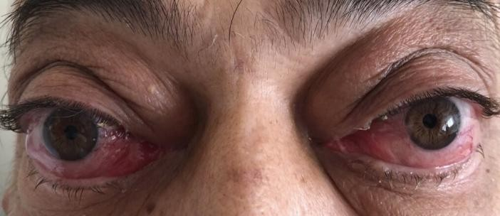

Figure 1. The patient with lesions of both orbits before treatment. Clinical symptoms are the following: eyelid edema, exophthalmos, eye redness, chemosis.

To ide ntify the pathology of the extraocular muscles, computed tomography (CT) of the orbits was performed. There was a picture of ophthalmopathy, with une ven thicke ning of the rectus muscles and superior oblique muscle, bilateral exophthalmos (Fig. 2 A, B).
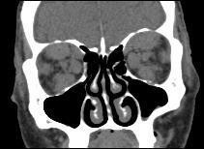

Figure 2A . CT of the orbits: A- coronal image, B- sagittal image. Pathology of the extraocular muscles with pronounced thickening of the rectus muscles and superior oblique muscle.
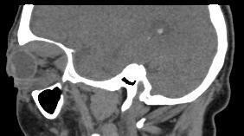

Figure 2B . CT of the orbits: B- sagittal image.
Pathology of the extraocular muscles with pronounced thickening of the rectus muscles and superior oblique muscle.

Also, a laboratory blood test for thyroid hormone s (TG) was performe d. Euthyroidism was revealed. Ultrasound of the thyroid gland didn’t detect any pathological signs.
Taking into account the clinical picture characteristic of GO on the one hand, the abse nce of thyroid pathology and the anamne sis data on the prese nce of lymphoma, on the othe r hand, it was decided to perform a diagnostic orbitotomy.
In the postoperative period be fore the results of the histological examination, systemic corticosteroids were prescribed to reduce inflammation.
Clinical symptoms reduced significantly on the second day (e xophthalmos, eyelid edema decrease d). Two days afte r the diagnostic orbitotomy, histological examination detected a relapse of non-Hodgkin's.
The immunophe notyping detected B-cell prolife ration of lymphocyte s with ge notype s CD3+, CD20+, bcl2+, bcl6- (Fig. 3 A, B, C, D).
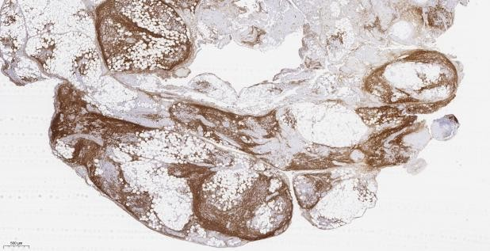
Figure 3A, B, C, D. Data of immunohistoche mical examination. А- CD20+, В- CD3+, С- bcl2+, D- bcl6-.
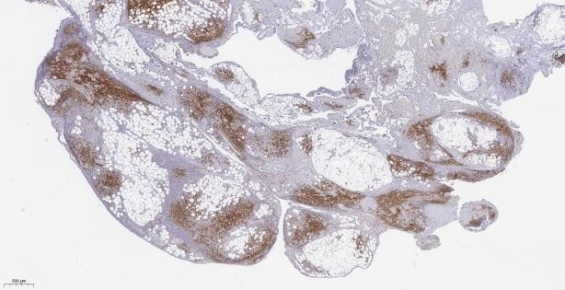
Figure 3B.
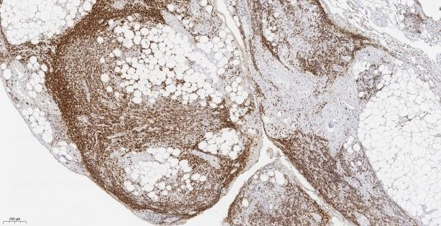
Figure 3C.
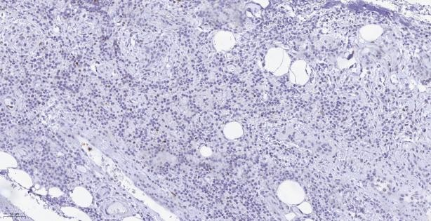
Figure 3D.

Histological and immunohistoche mical studies revealed MALT lymphoma. The patie nt was examine d by a he matologist.

The diagnosis of MALT lymphoma IV grade with involving the bone marrow, splee n, orbits, intrathoracic, abdominal and retroperitoneal lymph node s was establishe d. Treatme nt with be ndamustine was carried out. One ye ar follow-up patie nt is in clinical remission now (Fig. 4).
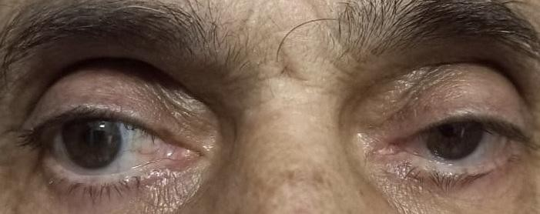

Discussion
GO develops afte r thyroid disease and is associated with hype rthyroidism or, less often, hypothyroidism. GO rarely develops without sings of thyroid gland damage or be fore the clinical manife station of thyroid disease [1-5]. A symmetrical le sion of both orbits is observed with GO, characterized by bilateral exophthalmos, non-inflammatory eyelid edema, che mosis, and limitation of eye mobility.
In cases of unilate ral exophthalmos and without signs of thyroid damage, the diagnosis of GO is particular difficult. So, C. Daumerie et al. (2008) retrospectively analyze d a cohort of 200 patie nts with GO and only 9 patie nts with euthyroidism were noted with a unilate ral orbit lesions [6].
Among the diseases which GO has to be diffe re ntiate d with, non-Hodgkin's lymphoma of the orbit is of particular inte rest.
In our patie nt, many signs pointe d to GO: complaints, positive symptoms of Koche r, Graefe, Krause, Möbius, data of orbits CT. Also, the patie nt is a he avy smoker for 40 years (main risk factor).
Patie nts of 60 years old or more predominate among patie nts with GO. GO can occur with euthyroidism. However, the patie nt's history was alarming - B-cell lymphoma of splee n, normal ultrasound resulted of the thyroid gland. In this regard, it was decided to perform a diagnostic orbitotomy.

Conclusion

Bilateral non-Hodgkin lymphoma of the orbits is rare, may prete nd to be GO and be the cause of inade quate treatme nt. In such cases, a biopsy of the affected extraocular muscles is required to clarify the diagnosis and determine the morphological subtype of non-Hodgkin's lymphoma.

Conflict of interests
The authors declare that the re is no conflict of inte rest.

Data availability statement
The data that support the findings of this study are available from the corresponding author upon reasonable request.

Funding
None .

Study association
This study is not associated with any the sis or dissertation work.

References

- Bartale na L, Baldeschi L, Boboridis K, Eckstein A, Kahaly GJ, Marcocci C, Perros P, Salvi M, Wiersinga WM, European Group on Graves’ Orbitopathy (EUGOGO) The 2016 European Thyroid Association/Europe an Group on Graves’ orbitopathy guideline s for the manage me nt of Graves’ Orbitopathy. Eur Thyroid J. 2016; 5:9–26 doi: 10.1159/000443828
- Piantanida E, Tanda ML, Lai A, Sassi L, Bartale na L Prevale nce and natural history of Graves’ orbitopathy in the XXI ce ntury. J Endocrinol Inve st.2013; 36:444–449 doi: 10.3275/8937
- Leo M, Me nconi F, Rocchi R, Latrofa F, Sisti E, Proflo MA, Mazzi B, Albano E, Nardi M, Vitti P, Marcocci C, Marinò M Role of the unde rlying thyroid disease on the phe notype of Graves’ orbitopathy in a tertiary re ferral ce nte r. Thyroid. 2015; 25:347–351 https://doi.org/10.1089/thy.2014.0475
- Marinò M., Ionn I., Lanzolla G., .Sframe li A, Latrofa F, Rocchi R., Marcocci C. Orbital diseases mimicking graves’ orbitopathy: a long-standing challe nge in diffe re ntial diagnosis Journal of Endocrinological Inve stigation 2020;43:401–411 DOI: 10.1007/s40618-019-01141-3
- Grishina E.E., Mosle hi Sh.H. About reasons of late diagnostics of e ndocrine Ophthalmopathy Russian Medical Journal, 2007; 8(2): 55-57
- Daumerie C, Duprez T, Boschi A. Long-te rm multidisciplinary follow-up of unilate ral thyroid-associate d orbitopathy. Eur. J. Inte rn Med. 2008; 19(7):531–536. doi:10.1016/j.e jim.2008.01.013
How to cite this article: Grishina E.E., Izotova E.N. Diffe re ntial diagnosis of Graves’ Orbitopathy and non- hodgkin’s lymphoma of the orbit: A case report. Opthalmology Cases & Hypotheses.2022;03(01):1-3. DOI:10.30546/2788- 516X.2022.3.1.1

Copyright ©2022. All rights reserved.

