Submission: 18-07-2022 Accepted: 12-09-2022 Published: 15-11-2022
Journal of Ophthalmology Cases & Hypotheses

EXPERIMENTAL STUDIES OF THE EFFECTS OF HYPOXIA ON THE APOPTOTIC DEATH OF THE EYE

Musayev P.I.1 (Corresponding Author)

1Azerbaijan Medical University, Department of Ophthalmology, Baku.

Markitantova Yu.V.2, Babayev H.F.3, Ryabtseva A.A.4, Akberova S.I.5

2Institute of Developmental Biology named after N.K. Koltsshva RAS, 3Institute of Physiology, Russian Academy of Sciences, A.I. Karaev National Academy of Sciences of Azerbaijan,4 SBHI (State Budgetary Healthcare Institution) Moscow Regional Research Institute. M.F. Vladimirskogo, 5Medical clinic "MedKvadrat".

Abstract

Hypoxia plays an important role in the pathogenesis of dry eye syndrome and hereditary, dystrophic, ischaemic, inflammatory, infectious and other diseases of the eye 3,5. During hypoxia, the conditions for maintaining normal metabolism and functioning of cells are violated, which can lead to cell death. In many human eye diseases, including glaucoma, cataracts, diabetic retinopathy, and retinal dystrophy, cell death is observed by the mechanism of apoptosis1,2,4,6,7,8,9..

Experimental studies on the effect of hypoxia on apoptotic cell death were carried out on individual eye tissues under in vitro conditions. Thus, it was shown in the culture of purified rat retinal ganglion cells, as well as corneal keratocytes, that hypoxia induces apoptosis in these cells11,12.

Access this article online

Quick Response Code: | Website:  https://ophthalmolcases.com/index.php/ hat
DOI:
10.30546/2788-516X.2022.3.2.10

7

The aim of this work is to study the effect of hypoxic hypoxia and acute hypobaric hypoxia on the eye tissues of adult rats in various in vivo experimental models of hypoxia.

Keywords: hypoxia, eye diseases, apoptosis, cell death

Materials and research methods

The work was performed on 24 mature male Wistar rats aged 3–4 months. In each experiment, 12 rats (24 eyes) were used: Group I - intact control (4 rats); Group II - after hypoxia for 1 hour (4 rats); and Group III (4 rats) - after hypoxia for 3 hours. Control animals (4 rats) were not exposed to hypoxia. In the experimental groups, the eyes of the animals were examined 1 and 3 hours after hypoxia.

Experimental modelling of acute hypoxia. In the experimental group, the animals were subjected to a single exposure of acute hypoxic hypoxia. Hypoxia was achieved by replacing room air with nitrogen in a hermetic chamber with a volume of 0.12 m 3, where experimental animals were placed for 7–10 minutes until convulsions occurred. The eyes of animals from the experimental group were analysed three hours after hypoxic exposure. The control group of animals not subjected to hypoxia was kept at room temperature. Animals from both groups were sacrificed by anaesthesia with ether vapour, after which the eyes of rats from both groups were enucleated, their histological examinations were carried out, and the distribution of apoptotic cells in
the tissues of the eye was analysed.

Journal of Ophthalmology Cases & Hypotheses
Volume 3, Number 2, 2022. 7-10.

Experimental modelling of acute hypobaric hypoxia. In the experimental group, the animals were subjected to a single exposure to acute hypobaric hypoxia, which was achieved by pumping out air for 1 min until the pressure chamber reached a pressure of 180 mmHg. The rats were kept in these conditions for 3 min before the onset of convulsions. The results of the experiments were recorded 3 hours after hypoxia. Animals were sacrificed by intraperitoneal injection of chloralhydrate (Riedel-de-Haen, Germany) followed by euthanasia with ether vapour after the animals recovered from anaesthesia. The eyes of experimental and control rats were enucleated.

The experiments were carried out in accordance with the Rules for the Keeping and Use of Laboratory Animals and the provisions of the European Convention for the Protection of Animals Used for Experimental and Other Scientific Purposes. To detect apoptosis in eye tissues, the traditional TUNEL method (terminal deoxynucleotidyl transferase-mediated deoxyuridine triphosphate (UTP) nick end labelling) was used using the DeadEnd Fluorometric TUNEL System reagent kit (Promega Corporation, USA).

The experiments were carried out in accordance with the Rules for the Keeping and Use of Laboratory Animals and the provisions of the European Convention for the Protection of Animals Used for Experimental and Other Scientific Purposes. To detect apoptosis in eye tissues, the traditional TUNEL method (terminal deoxynucleotidyl transferase-mediated deoxyuridine triphosphate (UTP) nick end labelling) was used using the DeadEnd Fluorometric TUNEL System reagent kit (Promega Corporation, USA).

Histological examination. The material for light microscopy was processed by conventional histological methods. For histological analysis, the rat eyes were fixed in Bouin's fluid, embedded in paraffin, and used for sectioning according to
16

Fragmented DNA was labelled by the TUNEL method according to the manufacturer's protocol. Before carrying out the enzymatic reaction, the sections were washed in 0.1 M PBS, fixed in 4% paraformaldehyde for 5 minutes, and then washed from the fixative in 0.1 M phosphate-buffered saline (PBS) three times for 5 minutes. The reaction was carried out for an hour at 37 °C then stopped by washing the sections in a 2X SSC solution. To confirm the specificity of the reaction, a standard control reaction was also performed in the absence of the rTdT enzyme. Cell nuclei were stained with Hoechst 33342 diluted in 0.1 M PBS (1:1000, Leica, Germany) for two minutes. After staining, the sections were washed several times with 0.1 M PBS for 15 minutes in each solution and placed in a special medium for preparations with a fluorescent label - Vectashield (Vector, USA).

Microscopy and computer image analysis. The localization of the fluorescent glow and its intensity in the cells of the eye tissues were analysed using a Leica DM RXA2 fluorescence microscope (Germany), with the image transferred to a computer console equipped with the Leica for Windows program. No fluorescent emissions were observed in the control preparations.

Results of the study

Viewing the selected transverse sections to identify apoptotic cells in the tissues of the eye clearly showed that under conditions of acute hypoxic hypoxia, the primary lesion occurs in all layers of the conjunctiva, in the anterior corneal epithelium, in the choroid, and in the photoreceptor layer of the retina (Figure 1. e,f,g,h,i,j). In dynamics, there is
an increase in cell damage by apoptosis. In other words, 3 hours after hypoxia, a more intense glow of damaged cells

the standard protocol . Sections 7 µm thick were glued onto

adhesive-coated slides (Silane-Prep Slides, Sigma), and after deparaffinization, the sections were stained with haematoxylin and eosin. The preparations were examined under a Leica light microscope (Germany).

Material preparation and deoxyribonucleic acid (DNA) labelling reactions were performed according to the TUNEL method. The eyes were fixed in 4% neutral formalin prepared in
0.1 M phosphate buffer (pH 7.4) for 4 h. Then, the samples were washed in phosphate buffer, three changes of phosphate buffer with 5% sucrose, three changes of phosphate buffer with 10% sucrose, then 20% sucrose (in each solution for 15 minutes) and left overnight in phosphate buffer with 20% sucrose at 4 °C. After freezing the eyes in a special medium (Tissue-Tec OST, Leica, Germany) using a cryostat (Leica M1900, Germany), transverse sections of the eyeball were obtained and selected for analysis. The slice thickness was 12 µm.

8
is noted (Figure 1. i,j) than after 1 hour. The images were
processed using the ImageJ computer program (Figure 1. e,f).

It has been shown that the simulated conditions of hypoxia cause a pronounced cellular reaction in the conjunctiva, anterior epithelium of the cornea, and photoreceptor layer of the retina, which leads to apoptotic death in several regions. Staining DNA with Hoechst 33342 dye confirmed the localization of apoptosis in the cell nuclei. In other tissues of the eye, including the lens, iris, and ciliary body, apoptotic cells were absent in this type of lesion (Figure 1.c,d). The same picture was observed in all studied eyes. In eye tissues from the animal control group (without exposure to hypoxia), only single apoptotic cells were found in the conjunctiva and in the anterior epithelium of the cornea. No apoptotic cells were found in the lens, iris, ciliary body, or retina (Figure 1. c,d). In the control preparations, which served as a negative control to confirm the specificity of the reaction in the experiment, no labelled cells were observed. (Figure 1. )

Figure 1. Apoptotic cells in rat eye tissues in normal conditions and after experimental hypoxia. Arrows show TUNEL-positive cells in the conjunctiva and corneal epithelium. Nuclei were stained with Hoechst 33342. Intact negative control: (a,b); intact control conjunctiva (c, d); fixation after a single hypoxia: after 1 hour the conjunctiva (e, f),fixation after a single hypoxia after 1 hour the retina (g, h); fixation after 3 hours, conjunctiva (i, j). C
- conjunctiva; PrL, photoreceptor layer of the retina; Co - choroid (choroid). Scale: 200 (a–f), 500 µm (g– h).

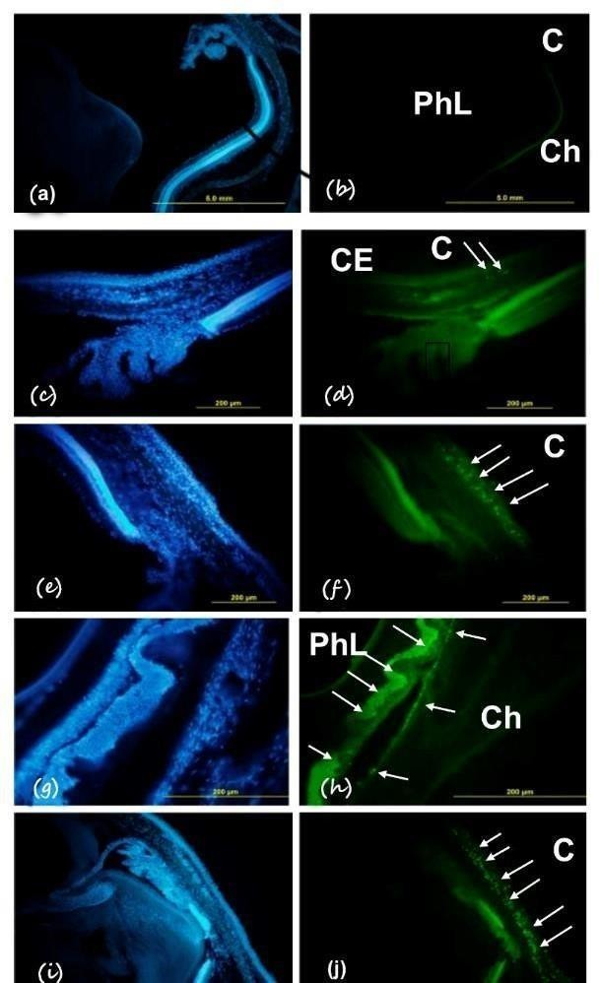

Thus, acute hypoxic hypoxia under the conditions modelled in this work caused an intense process of DNA fragmentation and apoptosis in the cells of the tissues of the anterior surface of the eye, the choroid, and the photoreceptor layer of the retina. In acute hypobaric hypoxia, we found a uniform, selective localization of cells with damaged DNA in the anterior corneal epithelium and
in the conjunctiva. These cells were subjected to apoptosis, which was confirmed by staining eye sections with the fluorescent DNA-binding dye Hoechst 33342. In dynamics, there was an increase in cell damage by apoptosis. In other words, 3 hours after hypoxia, a more intense glow of damaged cells is noted than after 1 hour.

In the studied tissues of the eye of animals from the control group (without exposure to hypoxia), only single apoptotic cells were found. In the lens, iris, ciliary body, choroid and retina, apoptotic cells were absent, both in the experimental and control groups. In the control preparations, which served as a negative control to confirm the specificity of the reaction in the experiment, no labelled cells were observed.

Discussion

Acute hypoxia under the conditions modelled in this work causes an intense process of DNA fragmentation and apoptosis in the cells of the tissues of the anterior surface of the eye—the conjunctiva and the anterior corneal epithelium. Unlike acute hypobaric hypoxia, hypoxic hypoxia also causes apoptosis of the choroid and retina. Acute hypoxia in the conditions of these experiments does not cause apoptotic changes in cells of the lens, iris, and ciliary body; in other words, these tissues remain undamaged. Thus, the cells of different parts of the eye of adult rats are characterized by different sensitivities to hypoxia, as modelled in this study.

These results open up further prospects for experimental studies of the mechanisms of eye tissue pathology under conditions of hypoxia of various genesis. Given the role of apoptosis in the pathogenesis of pathologies of the surface of the eye and retina, it is possible to study the fundamental mechanisms of the effectiveness of certain drugs in the treatment of eye diseases using these experimental models.

Conclusions

- Acute hypobaric hypoxia causes an intense process of DNA fragmentation and apoptosis only in the cells of the tissues of the anterior surface of the eye—the conjunctiva and the anterior epithelium of the cornea.

- Acute hypoxic hypoxia causes an intense process of DNA fragmentation and apoptosis in the cells of the tissues of the anterior surface of the eye—the conjunctiva and the anterior epithelium of the cornea, choroid, and retina.

9

Conflict of interests
The authors declare that there is no conflict of interest.

Data availability statement
The data that support the findings of this study are available from the corresponding author upon reasonable request.

Funding
None.

Study association
This study is not associated with any thesis or dissertation work.

References and notes :

- Ermilov V. V., Makhonina O. V. Correlation of metabolic disorders in eye structures with aging, apoptosis and age- dependent diseases // Vestnik VolgSMU 2011. V. 37. P. 67-69
- Slepova O.S., Frolov M.A., Morozova N.S., Lovpache
J.N. Markers of Fas-mediated apoptosis in primary open-angle glaucoma and the possibility of their pharmacological correction. Vestn. Ophthalmol. 2012. V.128. No. 4. S. 27-31
- Blasiak J., Petrovski G., Veréb Z., Facskó A., Kaarniranta K. Oxidative stress, hypoxia and autophagy in the neovascular processes of age-relatedmacular degeneration. Biomed. Res. Int. 2014. Р. 768026
- Cervellati F., Cervellati C., Romani A., Cremonini E., Sticozzi C., Belmonte G., Pessina F., Valacchi G. Hypoxia induces cell damage via oxidative stress in retinal epithelial cells. Free Radic. Res. 2014. V. 48. № 3.P. 303-312
- Chao H.M., Chuang M.J., Liu J.H., Liu X.Q., HoL.K., Pan W.H., Zhang X.M., Liu C.M., Tsai S.K., KongC.W., Lee S.D., Chen M.M., Chao F.P. Baicalein protects against retinal ischemia by antioxidation, antiapoptosis, downregulation of HIF-1α, VEGF, and MMP-9 and upregulation of HO-1. J. Ocul. Pharmacol. Ther. 2013. V. 29. № 6. Р. 539-549
- Ishibashi T. Comprehensive strategy for retinal neuroprotection. Challenging the clinical application. Nihon Ganka Gakkai Zasshi. 2012. V. 116. № 3. P. 165-198
- Kaur C., Foulds W.S., Ling E.A. Hypoxia-ischemia and retinal ganglion cell damage. Clinic. Ophthalmol.2008. V. 2. № 4. P. 879- 889
- Ozaki T., Nakazawa M., Yamashita T., Sorimachi H., Hata S., Tomita H., Isago H., Baba A., Ishiguro S.I. Intravitreal injection
or topical eye-drop application of aµ-calpain C2L domain peptide protects against photoreceptor cell death in Royal College of Surgeons' rats, a model of retinitis pigmentosa. Biochem. Biophys. Acta. 2012

10
- Saccà S.C., Izzotti A. Oxidative stress and glaucoma: injury in the anterior segment of the eye. Prog. Brain Res.2008. V. 173. P. 385-407
- Sennlaub F., Courtois Y., Goureau O. Inducible Nitric Oxide Synthase Mediates Retinal Apoptosis in Ischemic Proliferative Retinopathy. The J. of Neuroscience. 2002. 22.№ 10. P. 3987-3993
- Unterlauft J.D., Claudepierre T.M., Müller K., YafaiY., Wiedemann P., Reichenbach A., Eichler W. Enhanced survival of retinal ganglion cells is mediated by Müller glial cell-derived PEDF. Exp. Eye. Res. 2014. V.127. P. 206- 214
- Yang X., Wei A., Liu Y., He G., Zhou Z., Yu Z. IGF-1 protects retinal ganglion cells from hypoxia- induced apoptosis by activating the Erk-1/2 and Aktpathways. Mol. Vis. 2013. V. 19. P. 1901-1912

How to cite this article: Musayev P.I., Markitantova Yu.V Babayev H.F., Ryabtseva A.A., Akberova S.I.R.V. Experimental studies of the effects of hypoxia on the apoptotic death of the eye. Journal of Ophthalmology Cases & Hypotheses. 2022;03(02) 7-10.

Copyright ©2022.

