Submission: 29-06-2022
Accepted: 17-08-2022
Published: 15-11-2022
Journal of Ophthalmology Cases & Hypotheses

ON THE RELATIONSHIP BETWEEN DISEASES OF THE GASTROINTESTINAL TRACT AND THE OCCURRENCE OF DEMENTIA IN HUMANS (TESSELATED FUNDUS).

Hajiyev R.V. MD PhD
(Corresponding Author)

HAT Medicine Clinic, Baku, Azerbaijan

Abstract

Purpose: The purpose of this article is to reveal the relationship between eye diseases and common systemic diseases.

Methods: This article is an observational study of clinical cases of eye diseases and their association with common diseases. Four patients took part. These patients all had a similar picture of the posterior segment of the eye, a tessellated fundus. Additionally, all four patients had certain diseases of the gastrointestinal tract.

Results: We found that patients with a parquet type (tessellated fundus) fundus, before the appearance of this symptom, often had diseases of the gastrointestinal tract. In turn, the parquet type of fundus is an important predictor of degenerative brain diseases and cerebrovascular accidents.

Conclusion: There is a link between eye diseases and the gastrointestinal tract. In turn, disorders of the gastrointestinal tract are associated with a disturbance of the microbiota located on the mucous membranes of this tract. Recently, scientific articles have appeared that establish this connection. We consider it important to conduct further research in this direction.

Access this article online

Quick Response Code: | Website:  https://ophthalmolcases.com/index.php/ hat
DOI:
10.30546/2788-516X.2021.3.2.14

11
Moreover, the careful observation of clinical cases of eye diseases and their connection with common diseases can answer many questions in the medical field.

Keywords: Dementia, microbiota, parquet type, tessellated fundu.s

Introduction
In our practice, we often pay attention to the fact that some
eye diseases occur after the patient develops a common disease. For example, a few years after manifestation of diseases of the gastrointestinal tract or operations on it, such as cholecystectomy (an operation to remove the gallbladder), a number of people experience memory loss and the occurrence of ischemic stroke. We would like to share a few such cases.

Case report 1

A 61-year-old man asked for a prescription of glasses with
a complaint of poor near vision.Refraction of the right and left eyes +3.0 spherical dioptre (SD) (probably due to concomitant initial cortical cataract). His best corrected visual acuity (BCVA) in both eyes was 20/20.

With slit-lamp biomicroscopy, clouding of the lens in the cortical layers was observed.

Examination of the posterior segment revealed a parquet type of fundus (Figure 1).

Journal of Ophthalmology Cases & Hypotheses
Volume 3, Number 2, 2022. 11-14

2
He has a history of surgery - cholecystectomy, 8 years ago. There are complaints of severe dizziness and fleeting losses of consciousness. His memory has sharply weakened and he forgets what happened yesterday.

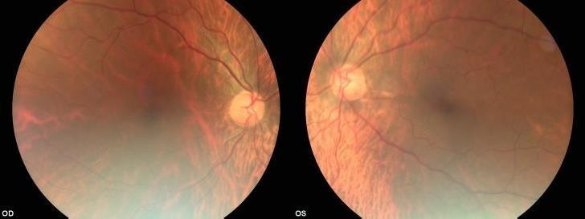

Figure 1. Fundus photo of the both eye.

Case report 2

A 68-year-old woman presented with complaints of visual impairment.

Refraction of the right and left eyes +2.0 SD, BCVA was 20/50 in both eyes. Pronounced senile cortical cataracts were also observed in both eyes. She temporarily refused surgery for cataract extraction. On the fundus of both eyes, there were parquet-type changes (Figure 2). She has a history of hypertension. For a long time, she suffered from severe pain
in the right hypochondrium. Nine years ago, she underwent cholecystectomy. Seven years ago, the patient was diagnosed with diabetes mellitus.

She also has complaints about a sharp deterioration in memory, which began to occur 2 years after the cholecystectomy. Additionally, she experiences dizziness. The patient was told that she was at risk of ischaemic stroke. A re- examination a year later showed that 6 months ago, she had suffered an ischaemic stroke.

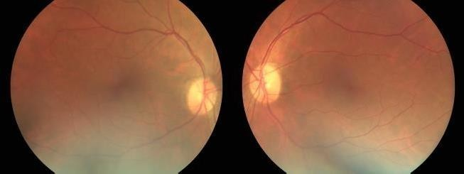

Figure 2. Fundus photo of both eyes.

Case report 3

A male patient, 61 years old. Refraction is emmetropic. Went with a complaint of poor near vision.
BCVA of both eyes is 20/20.

12

Slit lamp examination revealed an initial cortical cataract. Examination of the posterior segment revealed a pronounced parquet type fundus (Figure 3).

The patient underwent surgery for oesophageal cancer 7 years ago. He received chemotherapy. Currently, there is no recurrence, and he feels well.Two to three years after the operation, he noticed that his memory began deteriorating.

The patient, with a further complaint of deterioration in vision, was offered a cataract extraction operation. It was also said that, due to his special type of fundus, he was at risk of ischaemic stroke.The patient returned for a follow-up 3 years later. His visual acuity had decreased to 20/32. Moreover, he noted that the doctors were right and he had an ischaemic stroke 6 months ago.

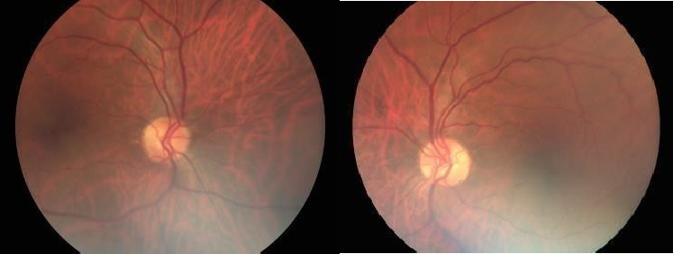

Figure 3. Fundus photo of both eyes.

Case report 4

The patient is 63 years old with complaints of periodic reddening
of the eyes, and seeing flies flying in front of his eyes. He also complained of very frequent dizziness and a sharp decrease in memory.
Refraction hypermetropia of 1.0 D with an astigmatism component of -0.75 D axis 90°. The BCVA was 0.8
Slit biomicroscopy revealed initial clouding of the lens in the cortical layers. In the vitreous body, filamentous destruction had occurred with an absence of inflammatory cells. The fundus was the parquet type (Figure 4).
The patient had been treated for diseases of the gastrointestinal tract for a long time with frequent vomiting, nausea, and pain in the stomach and intestines. The patient had severe gastritis. Then, after a long period of treatment, all of those symptoms disappeared. Two years later, the patient began to notice a decrease in memory, and dizziness appeared.
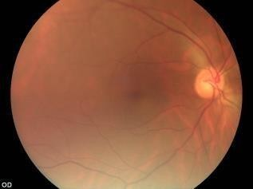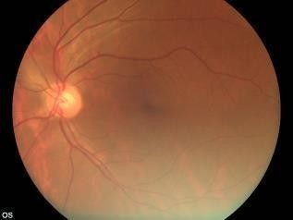

Figure 4. Fundus photo of both eyes.

Chaotic nutrition was a characteristic of all of these patients. They ate frequently, some just before bed. Each of them ate at least 4-6 times a day with periodic snacks.

Discussion

In the studies conducted by us, it was previously found that the parquet type of fundus (tessellated fundus) is accompanied by memory impairment, as well as periodic dizziness. Patients with such symptoms were more likely to be at risk of ischaemic stroke1,2,3,4.

When examining patients, our clinic attaches great importance to a thorough collection of anamnesis. In particular, we are interested in what common diseases patients had 5-10 years ago. We found that patients with a parquet type of fundus often had a history of diseases of the gastrointestinal tract.

In this article, we summarized the clinical cases of patients with a parquet type of fundus. In all cases, there was a sharp weakening of memory and frequent, short-term spells of dizziness.

It is also noteworthy that in all of these cases, pathologies of the gastrointestinal tract were observed 5-10 years ago. In two cases, patients underwent cholecystectomy; in one case, oesophageal cancer was observed; and in the fourth case, gastritis was observed. Subsequently, 3 patients had ischaemic stroke.

Interestingly, during the period when the parquet type of the fundus developed, there were no changes in the gastrointestinal tract. In contrast, in all four patients, when they had diseases in their gastrointestinal tract, there were no signs of memory impairment or dizziness. These symptoms only appeared a few years after the improvement of the condition of the stomach and intestines.

Disorders of the gastrointestinal tract are associated with a disturbance of the microbiota located on these mucous membranes. Recently, scientific articles have appeared that establish a link between the microbiota of the gastrointestinal tract and eye diseases (glaucoma and retina) 5. The microbiota of the gastrointestinal tract is inextricably linked to the population of antibodies that surround them. That is, an imbalance between the microbiota of the gastrointestinal tract and the antibody population can lead to various diseases of the stomach, intestines, gallbladder, oesophagus, and others.

In cases of imbalance between the microbiota and the antibody population, especially with age, diseases of the central nervous system and diseases of the retina can occur (parquet type of the fundus and probably some others). At the same time, the symptoms associated with diseases of the gastrointestinal tract are reduced. An indirect confirmation of this is the headaches that appear in some people, more often at a young age, during hunger.

13
Thus, there is a certain relationship. That is, when some diseases appear, others disappear. We consider it important to conduct further research in this direction. Moreover, the careful observation of clinical cases of eye diseases and their association with common diseases can answer many questions in the medical field.

For example, to treat diseases of the central nervous system or the eyes, it might be necessary to restore the balance between the microbiota of the gastrointestinal tract and the antibody population. These assumptions are based on specific clinical examples.

Once again, we would like to note that in previously published data, the presence of a tessellated fundus (we call it a parquet type of fundus) is an important diagnostic criterion for a high risk of degenerative brain diseases such as dementia, ischaemic stroke and Alzheimer's disease.

Conflict of interests
The author declares that there is no conflict of interest.

Data availability statement
The data that support the findings of this study are available from the corresponding author upon reasonable request.

Funding
None.

Study association
This study is not associated with any thesis or dissertation work.

References and notes:

- Hajiyev R.V. Influence of the "parquet" type of the fundus on the state of the retina in diabetes mellitus. Materials of the international ophthalmological conference Baku city, 1996 34-35
- Hajiyev R.V. Diagnosis of dyscirculatory encephalopathy according to ophthalmoscopy. Guidelines for doctors, Baku, Elm 1997, 11
- Hajiyev R.V. Influence of diabetic encephalopathy on the condition of the fundus in diabetes mellitus. Vestnik Oftalmologii. 1998;114(6):17-19
- Hajiyev R.V. Materials of the international ophthalmological conference Ophthalmol. Baku city, 1996, 34-35.
- Hajiyev R.V. Diabetic retinopathy. Intraocular risk factors and protection in pathogeneses of diabetic retinopathy. 1999. Baku, Elm, 72.

How to cite this article: Hajiyev R.V. On the relationship between diseases of the gastrointestinal traxt and the occurrence of dementia in humans. Journal of Ophthalmology Cases & Hypotheses. 2022;03(02):11-14.

Copyright ©2022.

14

