Journal of Ophthalmology Cases & Hypotheses

UDC 617.73

BILATERAL PAPILLEDEMA -CASE REPORT.

Mammadkhanova A.I. MD (Corresponding Author) National Prime Hospital, Baku, Azerbaijan ayanmammadkhanova@gmail.com

Galbinur T.P. MD PhD
National Prime Hospital, Baku, Azerbaijan

Galbinur A.P. MD
Azerbaijan Medical University, Baku, Azerbaijan

Abstract

This case report presents a detailed analysis of a patient with papilledema, discussing the clinical presentation, diagnostoc evalution, management strategies, and long-term prognosis. Papilledema is characterized by swelling of the optic disc due to increased intracranial pressure, typically associated with various neurologic conditions. The report aims to enhance understanding of papilledema, emphasizing the importance of early diagnosis and prompt intervention for better patient outcomes.
Keywords: papilledema, increased intracranial pressure.

Access this article online
Quick Response Code: | Website:
 | https://ophthalmolcases.com/in
 | dex.php/ hat
 | DOI:
 | 10.30546/2788-
 | 516X.2023.4.2.1

Introduction

Papilledema is a condition characterized by optic disc swelling caused by increased intractranial

Submission: 16-04-2023
Accepted: 23-08-2023
Published: 15-12-2023

pressure. It is a key clinical sign often associated with a variety of intracranial pathologies, such as brain tumors, hydrocephalus, and idiopathic intracranial hypertension (IIH). early recognition and prompt management are imperative to prevent permanent vision loss.

Case report
A 32-year-old female presented to the clinic due to a sudden decrease in the central and peripheral vision in both eyes (OU). She also experienced complete loss of vision for several seconds. At the initial visit, her best-corrected visual acuity was 20/28 in her right eye (OD) and 20/25 in her left eye (OS). There was no relative afferent pupillary defect. Dilated fundus examination showed bilateral optic disc oedema (Frisén grade 4) with peripapillary wrinkles (Figure 1). The slit lamp examination showed that the anterior segment was unremarkable in terms of OU.

Optical coherence tomography (OCT) showed that the thickness of the retinal nerve fibre layer (RNFL) was 267 µm in the right eye and 460 µm in the left eye at that time (Figure 2).

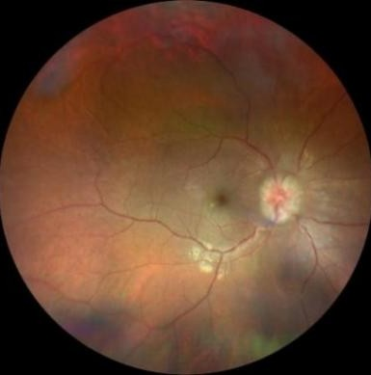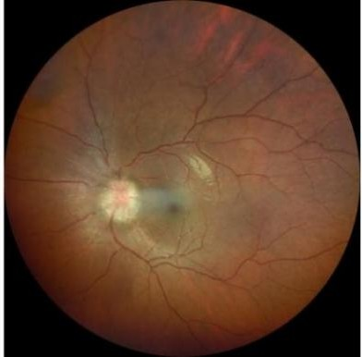The patient at the time of examination weighed 110 kg, measured 165 cm in height and had a body mass index of 40.4. This, in turn, corresponds to Obesity Class III.
The patient underwent magnetic resonance imaging (MRI) of the brain, which did not reveal any pathology. The patient was then referred to a neurologist for lumbar puncture, which included determination of cerebrospinal fluid pressure.
Lumbar puncture in the left lateral decubitus position revealed an opening pressure of 36 cm H2O and that the cerebrospinal fluid contents were normal. It should be noted that the patient immediately noted an improvement in vision after lumbar puncture.
She was started on 500 mg acetazolamide 3 times a day initially and then 2 times a day thereafter for 6 months.

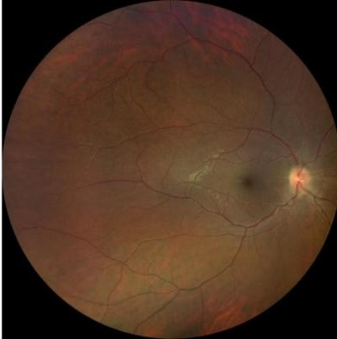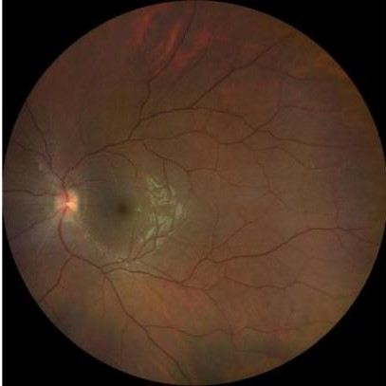Figure 1. Fundus photo of both eyes at initial examination demonstrated moderate bilateral optic disc edema (Frisén Grade 4)

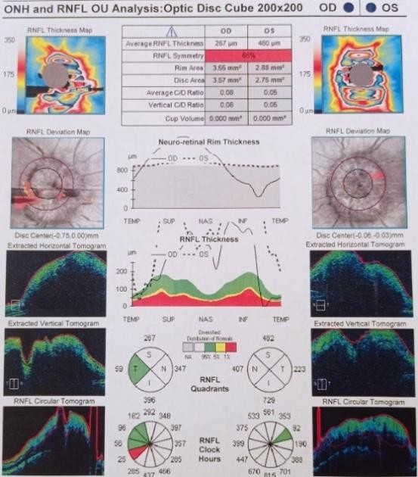

Figure 2. The optical coherence tomography (OCT) retinal nerve fiber layer (RNFL) thickness of both eyes at initial examination.
Figure 3. The fundus of both eyes of the patient after 6 months of taking acetazolamide. The amount of edema is minimal.

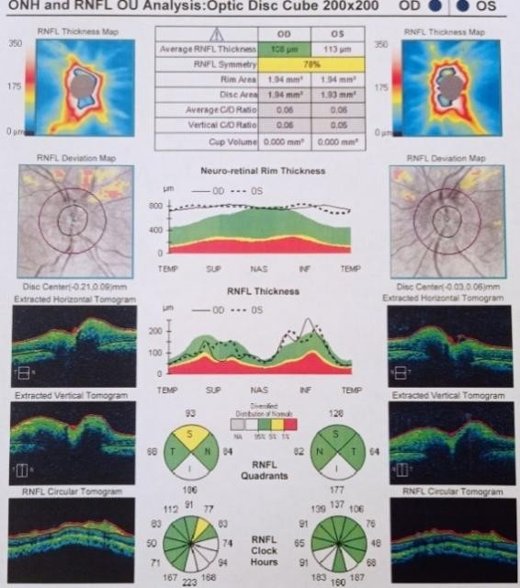
Figure 4. The optical coherence tomography (OCT) retinal nerve fiber layer (RNFL) thickness after 6 months of taking acetazolamide.

After 6 months of treatment, re-examination showed that the papilledema had improved significantly, but had not disappeared completely and was present with peripapillary wrinkles (from Friesen grade 1) at the follow-up visit (Figure 3). The patient's BCVA was restored to 20/20, and complaints of visual field defects disappeared. The thickness of the retinal nerve fibre layer (RNFL) on optical coherence tomography (OCT) images obtained 6 months after taking acetazolamide was dramatically decreased in both eyes. Namely, in the right eye, it decreased from 267 µm to 121 µm, and in the left eye, it decreased from 460 µm to 96 µm. In parallel, during this 6-month period, the patient’s weight decreased slightly from 110 kg to 97 kg (Figure 4). Thus, the body mass index decreased to 35.6, which corresponds to Obesity Class II.

Discussion
Papilledema is an optic disc swelling with increased intracranial pressure (ICP) as the underlying cause1. In most cases the process is bilateral. But in extremely rare cases, unilateral edema can be observed. In the early stages, papilledema may be asymptomatic. It can also be accompanied by an increase in the blind spot,
blurred vision, or defects in a certain part of the visual field for a certain period of time. Ultimately, complete loss of vision may occur.
Causes of increased intracranial pressure can be: mass effect such as brain tumor, infarction with edema, contusions, subdural or epidural hematoma, or abscesses all tend to deform the adjacent brain, generalized brain swelling, increase in venous presure. Obstruction to CSF flow and/or absorption can occur in hydrocephalus. Increased CSF production can occur in meningitis, subarachnoid hemorrhage, or choroid plexus tumor.
If papilledema is clinically suspected, blood pressure should be measured, followed by magnetic resonance imaging of the brain to look for causes of increased ICP and rule out non- idiopathic causes. Then, a lumbar puncture should be performed with measurement of opening pressure and assessment of the composition of the cerebrospinal fluid. A complete blood count, creatinine determination, and many other examination methods can identify most secondary causes of intracranial hypertension3.
The most common cause of papilledema is particularly in young patients, i.e. younger than 50 years, is idiopathic intracranial hypertension (IIH)4,5. IIH is thought to be most prevalent among obese women of childbearing age, with the incidence predominating among obese women aged 20–44 years2.
The CSF opening pressure (CSFOP) is reducing with increasing age and CSFOP is increasing with increasing BMI. As a “rule-of-thumb” it suggest, the following cut-of: for males<30 cm H2O (<25 if over age 70), and for females<25 cm H2O (27.5 if over 30 BMI). A diagnosis of intracranial hypertension should not be given without such considerations6.
Treatment of patients with papilledema depends on the etiology of the underlying process that caused the increase in intracranial pressure. In our patient, the cause of the IIH was not identified.
Thus, the diagnosis of idiopathic papilledema was made. Medical treatment and weight loss counseling is usually started in IIH patients with papilledema to prevent permanent vision loss7. So, it is reasonable to observe patients with

papilledema as they work on weight loss, which is beneficial for both IIH and overall health. In the case of our patient, the decision was made to take acetazolamide, which resulted in a significant improvement in the clinical picture and the virtual disappearance of subjective complaints. This clinical case confirms the effectiveness of timely targeted therapy.

Conclusion
Papilledema is a significant clinical sign that warrants immediate attention. This case report emphasizes the importance of a thorough evalution to determine the underlying cause, establish an appropriate mangement plan, and prevent long-term complications. Early dianosis, multidisciplinary collaboration, and regular ophthalmologic follow-ups are essential for achieving optimal outcomes in patients with papilledema.

Conflict of interests
The author declares that there is no conflict ofinterests.

Data availability statement
The data that support the findings of this study areavailable from the corresponding author upon reasonable request.

Funding
None.

Study association
This study is not associated with any thesis ordissertation work.

References:

- Anandi L, Budihardja BM, Anggraini E, Badjrai RA, Nusanti S. The use of artificial intelligence in detecting papilledema from fundus photographs. Taiwan J Ophthalmol. 2023 Jun
1;13(2):184-190. doi: 10.4103/tjo.TJO-D-22-
00178. PMID: 37484606; PMCID: PMC10361430.
- Malhotra K, Padungkiatsagul T, Moss HE. Optical coherence tomography use in idiopathic intracranial hypertension. Ann Eye Sci 2020;5:7.
- Xie JS, Donaldson L, Margolin E. Papilledema: A review of etiology, pathophysiology, diagnosis, and management. Surv Ophthalmol. 2022 Jul-Aug;67(4):1135-1159. doi: 10.1016/j.survophthal.2021.11.007. Epub 2021 Nov 20. PMID: 34813854.
- Rigi M, Almarzouqi SJ, Morgan ML, Lee AG. Papilledema: Epidemiology, etiology, and clinical management. Eye Brain 2015;7:47-57.
- Xie JS, Donaldson L, Margolin E. Papilledema: A review of etiology, pathophysiology, diagnosis, and management. Surv Ophthalmol 2022;67:1135-59.
- Siri H, Christofer L. Cerebrospinal fuid opening pressure in clinical practice –
a prospective study. Journal of Neurology (2020) 267:3696–3701
- Thurtell MJ. Idiopathic intracranial hypertension. Continuum. 2019;25:1289–1309.

Copyright ©2023. All rights reserved.

