UDC 617.73
Journal of Ophthalmology Cases & Hypotheses

STEROID-INDUCED GLAUCOMA IN A 6-MONTH-OLD GIRL - case
report.

Hajiyev R.V. MD PhD (Corresponding Author- rasim.gadjiev@gmail.com)
HAT Medicine Clinic, Baku, Azerbaijan

Abstract.

Steroids are a group of anti-inﬂammatory drugs, commonly used to treat ocular and systemic conditions. Unmonitored use of steroids especially in eye drop formulations is common in situations when it is easily available over-the-counter, resulting in undesirable side eﬀects. Among the ocular side eﬀects, cataract and glaucoma are common.
Chronic administration of steroids in any form with raised IOP can cause optic neuropathy resulting in steroid-induced glaucoma1,2,3.
Steroid-induced glaucoma is the most serious complication of the injudicious use of steroids, particularly among children aﬀected by allergic conjunctivitis. This condition is steroid-dependent, and children are commonly being prescribed topical anti-inﬂammatories, including topical steroids, by general practitioners. Furthermore, topical steroids are also available over the counter, and this availability contributes to overuse without proper monitoring by an ophthalmologist 4,5.
Corticosteroid-induced IOP rise has been shown to occur with various methods of steroid administration, but is most identiﬁed as a complication of topical corticosteroid

Submission: 05-01-2023
Accepted: 12-08-2023
Published: 15-12-2023

application with drugs such as dexamethasone or prednisolone. In responsive patients, the IOP typically rises after several weeks of continual corticosteroid therapy and returns to normal following cessation of such therapy 6.
Corticosteroid glaucoma often occurs in children undergoing treatment for vernal keratoconjunctivitis 7.
Corticosteroid-induced glaucoma is a well- recognized phenomenon in adults, but not in children. We describe an infant who developed juvenile glaucoma with buphthalmos while receiving topical steroid treatment. The intraocular pressure normalized several months following discontinuation of treatment.

Keywords: glaucoma, ocular side eﬀects, corticosteroids.

Access this article online
Quick Response Code: | Website:
 | https://ophthalmolcases.com/in
 | dex.php/ hat
 | DOI:
 | 10.30546/2788-
 | 516X.2023.4.2.4

Case Report

The parents of an 8-month-old girl consulted an ophthalmologist with complaints of an increase in the size of both eyes, especially the right eye (Figure 1).
According to the parents, 3 months ago, the child had signs of conjunctivitis, and the general practitioner prescribed antibiotic drops with corticosteroids. They periodically administered these drops for 3 months, after which an increase in the size of the eyes was observed. The drops were not administered for the last 3 weeks.

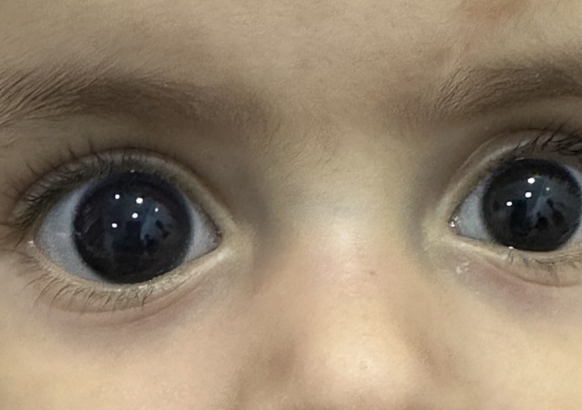

Figure 1. Enlargement of the diameter of the right eye,s cornea

The examination revealed a weak myopic refraction of 0.75 spherical dioptres and astigmatism of 0.75 cylindrical dioptres in both eyes. The intraocular pressure of the right eye was 15 mmHg, and that of the left eye was 14 mmHg. The optical media of the eyes were transparent.
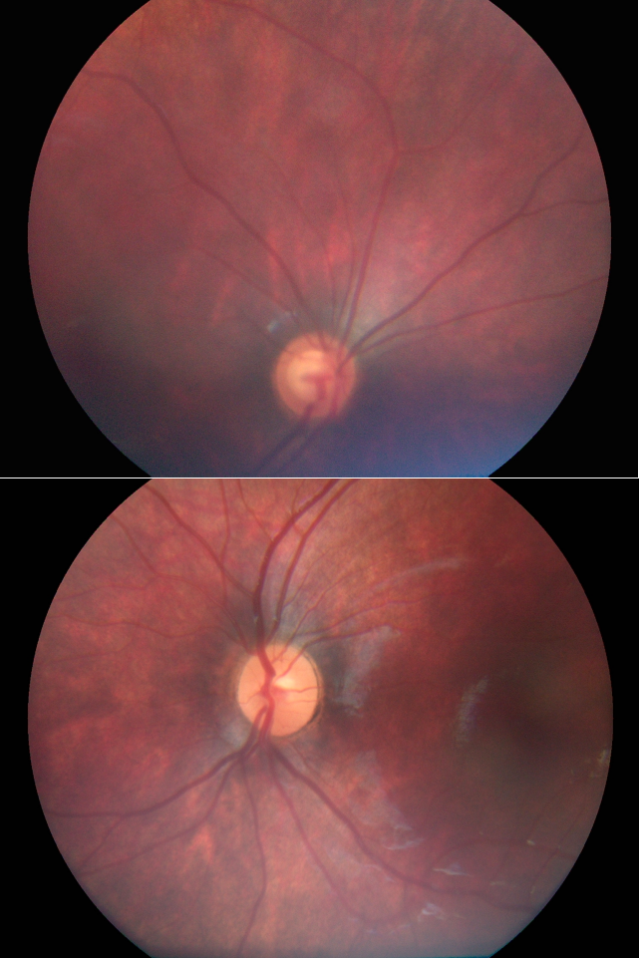
Figure 2. Fundus photo of the right and left eye.

Severe glaucomatous excavation was noted in the fundus of the right eye. There was a slight excavation on the left eye (Figure 2).
Figure 3. Photo of a child before using corticosteroids

The parents stated that 3 months ago, the size of the child’s eyes was normal. They also provided a photo of the baby at 3 months (Figure 3).

Discussion
Congenital glaucoma is accompanied by macrocornea and buphthalmos 8. Our case indicates that even topical use of corticosteroids in infants quickly leads to an increase in intraocular pressure and the occurrence of macrocornea. Timely withdrawal of corticosteroids leads to normalization of intraocular pressure.
Rare cases of the ﬁrst model of megalocornea in children are associated with higher intraocular pressure that is still within the physiological norm in the late period of intrauterine development.
Model II megalocornea, also known as anterior megalophthalmos, X-linked megalocornea and macrocornea, is a rare bilateral nonprogressive birth defect that is characterized by an increase in corneal diameter greater than 12.5–13 mm at birth and a deep anterior chamber with normal intraocular pressure 9,10.
Corneal thinning is also often associated with macrocornea 11. The defect is classified as an anterior segment dysgenesis and is associated with a number of other conditions, including Axenfeld-Rieger syndrome, Peters anomaly, primary congenital glaucoma, aniridia, congenital hereditary endothelial dystrophy, and sclerocornea. In addition, it is a component of many different congenital syndromes.
Buphthalmos develops in the early period of child development. The earlier topical corticosteroids are used, the faster buphthalmos occurs. The authors described a clinical case in which a 3- week-old child received topical corticosteroids. Buphthalmos occurred one week after topical corticosteroid application 12.

Steroid-induced glaucoma is the most serious complication of harmful steroid use, especially among children with allergic conjunctivitis. This condition is steroid dependent and children are usually prescribed topical anti-inﬂammatory drugs, including topical steroids, by general practitioners (GPs). Additionally, topical steroids are also available over the counter, and this availability encourages overuse without proper supervision by an ophthalmologist.Furthermore, topical steroids are also available over the counter, and this availability contributes to overuse without proper monitoring by an ophthalmologist. As many forms of cortico-steroids are widely used, children on corticosteroids should have regular intraocular pressure measurements as part of their management.

Conﬂict of interests
The author declares that there is no conflict ofinterests.

Data availability statement
The data that support the findings of this study areavailable from the corresponding author upon reasonable request.

Funding
None.

Study association
This study is not associated with any thesis ordissertation work.

References

- Phulke S., Kaushik S., Kaur S., Pandav S. Steroid- induced glaucoma: an avoidable irreversible blindness. J Curr Glaucoma Pract. 2017;11(2):67-72. doi: 10.5005/jp-journals-l0028-1226).
- Yamashita T., Kodama Y., Tanaka M. et al. Steroid-induced glaucoma in children with acute lymphoblastic leukemia:a possible complication. J Glaucoma 2010;19(3):188-90
DOI: 10.1097/IJG.0b013e3181af321d).
- Feroze KB, Zeppieri M, Khazaeni L. Steroid- Induced Glaucoma. 2023 Jul 16. In: StatPearls [Internet]. Treasure Island (FL): StatPearls Publishing; 2023 Jan–. PMID: 28613653.)
- Lam CS, Umi Kalthum MN, Norshamsiah MD, Bastion M. Case series of children with steroid- Induced glaucoma. Malays Fam Physician. 2018
Dec 31;13(3):32-37. PMID: 30800232; PMCID: PMC6382086.
- Sen P, Jain S, Mohan A, Shah C, Sen A, Jain E. Panern of steroid misuse in vernal keratoconjunctivitis resulting in steroid induced glaucoma and visual disability in Indian rural population: An important public health problem in pediatric age group. Indian J Ophthalmol. 2019 Oct;67(10):1650-1655. doi: 10.4103/ijo.IJO_2143_18. PMID: 31546501; PMCID: PMC6786207.)
- (Gupta S, Shah P, Grewal S, Chaurasia AK, Gupta
V. Steroid-induced glaucoma and childhood blindness. Br J Ophthalmol. 2015 Nov;99(11):1454-6. doi: 10.1136/bjophthalmol-2014-306557. Epub 2015 May 22. PMID: 26002945.)
- Badawi AH, Al-Muhaylib AA, Al Owaifeer AM, Al-Essa RS, Al-Shahwan SA. Primary congenital glaucoma: An updated review. Saudi J Ophthalmol. 2019 Oct-Dec;33(4):382-388. doi: 10.1016/j.sjopt.2019.10.002. Epub 2019 Nov 7. PMID: 31920449; PMCID: PMC6950954.
- Meire FM. Megalocornea. Clinical and genetic aspects. Doc Ophthalmol. 1994;87(1):1-121;
- Ito YA, Walter MA. Genomics and anterior segment dysgenesis: a review. Clin Exp Ophthalmol. 2014 Jan-Feb;42(1):13-24;)
- Webb TR, Matarin M, Gardner JC, Kelberman D, Hassan H, Ang W, Michaelides M, Ruddle JB, Pennell CE, Yazar S, Khor CC, Aung T, Yogarajah M, Robson AG, Holder GE, Cheetham ME, Traboulsi EI, Moore AT, Sowden JC, Sisodiya SM, Mackey DA, Tuft SJ, Hardcastle AJ. X-linked megalocornea caused by mutations in CHRDL1 identiﬁes an essential role for ventroptin in anterior segment development. Am J Hum Genet. 2012 Feb 10;90(2):247-59.
- Hutcheson KA. Steroid-induced glaucoma in an infant. J AAPOS. 2007 Oct;11(5):522-3. doi: 10.1016/j.jaapos.2007.03.008. Epub 2007 Jul 12. PMID: 17629528.

Copyright ©2023. All rights reserved.

