Submission: 20-10-2023

Accepted: 14-12-2023

Published: 17-05-2024

***Journal of Ophthalmology Cases & Hypotheses***

**On The Connection between Inflammatory Diseases of the Female Reproductive System and The Occurrence of Optic Neuritis**

**Hajiyev R.V. MD PhD**

*(Corresponding Author) HAT Medicine Clinic, Baku, Azerbaijan*

*rasim.gadjiev@gmail.com*

**Abstract**

**Objective**  
In this paper, we present a clinical case of the connection between the occurrence of menstrual irregularities and inflammation of the female reproductive system and optic neuritis.

**Methods**  
We present a clinical case of a 47-year-old woman who suffered from delayed menstruation, accompanied by menorrhagia, inflammatory disease of the female reproductive system, followed by the development of a sharp decrease in visual acuity and the occurrence of optic neuritis of the right eye.

**Results**  
The patient was treated for female reproductive system diseases. The treatment included a combination of systematic short-term antibiotics followed by intravenous corticosteroids. After treatment, a significant increase in visual acuity was noted.

**Conclusion**

This case report as well as the literature data on the connection between menstrual irregularities and retinal diseases highlights that it can be assumed that optic neuritis and some retinal diseases may be associated with an imbalance of the genitourinary microbiota and surrounding antibodies. Further research and larger-scale studies are warranted to validate these findings.

***Keywords:*** *genitourinary* *microbiota , optic neuritis*



**Access this article online**

|  |  |
| --- | --- |
| **Quick Response Code:** | **Website:**  https://ophthalmolcases.com/index.php/ hat |
|  |
| **DOI:**  **10.30546/2788-516X.2024.018.0275** |
|  |

**Introduction**

Inflammatory diseases of the female reproductive system and optic neuritis are both medical conditions that can significantly impact a person's health and quality of life. Optic neuritis is an inflammatory condition that affect optic nerve and a common cause of acquired vision loss.The main causes of optic neuritis (ON) are multiple sclerosis (MS), neuromyelitis optica spectrum disorder (NMOSD) and myelin oligodendrocyte glycoprotein  
antibody disease, also known as MOGAD.1 Although there are cases of infectious optic neuritis, such as syphilis, Lyme disease, tuberculosis.2,3,4 There is also a connection between optic neuritis and systemic diseases.5 While these two conditions may seem unrelated at first glance, it may be a potential connection between inflammatory diseases of the female reproductive system and the occurrence of optic neuritis.

**Clinical case**

Woman 47 years old. Complaints of very poor vision in the right eye.

Suffering from hypertension for the last 3 years. She takes anti-hypertensive drugs in the morning. 3 months ago there was a delay in menstruation for 59 days. Then heavy bleeding appeared for 10 days. The bleeding was so severe that she turned to gynecologists.

After the bleeding stopped, she began to notice that the vision in her right eye began to deteriorate. At the same time, she noticed that her blood pressure had normalized.

The patient was examined in various clinics. The correct diagnosis was made, but there was no treatment. A month later she contacted us.

On examination, she had a visual acuity of 20/200 in her right eye with a relative afferent pupillary defect (RAPD) and fundoscopy revealed disc edema in the right eye (Figure 1,2). Visual acuity of the left eye was 20/20.

Spectral-domain optical coherence tomography (SD-OCT) showed an increase in retinal nerve fiber layer (RNFL) thickness. This thickening was mainly in the inferior and superior peripapillary region (Figure 3).

Visual evoked potential was suggestive of a retino-optic pathway dysfunction in the right eye.

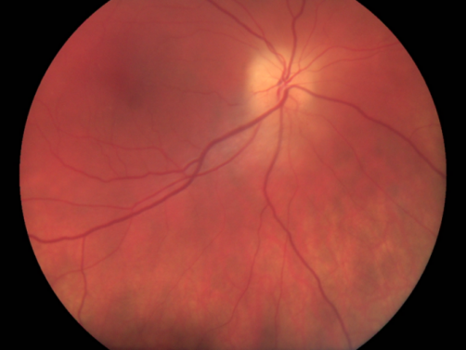

*Figure 1. Fundus photo of the the right eye with disc edema.*

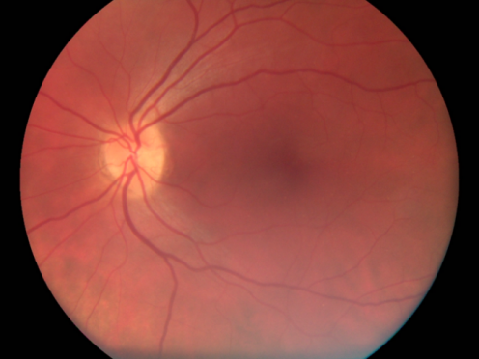

*Figure 2. Fundus photo of the the left eye.*

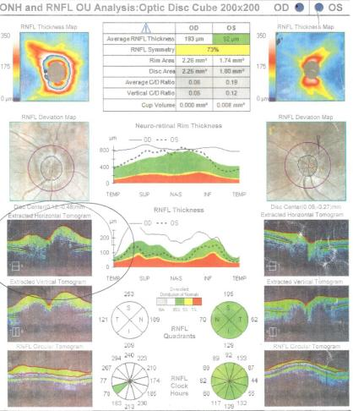

***Figure 3.*** *OCT RNFL thickness measurements of the both eyes.*

The field of vision of the right eye is narrowed, the left is also but to a lesser extent (Figure 4,5).

Laboratory investigation results revealed a normal blood count, and normal levels of liver enzymes, serum creatinine, angiotensin-converting enzyme

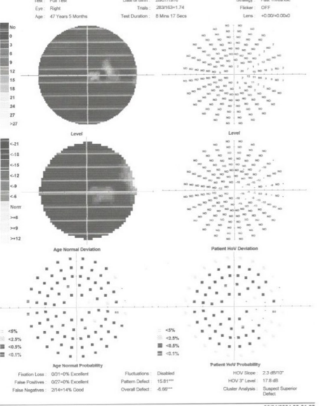

***Figure 4.****The field of vision of the right eye is narrowed.*

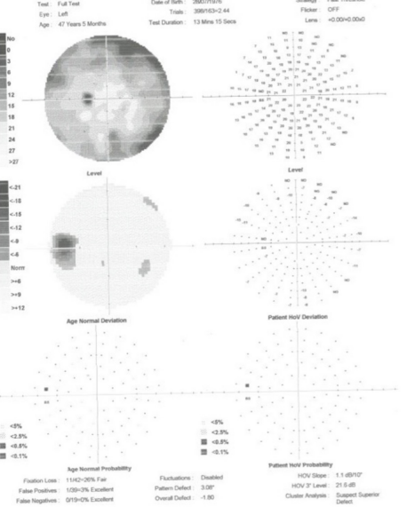

***Figure 5.****The field of vision of the left eye is.*

Serum serologies for Lyme, syphilis, Brucella, viral hepatitis, Bartonella henselae and HIV were negative.

Corticosteroid intravenous therapy with Dexamethasone was prescribed for 6 days (3 days at 8 mg and 3 days at 4 mg).

Post-treatment examination was carried out a week later. The patient felt a dramatic improvement in vision.

Visual acuity of the right eye increased to 20/63. The boundaries of the field of view also expanded (Figure 6,7).

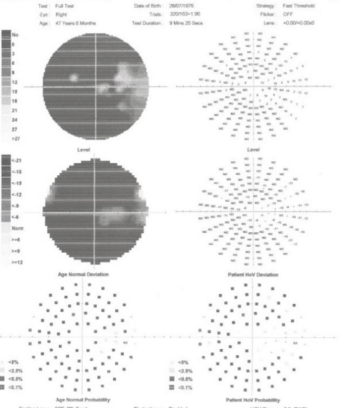

***Figure 6.****The field of vision of the right eye after treatment.*

***Figure 7.****The field of vision of the left eye after treatment.*

The next examination was carried out after 3 months.

Visual acuity of the right eye was 20/63, left 20/20. In the fundus, pallor of the optic disc is noted, the blurring has disappeared (Figure 8,9).

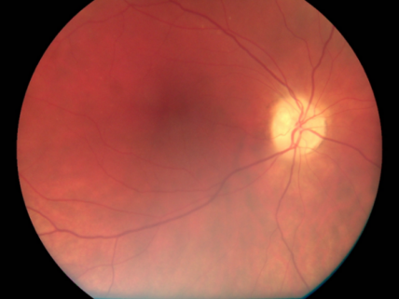

*Figure 8. Fundus photo of the the right eye. 3 months after treatment.*

*Figure 9. Fundus photo of the the left eye. 3 months after treatment.*

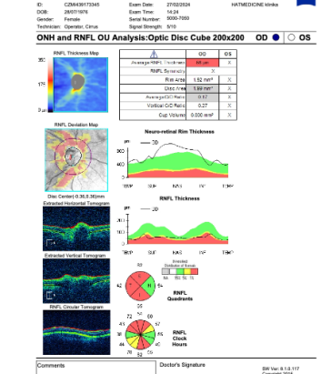

***Figure 10.*** *OCT RNFL thickness measurements of right eye. After treatment.*

OCT data showed a decrease in the thickness of RNFL and ganlion cells (Figure 10). Swelling of the optic nerve gave way to its atrophy. This was to be expected.

**Discussion**

Our earlier studies showed that retinal diseases may be associated with genitourinary tract disorders 6 and kidney diseases.7,8  Uveitis is known to occur in Behçet's disease. 9 It can be assumed that diseases of the genitourinary organs and kidney diseases are associated with inflammation, which occurs as a result of an imbalance between the genitourinary microbiota and the surrounding immune cells. This disorder in some cases leads to the occurrence of diseases of the genitourinary tract, in other cases to the occurrence of other diseases, including optic neuritis and some diseases of the retina.

The patient suffered from hypertension for 3 years. She took a blood pressure pill every morning. The patient suddenly experienced a delay of 59 days. Then there was heavy bleeding during menstruation. It was so severe that she had to see doctors. The bleeding continued for 10 days. Then it stopped, and the patient began to notice a gradual deterioration in the vision of the right eye. Interestingly, after this, the jumps in blood pressure disappeared and the pressure returned to normal. She stopped taking her hypertension medications. Her vision continued to deteriorate and optic neuritis occurred.

Is there a connection between the restoration of the normal menstrual cycle and the occurrence of optic neuritis. Apparently, this is a property of the organism. It can not have two critical illnesses at a particular moment. The relief of physical symptoms in the dying is known. There was often a brief improvement in condition, with reduced need for analgesic, shortly before death.10 Apparently, the human body constantly undergoes a transition from one disease to another. During the transition, some symptoms disappear, while others have not yet appeared. It is at this time that the person’s condition improves for a while. And then new symptoms may appear and a new organ may be affected. In this case, the initial disease completely disappears.

The question arises what is the connection between menstrual irregularities, normalization of blood pressure and the occurrence of optic neuritis.

In previous studies, we suggested that a sudden decrease in vision in acquired retinal diseases may be associated with an imbalance in the microbiota of the genitourinary tract and the immune cells surrounding them.11

Probably, a similar mechanism operates when optic neuritis occurs. An imbalance of the microbiota at the level of the genitourinary tract can cause diseases such as chronic prostatitis in men, female inflammatory diseases, kidney and urinary tract diseases, hypertension and a number of other diseases.

But at the same time, the principle of one dominance applies: in women’s inflammatory diseases there is no damage to the retina and optic neuritis. If the balance at the level of the microbiota of the genitourinary tract is not restored (female inflammatory diseases, menstruation disorders), then the body finds a way to transfer the pathology to another place that is under its control (retina and optic neuritis). This incredible hypothesis may seem absurd and requires further proofs.

### Conflict of interests

The author declares that there is no conflict of interests.

### Data availability statement

The data that support the findings of this study are available from the corresponding author upon reasonable request.

### Funding

None.

### Study association

This study is not associated with any thesis or dissertation work.

**References**

1. Rodríguez-Acevedo B, Rovira A, Vidal-Jordana A, Moncho D, Pareto D, Sastre-Garriga J. Neuritis óptica: etiopatogenia, diagnóstico, pronóstico y manejo [Optic neuritis: aetiopathogenesis, diagnosis, prognosis and management]. *Rev Neurol.* 2022 Feb 1;74(3):93-104. Spanish. doi: 10.33588/rn.7403.2021473. PMID: 35084734.
2. Frohman LP. Other inflammatory optic neuropathies. Neuro-ophthalmology the practical guide. New York: Thieme, 2005: 202–216.
3. Jaafar J,, Hitam WH,, Noor RA. Bilateral atypical optic neuritis associated with tuberculosis in an immunocompromised patient. *Asian Pac J Trop Biomed* 2012; 2 (7): 586–588
4. 38. Agarwal U,, Kumar A,, Behera D, et al. Tuberculosis associated immune reconstitution inflammatory syndrome in patients infected with HIV: meningitis a potentially life threatening manifestation. *AIDS Res Ther* 2012; 9 (1): 17
5. Faillace C,, de Almeida JR,, de Carvalho JF. Optic neuritis after infliximab therapy. *Rheumatol Int* 2013; 33 (4): 1101–1103
6. Mammadkhanova, A. (2021) «Acute posterior multifocal placoid pigment epitheliopathy (APMPPE), its possible relationship with urogenital tract disorder and treatment», *Ophthalmology Cases & Hypotheses, 2*(2). doi: 10.30546/2788-516X.2021.2.2.9.
7. Wong C.W., Tien Yin Wong T.Y., Ching-Yu Cheng C.Y., Charumathi Sabanayagam C. Kidney and eye diseases: common risk factors, etiological mechanisms, and pathways. *Kidney International.* 2014;85(6):1290-1302. doi.org/10.1038/ki.2013.491
8. Farrah T.E., Dhillon B., Keane P.A., Webb D.J.,Dhaun N., The eye, the kidney, and cardiovascular disease: old concepts, better tools, and new horizons. *Kidney International,*Volume 98, Issue 2, 2020, Pages 323-342. doi.org/10.1016/j.kint.2020.01.039.
9. Ozyazgan Y, Ucar D, Hatemi G, Yazici Y. Ocular Involvement of Behçet's Syndrome: a Comprehensive Review. *Clin Rev Allergy Immunol.* 2015 Dec;49(3):298-306. doi: 10.1007/s12016-014-8425-z. PMID: 24828904.
10. Witzel L. Behaviour of the dying patient. *Br Med J*. 1975 Apr 12;2(5962):81-2. doi:.1136/bmj.2.5962.81. PMID: 1131556; PMCID: PMC1673046.
11. Mammadova, G. (2023) «Sudden decrease in vision in one eye after sharp oains in the back and lower abdomen», *Ophthalmology Cases & Hypotheses,* 4(1). doi: 10.30546/2788-516X.2023.4.1.16

## Copyright ©2024. All rights reserved.