Submission: 02-07-2020
Accepted: 18-09-2020
Published: 09-10-2020
Journal of Ophthalmology Cases & Hypotheses

PUNCTATE INNER CHOROIDOPATHY AND SPONTANEOUS ABORTION OF THE PREGNANCY

Marina Shchadnykh, MD
(Corresponding Author)
British Ophthalmology Center, Kyiv, Ukraine

Abstract:
Purpose: The purpose of this work is to describe a case of punctate inner choroidopathy after the spontaneous abortion of a pregnancy at 11 weeks.
Methods: Case report.
Results: We report the case of a 30-year-old myopic woman who presented with loss of visual acuity and distortion in the right eye (OD) for 5 days; she was diagnosed with CNV associated with PIC.
Conclusion: This case report demonstrates a long-lasting favorable therapeutic effect when using aflibercept for CNV associated with PIC, with remission of the lesion and improvement of visual outcomes after 2 injections. This case is interesting because this disease occurred immediately after spontaneous abortion during pregnancy, which suggests that disorders of the genitourinary tract may be associated with eye diseases.
Keywords: PIC, Punctate inner choroidopathy, CNM

Access this article online
Quick Response Code: | Website:  https://ophthalmolcases.com/index.php/ hat
DOI:
10.30546/2788-516X.2020.1.1.5

5

Punctate inner choroidopathy (PIC) is a rare inflammatory chorioretinopathy characterized by multiple, small, round, yellow-white punctate lesions seen on fundoscopy._{1,2} Symptoms of PIC typically include loss of central visual acuity (VA), central scotomas, and photopsias.₂ Choroidal neovascularization (CNV) is one of the most common vision-threatening complications in patients with PIC._{2,3,4} Most patients with PIC do not require treatment, as the disease does not often threaten vision; however, when subfovealchoroidal neovascular membrane (CNV) ensues, patients usually lose sight rapidly, requiring immediate care.1PIC is a challenging condition where treatment has to betailored to the patient's individual circumstances, the extent of disease, and the risk of progression.₅

Case Reports

A 30-year-old woman presented with the complaints of sudden dimness of the right eye. The deterioration occurred immediately after the spontaneous abortion of the pregnancy at 11 weeks.
Upon examination, the best-corrected visual acuity (BCVA) was 20/32in the right eye and 20/20 in the left eye. Both eyes. Anterior segment examination and intraocular pressure were within normal limits in the OU.Refraction of -3.00-0.75x180 OD and -3.5-1.0x10 OS.
On fundus examination, a granular appearance of the macula was evident in the OU with some residual white spotsin the posterior pole. In the right eye, the foveal reflex was deformed due to a classic subretinal neovascular membrane with subretinal hemorrhages. No signs of inflammation were observed in the vitreous or anterior chamber. The patient was recommended for further examination in the gynecological department and consultation with an infectious disease specialist, who prescrived local dexamethasone and Nevanac. The gynecologist's examination revealed nonspecific oophoritis. Treatment was prescribed. The next patient visit was 2 months later. There was a decrease in visual acuity with a complete correction of up to 20/50. The fundus was marked by an increase in the SNM and deformities of the foveal reflex, and the appearance of subretinal hemorrhages along the edge of the membrane [Figure. 1].

Journal of Ophthalmology Cases & Hypotheses
Volume 1, Number 1, 2020.5-8

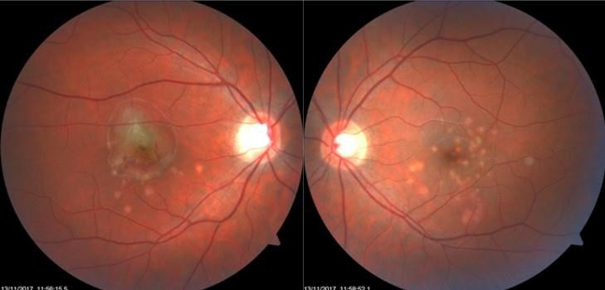

Figure.1. On fundus examination, a granular appearance of the macula was evident in the OU with some residual white spots in the posterior pole. In the right eye, the foveal reflex was deformed due to a classic subretinal neovascular membrane with subretinal hemorrhages.
Cross-sectional optical coherence tomography (OCT) visualized of the choroidal neovascularization (CNV) and window defects in the place of "white dots" [Figure.2].

O
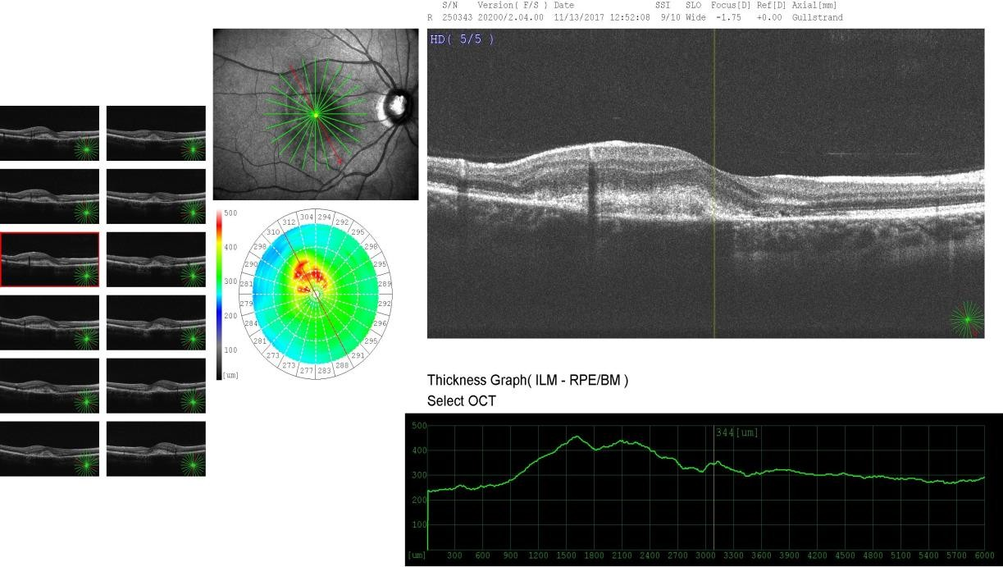
p h t h

a l
Figurem.2. Cross-sectional optical coherence tomography (OCT) images showinog of choroidal neovascularization (CNV) and window defects in
l
the place of "white dots".
o
g y

6

Fluorescent retinal angiography showed signs of an active subretinal neovascular membrane of the right eye, and marked defects in the places of "white dots" on both eyes (Figure. 3).
Autofluorescence OD showing inflammatory lesions (hypoautofluorescent spots) and an active inflammatory lesion (hyperautofluorescent spot) [Figure. 4].
The patient received 1 injection of aflibercept in the right eye. After that, there was an improvement in visual acuity of the right eye to 20/32. On the fundus, there was a resorption of the hemorrhages, a decrease in the subretinal neovascular membrane, and a decrease in the deformation and thickness of the retina. Subsequently, visual acuity increased to 20/25, but there was a detachment of the pigment epithelium and an increase in the thickness of the retina. The patient refused the proposed repeat injection since there was a high visual acuity.After 3 months, the patient returned to the clinic with a deterioration of vision in the right eye. The BCVA of the right eye dropped to 6/19.A repeated intravitreal injection of aflibercept into the right eye was performed. Visual acuity increased to 20/25. OCT showed a decrease in the length and compaction of the subretinal membrane of the right eye. This visual acuity remained during one year of observation.

Discussion

This case report illustrates the benefits of aflibercept in the resolution of CNV associated with PIC in a 30-year-old woman. Moreover, benefits were apparent after 2 doses and lasted during the 1 year of follow-up. The observation of typical signs of choroiditis on fundoscopy made us suspect the presence of PIC, especially given the bilateralism and the fact that the patient was a young myopic woman. Hence, some studies report using an initial loading dose (1 injection every 4 weeks for 3 months) of bevacizumab.₆ Other studies report the effectiveness of a single injection of ranibizumab.7In our case, the treatment effect was achieved by two injections of Aflibercept. The most important thing, apparently, there is a connection between inflammatory diseases of the urogenital tract in women and the occurrence of inflammatory diseases of the retina.

Conflict of interests
The authors declare that there is no conflict of interests.

Data availability statement
The data that support the findings of this study are available from the corresponding author upon reasonable request.

Funding
None.

Study association
This study is not associated with any thesis or dissertation work

Figure.3. OD Fluorescent retinal angiography showed signs of an active subretinal neovascular membrane of the right eye, and marked defects in the places of "white dots" on both eyes.

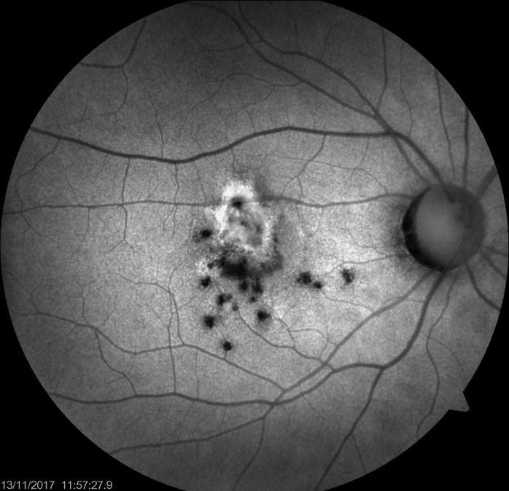

Figure. 4. Autofluorescence OD showing inflammatory lesions (hypoautofluorescent spots) and an active inflammatory lesion (hyperautofluorescent spot)
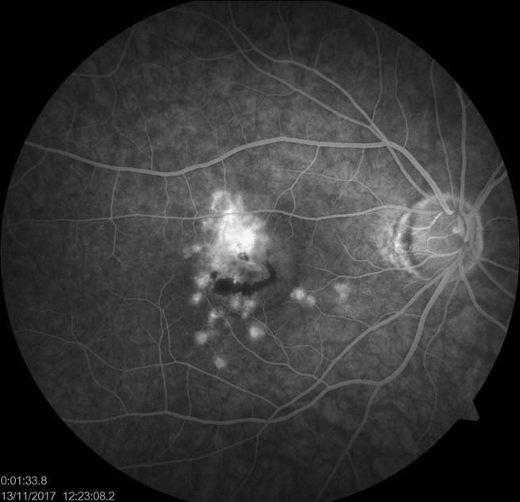

References

- Amer R, Lois N. Punctate inner choroidopathy. Surv Ophthalmol 2011; 56(1):36–53. doi:10.1016/j.survophthal.2010.03.009. DOI: 10.1016/j.survophthal.2010.03.009
- Campos J, Campos A, Mendes S, Neves A, Beselga D, Sousa JC. Punctate inner choroidopathy: a systematic review. Med Hypothesis Discov Innov Ophthalmol 2014;3(3):76–82.https://www.ncbi.nlm.nih. gov/pmc/articles/PMC4348489/
- Brouzas D, Charakidas A, Rotsos T, Moschos MM, Loukianou H, Koutsandrea C, et al. Choroidal neovascularization due to punctate inner choroidopathy: long-term follow-up and review of literature. Clin Ophthalmol 2010; Aug;4:871–876. DOI: 10.2147/opth.s10394
- Roca M, Menezo M, Ronchera JM, Esteban JM, Roca B. Punctate inner choroidopathy complicated with exudative neurosensory detachment: A favourable response to treatment with systemic corticosteroids and intravitreal ranibizumab. Arch Soc Esp Oftalmol 2017; 92(7):343–346. DOI: 10.1016/j.oftal.2016.07.010
- Ahnood D., Madhusudhan S, Tsaloumas M. Punctate inner choroidopathy: A review Survey of Ophthalmology 2017; 62(2): 113-126.
DOI:10.1016/j.survophthal.2016.10.003
- Chan WM, Lai TY, Liu DT, Lam DS. Intravitreal bevacizumab (avastin) for choroidal neovascularization secondary to central serous chorioretinopathy, secondary to punctate inner choroidopathy, or of idiopathic origin. Am J Ophthalmol 2007;143(6):977–83. DOI: 10.1016/j.ajo.2007.02.039
- Leung AK, Weisbrod DJ, Schwartz C. Intravitreal ranibizumab in the treatment of choroidal neovascular membrane secondary to punctate inner choroidopathy. Can J Ophthalmol 2010;45(3):300–1. DOI: 10.3129/i09-253

How to cite this article: Shchadnykh M., Punctate inner Choroidopathyand spontaneous abortion of the pregnancy . Ophthalmology Cases & Hypotheses. 2020;01(01):5-8.

Copyright © 2020. All rights reserved.

