Submission: 02-07-2021
Accepted: 11-10-2021
Published: 15-11-2021
Journal of Ophthalmology Cases & Hypotheses

ACUTE POSTERIOR MULTIFOCAL PLACOID PIGMENT EPITHELIOPATHY (APMPPE), ITS POSSIBLE RELATIONSHIP WITH UROGENITAL TRACT DISORDER AND TREATMENT.

Ayan Mammadkhanova, MD

HAT Medicine Clinic, Baku, Azerbaijan

Abstract

Purpose: To report a case of acute posterior multifocal placoid pigment epitheliopathy (APMPPE). The patient was a man who was being treated for back pain and then developed APMPPE. He was treated with systemic antibiotics and corticosteroids.
Methods: This study included a case report with ophthalmologic examination, optical coherence tomography, fluorescein angiography investigations, treatment options and review of the relevant literature.
Results: A 28-year-old man noted decreased vision in the right eye for 1 week, associated with a central scotoma with shimmering, cloudy effect of the vision. He had good vision with normal ophthalmic examinations in the past. He had back pain previously and was treated with antibiotics for prostatitis. An ophthalmic examination revealed an acuity of 20/400 with a central scotoma and normal anterior segment. Fundus examination, spectral domain optic coherence tomography (SD-OCT), fluorescein angiography (FA), and the course of the disease were typical of acute posterior multifocal placoid pigment epitheliopathy. The patient received systemic antibiotic treatment (3 days) and simultaneous intravenous corticosteroids (7 days). His vision was fully restored to 20/20. Then, a similar visual problem arose in the left eye. The treatment was repeated, and the eyesight was restored.
Conclusion: The symptoms of multifocal white dot syndrome occur suddenly. Often, this is preceded by the pathology of the genitourinary tract. In the case presented by us, it was preceded by back pain (prostatitis).Systemic treatment with antibiotics and corticosteroids led to stable remission of the disease. An important point is the brief systemic use of antibiotics with the continuation of the administration of dexamethasone.The positive effect of the systemic use of antibiotics with corticosteroids is possibly associated with the continuing latent disturbances of the genitourinary microbiota.

Keywords: APMPPE, white dot syndrome.

9

Access this article online
Quick Response Code: | Website:  https://ophthalmolcases.com/index.php/ hat
DOI:
10.30546/2788-516X.2021.2.2.16

Introduction
Acute posterior multifocal placoid pigment epitheliopathy (APMPPE) was first described by Gass, who observed these symptoms in 3 young women¹. At the same time, multiple white–yellow foci were observed in the fundus, accompanied by a sudden deterioration in central vision and spontaneous recovery within 3 weeks². Both eyes are usually involved.

The long-term follow-up of 15 patients (28 eyes) with this disease showed that the long-term visual effect after an acute episode of the onset of the disease may not be as favourable as originally portrayed by Gass and leads to a poor visual outcome³.

A similar case is described in the example of a young man. The disease has been observed for 22 years. After the first attack, his vision was restored to normal. However, periodically occurring exacerbations lead to atrophy of the choroid and a gradual loss of vision occurred⁴.

Subsequent studies by Deutman et al.⁵ showed that the inflammatory process is at the level of the choriocapillaris and that changes in the pigment epithelium are secondary. This is also confirmed by the data of other authors⁶. However, it is difficult to assume that the damage to the choriocapillaris and pigment epithelium will not lead to damage to the photoreceptors. Cause that is, the same complex (a complex of pigment epithelium and photoreceptors). The loss of one complex should lead to the defeat of others. Therefore, it was hypothesized that inflammation of the pigment epithelium leads to the dystrophy of photoreceptors⁷.

Journal of Ophthalmology Cases & Hypotheses
Volume 2, Number 2, 2021. 9-13

Why does this disease occur? Some authors have associated the occurrence of this disease with cerebral vasculitis⁸. Two patients developed visual loss 3 days to 2 weeks after the booster administration of 20 micrograms of recombinant hepatitis B virus surface antigen (Engerix-B)⁹. An 18-year-old female patient developed a painless significant bilateral decrease in vision, moderate photophobia, metamorphopsia and intermittent headaches two weeks after receiving a seasonal anti-flu immunization¹⁰.
This is associated with the activation of T lymphocytes and the appearance of type IV hypersensitivity. Vaccination appears to be a load on the immune system. Therefore, under certain conditions, vaccination can serve as a trigger mechanism for triggering an alternative inflammatory process: "The worst spoke in a cart breaks first."
Approximately one-third of patients have mild to moderate flu symptoms that precede visual impairment after a few days^{11,12}. A case of APMPPE associated with a tuberculous process has been previously described¹³.
A case of APMPPE in a patient with interstitial nephritis has also been described in the literature¹⁴. We were interested in this, since there were similar cases in our practice that were also associated with the pathology of the genitourinary tract.

Case report

A 28-year-old man presented with complaints of sudden dimness of vision of the right eye and headache. Prior to that, he was treated with antibiotics for chronic prostatitis. Then, the pain in the back area that was associated with prostatitis disappeared, the vision of the right eye deteriorated sharply, and there was pain behind the eye.Best corrected visual acuity was 20/100 in the right eye and 20/20 in the left eye.

Slit lamp examination revealed normal cornea, anterior segment and lens. Intraocular pressure was 13 mmHg in the right eye and 19 mmHg in the left eye.The fundus of the right eye was as follows: Multiple yellow–white placoid lesions were found both in the centre and in the middle periphery, not penetrating into the vitreous body (Figure 1). There were also isolated pigmented foci. The fundus of the left eye was within normal limits.

Figure 1. Fundus of the right eye.

An SD-OCT examination of the right eye at the onset of the disease showed numerous local defects ("detachments") of the pigment epithelium, a small cyst in the subfoveolar region, and serous detachment of the neuroepithelium. The outer boundary membrane was preserved (Figure 2). The ellipsoid zone and outer limiting membrane (OLM) were unchanged.

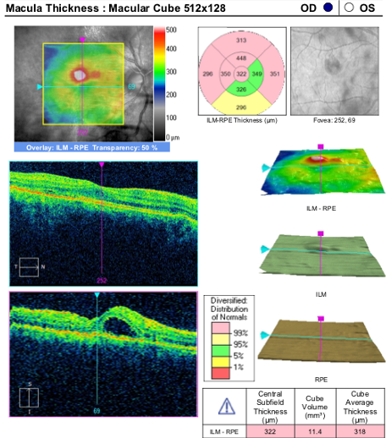
Figure 2. OCT of the right eye before treatment.

No changes were found in the left eye. On the basis of the clinical presentation, the diagnosis of acute posterior multifocal placoid pigment epitheliopathy was made.

Since the disease occurred suddenly and an inflammatory aetiology was suspected, it was decided to carry out anti-inflammatory treatment. The patient was prescribed 1.0 g of intramuscular ceftriaxone daily for 4 days. At the same time, the administration of dexamethasone was prescribed at a dose of 1.0 mg intravenously for 7 days. That is, dexamethasone took longer to take effect than the antibiotic.

On the second day of treatment, the patient felt an improvement in the visual acuity of the right eye. A week later, the vision in the right eye was 20/20. On OCT, the disappearance of the serous detachment of the neuroepithelium was noted (Figure 3).
10

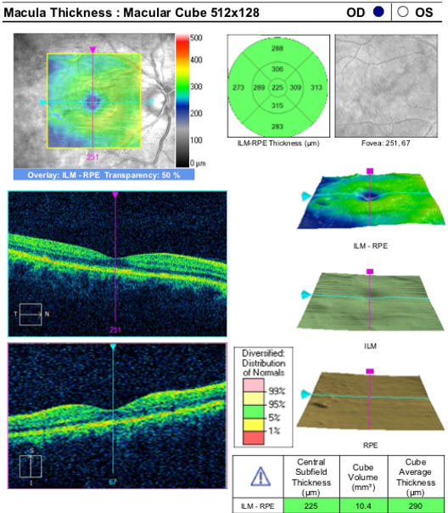
Figure 3. OCT of the left eye after treatment with systemic antibiotics and corticosteroids.

The patient was satisfied with the treatment, but after 3 weeks, he returned with complaints of decreased vision in the left eye. The BCVA of the left eye was 20/25. Imagine our surprise when we observed a similar picture of the disease in the left eye. The fundus picture of the left eye was identical to that of the right eye when the patient first visited our clinic (Figure 4).

Figure 4. The fundus of the left eye 3 weeks after the end of the treatment for the right eye.

The vision was relatively high, since the serous detachment of the neuroepithelium revealed on the OCT was not quite in the centre of the fovea but located rather eccentrically (Figure 5). At this time, retinal angiography was performed (Figure 6).
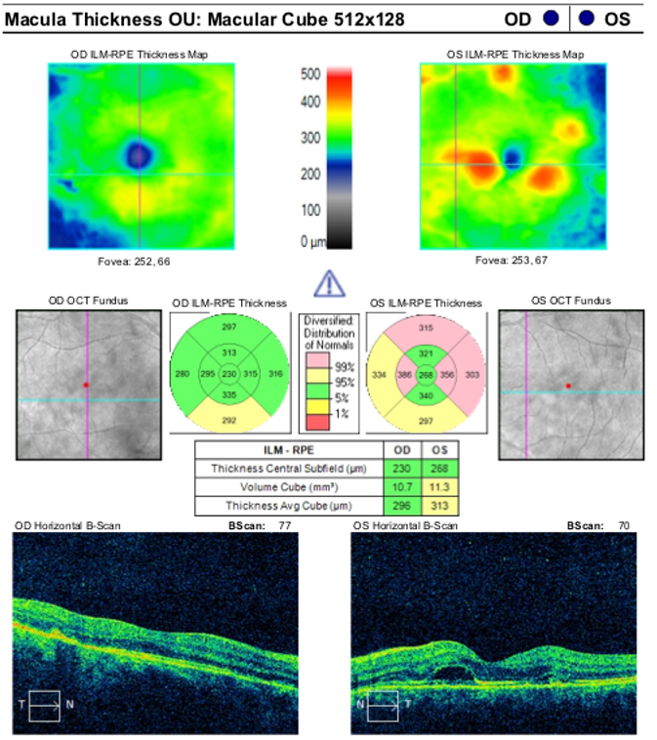
Figure 5. OCT of both eyes after visual impairment in the left eye.

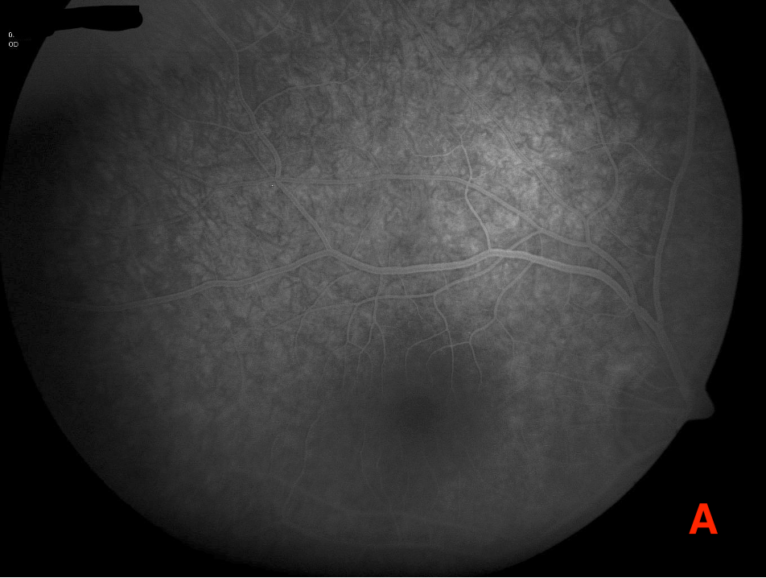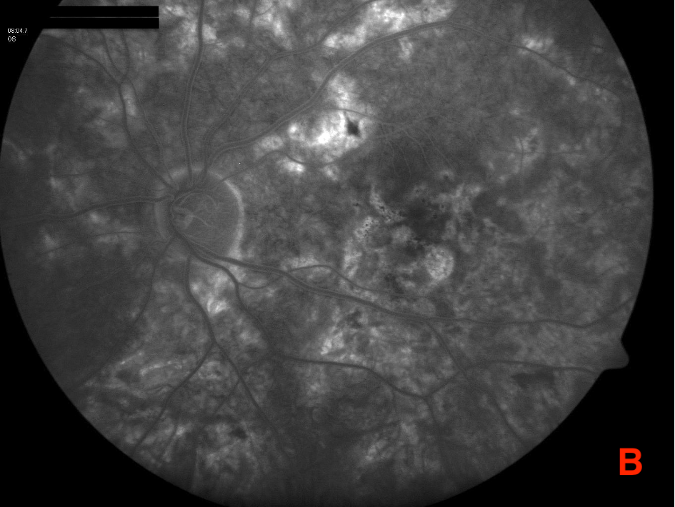
Fugure 6. Fluorescein angiography after visual impairment in the left eye (3 weeks after the completion of the treatment for right eye). A. Right eye B. Left eye.

11
We repeated the treatment but it was carried out in a slightly different scheme. This time, for 5 days, daily injections of 1 g of intramuscular ceftriaxone and 1 mg of intravenous dexamethasone were given; for the next 3 days, only 1.0 ml of dexamethasone was given; and then for 2 days, 0.5 ml of intravenous dexamethasone was given.
The patient's vision was fully restored to 20/20. The examination also revealed an improvement in the fundus (Figure 7, 8, 9).

Figure 7. The fundus of the left eye on the third day of the treatment.

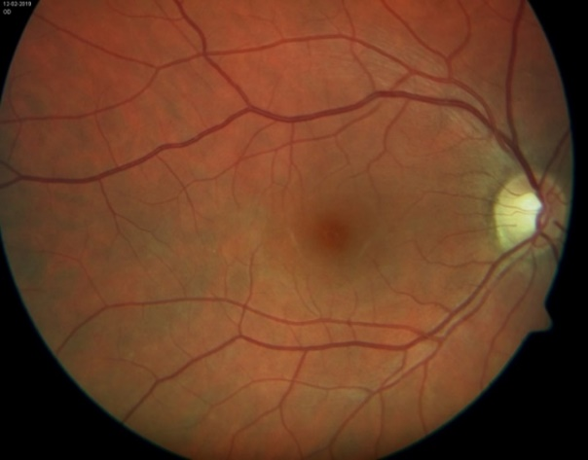
Figure 8. The fundus of the right eye one month later the start of the first systemic treatment with antibiotics and corticosteroids.

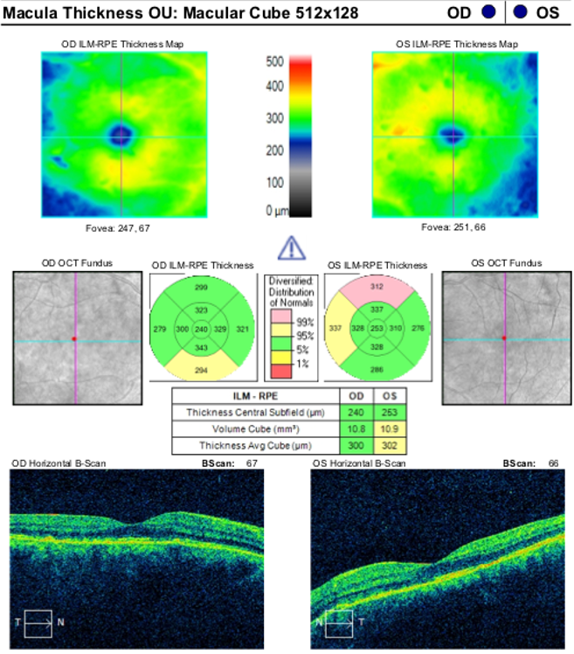
Figure 9. OCT of the both eyes after the second systemic treatment with antibiotics and corticosteroid.

Follow-up for 3 years did not reveal relapses of the disease.
It is interesting to note that his father had ankylosing spondylitis and posterior uveitis. His cousin came to us with anterior uveitis, which quickly disappeared after treatment.

Discussion

Acute posterior multifocal placoid pigment epitheliopathy is a rare bilateral ocular disorder. It most often develops in young people in the third decade of life and very rarely occurs in children. This is probably an independent inflammatory disease of the retina that occurs in the area of the pigment epithelium. Attempts to link this disease in our patients with sarcoidosis, tuberculosis, and adenovirus infections have failed. Additionally, none of our patients received vaccinations against hepatitis B.
Since the first patient experienced a sharp decrease in vision, which confirmed the inflammatory nature of the disease, it was decided to use systemic corticosteroids¹⁵. For the first four days, antibiotics were prescribed along with corticosteroids. The complete restoration of visual acuity was observed. In our case, the onset of the disease was noted first in the right eye and then in the left eye. Thus, damage to both eyes in the inflammatory process was determined.

In the present clinical case, recovery led to rapid fluid and inflammation resorption.

However, SD-OCT showed minor irreversible changes in the ellipsoid layer of the photoreceptors and pigment epithelium. It should be noted that the outer limiting membrane of the retina remained intact. Preservation of this layer during inflammation is decisive for the prognosis of high visual acuity after anti-inflammatory treatment.

Interestingly, these are not isolated cases of ocular disease, which was preceded by diseases of the genitourinary tract. A similar case was described in the literature of a patient with interstitial nephritis¹⁴. A case of APMPPE was described in an 18-year-old woman who was being treated for urinary tract infection¹⁶. A 41-year-old pregnant woman with HELLP (haemolysis, elevated liver enzymes and low platelets) syndrome developed decreased vision and extensive serous retinal detachment¹⁷.

Cases of APMPPE are described quite often, but the authors simply do not trace its connection with common diseases¹⁸. Thus, literature data and two of our cases have indicated the connection between APMPPE and diseases of the genitourinary tract. In some cases, it is a genitourinary infection; in others, pregnancy and abortion.

What is the traced connection between these different diseases?
The treatment of the first patient with systemic antibiotics and corticosteroids resulted in a dramatic improvement in both functional and anatomical parameters. At the same time, the topical application of corticosteroids initially caused visual impairment in the second patient. Only the intravitreal administration of aflibercept improved the prognosis.

12
Apparently, the "infection" was not on the mucous membrane of the conjunctiva but, possibly, on the mucous membranes of the urinary tract. This is confirmed by the fact that there was no effect of the topical application of corticosteroids. Only the systemic treatment with antibiotics and corticosteroids and the intravitreal use of aflibercept helped.

Conclusion

The symptoms of multifocal white dot syndrome occur suddenly. Often, this is preceded by the pathology of the genitourinary tract. After the onset of the disease, the pathology of the genitourinary tract decreases or disappears.

Systemic treatment with antibiotics and corticosteroids led to stable remission of the disease. An important point is the brief systemic use of antibiotics with the continuation of the administration of dexamethasone.

The positive effect of the systemic use of antibiotics with corticosteroids is possibly associated with the continuing latent disturbances of the genitourinary microbiota.

Conflict of interests
The author declares that there is no conflict of interests.

Data availability statement
The data that support the findings of this study are available from the corresponding author upon reasonable request.

Funding
None.

Study association
This study is not associated with any thesis or dissertation work.

References and notes:
1. Gass J.M. Acute posterior multifocal pigment epitheliopathy. Arch Ophthalmol 1968;80(2):177-185.
2. Stephen J. Ryan, M.D., A. Edward Maumenee, M.D. Acute Posterior Multifocal Placoid Pigment Epitheliopathy American journal of ophthalmology 1972;74(6):1066–1074.
3. Roberts TV1, Mitchell P. Acute posterior multifocal placoid pigment epitheliopathy: a long-term study. Aust N Z J Ophthalmol 1997;25(4):277-81. doi: 10.1111/j.1442-9071.1997.tb01515.x.
4. Daniele S. · Daniele C. · Orcidi F. · Tavano A. Progression of Choroidal Atrophy in Acute Posterior Multifocal Placoid Pigment Epitheliopathy Ophthalmologica 1998;212:66–72 https://doi.org/10.1159/000027264
5. Deutman AF, Oosterhuis JA, Boen-Tan TN, Aan de Kerk AL. Acute posterior multifocal placoid pigment epitheliopathy. Pigment epitheliopathy or choriocapillaritis? Br J Ophthalmol 1972;56(12): 863–874. doi: 10.1136/bjo.56.12.863.
6. Dhaliwal RS, Maguire AM, Flower RW, Arribas NP. Acute posterior multifocal placoid pigment epitheliopathy. An indocyanine green angiographic study. Retina 1993;13(4): 317–325.
7. Cheung CM, Yeo IY, Koh A. Photoreceptor changes in acute and resolved acute posterior multifocal placoid pigment epitheliopathy documented by spectral-domain optical coherence tomography. Arch Ophthalmol 2010;128(5):644–646. doi:10.1001/archophthalmol.2010.48
8. Weinstein JM1, Bresnick GH, Bell CL, Roschmann RA, Brooks BR, Strother CM. Acute posterior multifocal placoid pigment epitheliopathy associated with cerebral vasculitis. J Clin Neuroophthalmol 1988;8(3):195-201. PMID: 2971684
9. Brézin AP1, Massin-Korobelnik P, Boudin M, Gaudric A, LeHoang P.Acute posterior multifocal placoid pigment epitheliopathy after hepatitis B vaccine. Arch Ophthalmol 1995;113(3):297-300. doi: 10.1001/archopht.1995.01100030051021.
10. Branisteanu D, Bilha A. Acute posterior multifocal placoid pigment epitheliopathy following influenza vaccination Rom J Ophthalmol 2015; 59(1):52–58. PMID: 27373117
11. Crawford CM, Igboeli O. A Review of the Inflammatory Chorioretinopathies: The White Dot Syndromes. ISRN Inflammation 2013;783190. doi: 10.1155/2013/783190.
12. Senanayake S, Selvadurai S, Hawkins C, Tridgell D. Acute multifocal placoid pigment epitheliopathy associated with erythema nodosum and a flu-like illness. Singapore Medical Journal 2008;49(11):E333–E335.
13. Anderson K, Patel KR, Webb L, Dutton GN. Acute posterior multifocal placoid pigment epitheliopathy associated with pulmonary tuberculosis. Br J Ophthalmol 1996;80(2):186. doi: 10.1136/bjo.80.2.186
14. Andrew lR., Sumit S., Tamer M.H. Tubuloınterstıtıal nephrıtıs and uveıtıs syndrome wıth a prımary presentatıon of acute posterıor multıfocal placoıd pıgment epıthelıopathy Retinal Cases & Brief Reports 2017; 11(2): 100–103. doi.org/10.1097/ICB.0000000000000299
15. Fiore T., Iaccheri B., Androudi S., et al. Acute posterior multifocal placoid pigment epitheliopathy: outcome and visual prognosis. Retina 2009;29(7):994‐1001. doi: 10.1097/IAE.0b013e3181a0bd15.
16. Chan A., Blumenkranz MS, Sanislo SR. An extensive case of acute posterior multifocal placoid pigment epitheliopathy Retinal cases&Brief reports 2010;4(4):336–338. doi: 10.1097/ICB.0b013e3181aff47e.
17. Ayaka K. et al. Choroidal morphology in a patient with HELLP syndrome Retinal Cases and Brief Reports 2016;10(3):273–277. doi: 10.1097/ICB.0000000000000249.
18. Alain G., Sarah M. Why the dots are black only in the late phase of the indocyanine green angiography in multiple evanescent white dot syndrome Retinal Cases and Brief Reports 2017;11(Suppl.1):S81–S85. doi: 10.1097/ICB.0000000000000422.

How to cite this article: Mammadkhanova A.MD Acute posterior multifocal placoid pigment epitheliopathy (APMPPE), its possible relationship with urogenital tract disorder and treatment. Ophthalmology Cases & Hypotheses. 2021;02(02):9-13.

Copyright ©2021. All rights reserved.

13

