Submission: 09-12-2020
Accepted: 18-03-2022

Published: 22-07-2022
Journal of Ophthalmology Cases & Hypotheses

IpMODIFICATION OF POSTERIOR VITRECTOMY IN THE TREATMENT OF OPTIC DISC MACULOPATHY
Shutko E.Y. MD, PhD.
ICDC of PAO “Gazprom” Eye Microsurgery Clinic, Moscow, Russian Federation ORCID: 0000-0003-1377-8930
Antonyuk V.D. MD, PhD.
ICDC of PAO “Gazprom” Eye Microsurgery Clinic, Moscow, Russian Federation ORCID: 0000-0002-0766-6353
Grishina E.E.
Moscow Regional Research and Clinical Institute (“MONIKI”), Moscow, Russian Federation ORCID: 0000-0003-2668-9136 ORCID: 0000-0003-2668-9136
Abstract
Purpose: Optic disc pit is rare congenital anomalies of the optic nerve. The optic disc pit is asymptomatic lesion. With the development of maculopathy associated with optic disc pit, visual acuity decreases dramatically. We present our result of the treatment for an optic disc pit maculopathy.
Methods: Case report
Results: A 39-year-old woman complained of a progressive decrease in visual acuity of the left eye to 20/200. Fundus image illustrated an optic disc pit. In the macular region, detachment of the neuroepithelium, reaching the optic disc, was revealed. The diagnosis of maculopathy associated with the optic disc pit was established. The diagnosis was confirmed by OCT data. Posterior vitrectomy was performed with the application of platelets-rich plasma into the pit of the optic disc. In 12 months the vision of the affected eye improved from 20/200 to 20/32. Fluid in the layers of the retina and subretinal fluid in the macular area disappeared.
Conclusion:
There is no preventive treatment for maculopathy associated with optic disc pit.
Posterior vitrectomy in various modifications is the main method of treatment for maculopathy associated with optic disc pit. When performing a posterior vitrectomy, it is necessary to completely remove the posterior hyaloid membrane in order to avoid traction effects on the optic nerve pit. Restoration of vision after surgical treatment for a maculopathy associated with optic disc pit is a long process. The patient should be informed about this.

Keywords: Optic disc pit, maculopathy associated with optic disc pit, posterior vitrectomy, platelets-rich plasma
Accessthis article online
Quick Response Code: | Website:  https://ophthalmolcases.com/index. php/hat
DOI:
10.30546/2788-516X.2022/3.1.10

Introduction

Optic disc pit (ODP) is rare congenital anomalies of the optic nerve. It is an invagination of the rudimentary retina into the subarachnoid space through a defect in the lamina cribrosa. The optic disc pit is asymptomatic lesion. With the development of maculopathy associated with ODP, visual acuity decreases sharply. The development of ODP maculopathy is unpredictable, no triggers have been identified, and there are no preventive treatments. We present our result of the treatment for ODP maculopathy.

Case Reports

A 39-year-old woman complained of a progressive decrease in visual acuity of the left eye. Visual acuity of the right eye was 20/20. Visual acuity of the left eye was 20/200. Intraocular pressure OU was normal. There was a central scotoma in the visual field of the left eye. A slit lamp examination of the both eyes revealed normal anterior eye segment. Lens and vitreous body were transparent. The fundus of the right eye was without pathological sings.
There was ODP of the left eye (Fig.1).

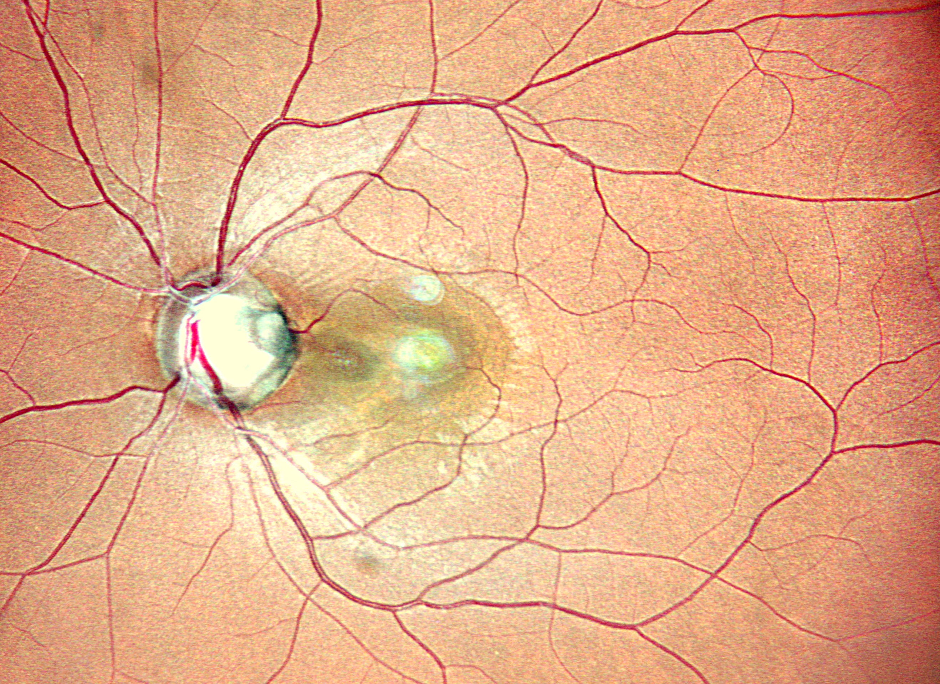

Figure 1. Fundus photo of the left eye. There is an optic pit in the temporal sector.

Journal of Ophthalmology Cases & Hypotheses Volume 3, Number 1, 2022.9-11.
Retinal neuroepithelial detachment reached the optic nerve disc. Optical coherence tomography (OCT) of the left eye fundus detected a high detachment of the neuroepithelium, extending over the entire area of the macular zone to the temporal edge of the optic nerve disc (Fig.2A). The retina is sharply thinned in the fovea.

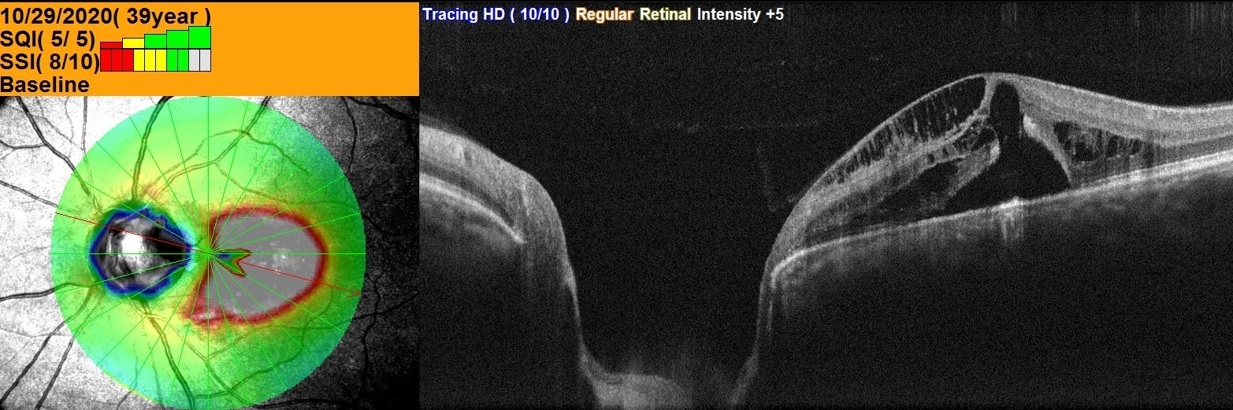

Figure 2A. OCT of the left eye. A- a high detachment of the neuroepithelium, extending over the entire area of the macular zone to the temporal edge of the optic nerve disc.

The diagnosis of maculopathy associated with optic nerve pit was established. A decision to perform a posterior vitrectomy was made. Three 25G ports were installed 3.5 mm from the limb. Central vitrectomy was performed.
Kenalog's solution was introduced into the vitreal cavity to stain the vitreous body fibers and better visualize the posterior hyaloid membrane. The posterior hyaloid membrane was captured and separated from the retina using a vitreotome in the mode of active aspiration.
An attention was drawn to the tight fixation of the posterior hyaloid membrane to the retina. The posterior hyaloid membrane has been completely removed.
The retina near the ora serrata was examined to exclude “silent” retinal tears. Replacement of liquid in the vitreal cavity with air was performed. Platelets- rich plasma was applied to the optic nerve pit. C3F8-12% gas was injected into the vitreal cavity.
Visual acuity and the condition of the macular area of the left eye gradually improved. In 12 months, the visual acuity of the left eye increased to 20/32.
OCT did not reveal fluid in the retinal layers and subretinal fluid in the macular region. The retinal layers were differentiated (Fig.2B). A foveolar contour has formed.

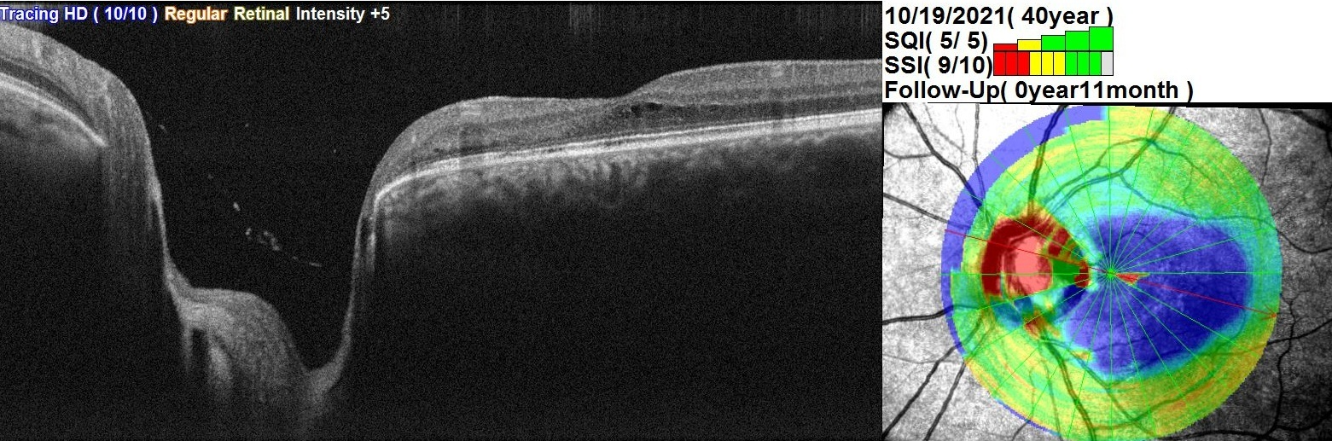

Figure 2B. There is not reveal fluid in the retinal layers and subretinal fluid in the macular region.

Conclusion

There is no preventive treatment for maculopathy associated with optic disc pit.

Posterior vitrectomy in various modifications is the main method of treatment for maculopathy associated with optic disc pit.

When performing a posterior vitrectomy, it is necessary to completely remove the posterior hyaloid membrane in order to avoid traction effects on the optic nerve pit.

Restoration of vision after surgical treatment for a maculopathy associated with optic disc pit is a long process. The patient should be informed about this.

Conflict of interests
The author declares that there is no conflict of interests.

Data availability statement
The data that support the findings of this study are available from the corresponding author upon reasonable request.

Funding
None.

Study association
This study is not associated with any thesis or dissertation work.

References

1. Georgalas I, Ladas I, Georgopoulos G, Petrou P Optic disc pit: areview. Graefes Arch Clin Exp Ophthalmol. 2011; 249:1113–1122 doi: 10.1007/s00417-011-1698-5.
2. Shah SD, Yee KK, Fortun JA, Albini T. Optic disc pit maculopathy: a review and update on imaging and treatment. Int Ophthalmol Clin. 2014;54(2):61–78. doi: 10.1097/IIO.0000000000000025.
3. Shafi A, Twaij S,Ibraheim A. Bilateral peripapillary serous retinal detachment in association with congenital optic disc pits BMJ Case report. 2013. doi:10.1136/bcr-2012-007971
4. Mekonnena B., Richardsona Q., Bhisitkula J.M., Diabb M., Rasoola N. Bilateral optic disc pits in a pediatric patient with Cobb syndrome. American Journal of Ophthalmology Case Reports.2020; 19: 100749 https://doi.org/10.1016/j.ajoc.2020.100749
5. Horton J.C. and Barkovich A.J. Bilateral Optic Disc Pits With Posterior Pituitary Ectopia. J Neuroophthalmol. 2017; 37(4): 401–402. doi:10.1097/WNO.0000000000000528.
6. Ceylan OM, Yılmaz AC, Durukan AH, Köylü MT, Mutlu FM. A Case of Multiple Optic Disc Pits: 21-Year Follow-up. Turk J Ophthalmol 2021;51:123-126 doi: 10.4274/tjo.galenos.2020.66909.
7. Brown GC, Shields JA, Goldberg RE Congenital pits of the optic nerve head. II. Clinical studies in humans. Ophthalmology.1980; 87:51–65 doi: 10.1016/s0161-6420(80)35278-0.
8. Bonnet M Serous macular detachment associated with optic nerve pits. Graefes Arch Clin Exp Ophthalmol. 1991; 229:526–532 doi: 10.1007/BF00203315.
9. Brodsky MC Congenital optic disk anomalies. Surv Ophthalmol. 1994 39:89–112 doi: 10.1016/0039-6257(94)90155-4.
10. Georgalas I, Ladas I, Georgopoulos G, Petrou P (2011) Optic disc pit: areview. Graefes Arch Clin Exp Ophthalmol 249:1113–1122 doi: 10.1007/s00417-011-1698-5.
11. Sadun AA, Khaderi KH Optic disc anomalies, pits, and associated serous macular detachment. In: Ryan SJ, Schachat AP, Wilkinson CP, Hinton DR, Sadda SR, Wiedemann P (eds) Retina, 5th edn. Elsevier Health Sciences, UK, 2013: 1583–1588 DOI: 10.1016/B978-1-4557-0737-9.00093-Х
12. Ohno-Matsui K, Hirakata A, Inoue M, Akiba M, Ishibashi T (Evaluation of congenital optic disc pits and optic disc colobomas by swept-source optical coherence tomography. Invest Ophthalmol Vis Sci. 2013; 54:7769–7778 doi: 10.1167/iovs.13-12901.
13. Bayborodov Y.V., Izmailov A.S. THE DETACHMENT OF THE RETINA CAUSED BY THE PIT OF THE OPTIC NERVE DISK AND ITS SURGICAL TREATMENT. Fyodorov Journal of Ophthalmic Surgery. 2017;(4):20-25. (In Russ.) https://doi.org/10.25276/0235-4160-2017-4-20-25
14. Theodossiadis GP, Ladas ID, Panagiotidis DN, Kollia AC, Voudouri AN, Theodossiadis PG Fluorescein and indocyanine green angiographic findings in congenital optic disk pit associated with macular detachment. Retina 1999; 19:6–11 doi: 10.1097/00006982-199901000-00002.

How to cite this article: Shutko E.Y., Grishina E.E. IpModification of posterior vitrectomy in the treatment of optic disc maculopathy. Opthalmology Cases & Hypotheses 2022;03(01):9-11.

Copyright ©2021. All rights reserved

