Submission: 23-04-2022
Accepted: 21-08-2022
Published: 15-11-2022
Journal of Ophthalmology Cases & Hypotheses

EPLERENONE TREATMENT FOR SYMPTOMATIC SUBFOVEAL SEROUS PIGMENT EPITHELIAL DETACHMENT

Vignesh T.P.

(Corresponding Author)

Medical Consultant, Department of Retina, Aravind Eye Hospital and Post Graduate Institute of Ophthalmology, Madurai, Tamil Nadu, India

Jayant Kumar M.S

Department of Retina, Aravind Eye Hospital and Post Graduate Institute of Ophthalmology, Madurai, Tamil Nadu, India

Abstract

A 47-year-old male presented with a complaint of metamorphopsia in the left eye (OS). His best corrected visual acuity was 20/20 in both eyes (OU). Fundus examination revealed subfoveal serous pigment epithelial detachment (PED) in OU which was confirmed on optical coherence tomography (OCT).
Fundus fluorescein and indocyanine angiography ruled out neovascularization. After no regression for 6 months, he was started on tablet Eplerenone 25 mg once daily for 2 months which resulted in complete resolution of PED in OU. He later had a recurrence of PED in OU, which responded to oral Eplerenone once again, highlighting its potential role in such cases.

Keywords: Serous pigment epithelial detachment, Eplerenone, Complete resolution, Alternative, Novel

Access this article online

Quick Response Code: | Website:  https://ophthalmolcases.com/index.php/ hat
DOI:
10.30546/2788-516X.2022.3.2.4

Introduction

Retinal pigment epithelial detachments (PED) are commonly associated with central serous chorioretinopathy (CSCR), age related macular degeneration (ARMD) and polypoidal choroidal vasculopathy (PCV) 1-4. Isolated large sub-foveal PED can often result in severe metamorphopsia and asthenopia and treating them can be a real therapeutic challenge4. Although PEDs are not commonly treated and many of them resolve over a period of 6 months, persistent PEDs after 6 months do not usually resolve without intervention⁴. Photodynamic therapy (PDT) has shown some efficacy in causing their resolution while surgical drainage of PED associated with ARMD has been reported in a few cases 4.,5 Eplerenone is an anti-mineralocorticoid agent with a well- established role in treating chronic CSCR and we report its novel use for treating a long-standing symptomatic sub-foveal PED.6-9

Case report

A 47-year-old male presented with difficulty in reading due to metamorphopsia and asthenopia in the left eye (OS) of one-month duration. His best corrected visual acuity (BCVA) was 20/20 in both eyes (OU). Anterior segment examination of OU was normal.
Fundus examination revealed the presence of juxta-foveal serous pigment epithelial detachment (PED) in OD (Fig 1a) and sub-foveal serous PED in OS (Fig 1b), which was confirmed on spectral domain optical coherence tomography (SD-OCT) (Fig 2a, 3a). Fundus fluorescein angiography (FFA) and indocyanine angiography (ICG) were done which ruled out any underlying neovascularization (Fig 1c,d). The patient was given the option of PDT but he could not afford the same.
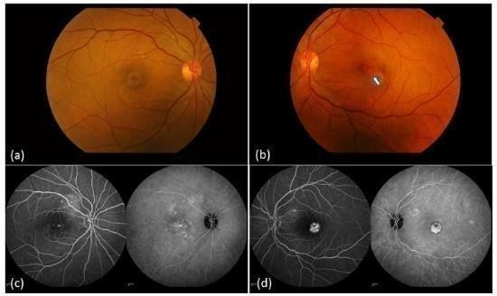

Figure 1: Colour fundus photographs of OD (a) showing clinically indistinct area of juxtafoveal PED and OS (b) showing distinct area of sub-foveal PED (arrow). Fundus fluorescein angiography and Indocyanine angiography of OD (c) showing stippled hyperfluorescence and hypercyanescencein the foveal Avascular zone (FAZ) and OS (d) showing well circumscribed area of heterogenous Hyperfluorescence and hypercyanescence located in the FAZ.

1 Journal of Ophthalmology Cases & Hypotheses Volume 3, Number 2, 2022. 1-4

After 6 months of observation, the patient continued to have no relief in his ocular symptoms and SD-OCT revealed persistence of PED in OU. His serum potassium was normal (4.2mmol/l) and evaluation by a physician ruled out any associated systemic abnormality, following which he was started on tablet Eplerenone 25 mg orally, once daily after explaining the possible side-effects, need for repeated monitoring of serum Potassium and obtaining an informed consent.

One month later, there was a significant reduction in the size of PED in OS and complete resolution in OD (Fig 2b, 3b). He was continued with Eplerenone 25 mg orally and at the end of
2 months, there was complete resolution of PED even in OS
with residual RPE irregularities in OU (Fig 2c, 3c). He also reported relief from his ocular symptoms of metamorphopsia and asthenopia. His BCVA continued to remain as 20/20 and Eplerenone was stopped.
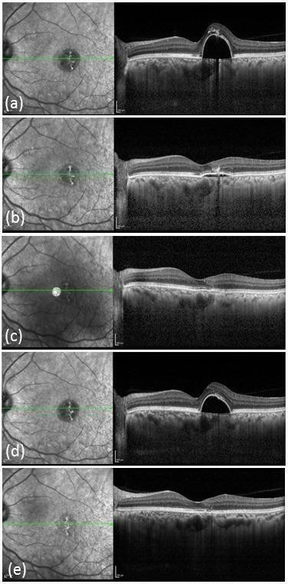

Figure 2: SD-OCT) images using high definition raster scan passing through the PED of OS at 6 months of presentation (a) showing the large sub-foveal PED, one month following oral eplerenone therapy (b) showing marked regression in the size of PED and two months following oral eplerenone therapy (c) showing complete resolution of the PED; one month
after stopping oral eplerenone therapy (d) showing recurrence of the PED and three months after re-starting oral eplerenone (e) showing complete resolution of the recurrent PED.
On follow-up, after a month of stopping Eplerenone, the patient had a recurrence of PED to the previous levels in OU (Fig 2d, 3d). He was started on Eplerenone 25 mg once daily again and was advised to continue it for 3 months. On follow-up after 3 months, PEDs had resolved with residual RPE abnormalities in OU (Fig 2e, 3e). He was asked to stop Eplerenone and is due for the next follow up.
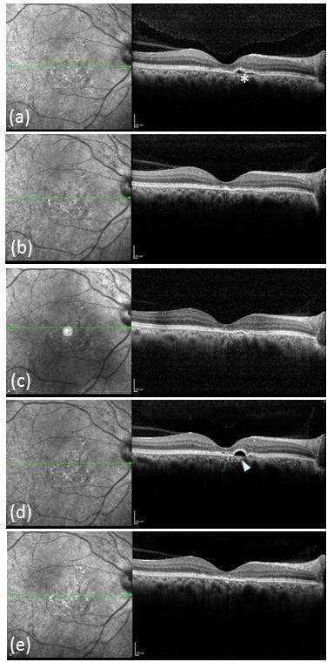

Figure 3: SD-OCT Images using high definition raster scan
passing through the PED of OD at 6 months of presentation (a) showing the juxtafoveal PED (asterix); one month (b) and two months © following
oral eplerenone therapy showing complete resolution of PED; one month after stopping oral eplerenone therapy (d) showing recurrence of the PED (arrowhead)
and three months after re-starting oral eplerenone (e) showing complete resolution of the recurrent PED with residual RPE irregularities.

Discussion

PED is classically defined as an anatomical separation between the retinal pigment epithelium (RPE) and the Bruch’s membrane and is commonly associated with CSCR and degenerative diseases like ARMD and PCV1-4. Isolated PEDs are often considered as a manifestation of CSCR, representing an intermediate stage between pachychoroid and classic CSCR⁴.

Although asymptomatic isolated PEDs are best observed, symptoms like metamorphopsia, asthenopia and binocular rivalry indicate the need for intervention4. An important concern with any persisting PED is its possible association with apical atrophy of RPE and the overlying photoreceptor layer, suggesting the need for treatment in long-standing and symptomatic cases10.

Arif et al, in their largest series on the role of PDT for treating isolated PEDs, reported complete resolution of PED in 7 out of
9 eyes (78%) that underwent PDT compared to spontaneous resolution of PED in only 5 out of 13 eyes (38%) which did not undergo PDT indicating a positive response of isolated PEDs to PDT4 and hence we offered the same to our patient as the first line of treatment which, unfortunately, as he could not afford.

Surgical drainage of large PED associated with ARMD has been reported by a few authors before⁵. The latest report by Sisk mentions about the risks associated with the procedure and preference of a surgical approach only in eyes with poor vision. Our patient had a BCVA of 20/20 and hence we did not consider the surgical option5.

Eplerenone is an anti-mineralocorticoid agent which has proven its efficacy in the resolution of chronic CSCR in various studies⁷⁻⁹. Zhao et al were the first to suggest the role of mineralocorticoid receptors in choroidal vascular bed relaxation by demonstrating choroidal enlargement in rat eyes following intravitreal injection of the glucocorticoid corticosterone7. Eplerenone has also been brought into novel use for the resolution of residual subretinal fluid (SRF) following retinal detachment with remarkable success9. A noteworthy point in the study by Arif et al was that in all 5 eyes of 4 patients who had spontaneous flattening of PED, the resolution happened within 6 months. The remaining 13 eyes with PED which did not undergo PDT either remained unchanged or showed progression⁴. This prompted us to try oral eplerenone in our patient when no signs of the spontaneous resolution were noted at the end of six months.

To the best of our knowledge, our case is the first reported case in literature where oral eplerenone has been brought into novel use for treating long-standing symptomatic PED, as an alternative to PDT. It also opens up a new option for isolated symptomatic PEDs that do not respond to PDT. Recurrence of the PED can however be an issue after stopping of eplerenone and further studies are needed to establish its role and efficacy in treating such cases.

Conflict of interests
The authors declare that there is no conflict of interests.

Data availability statement
The data that support the findings of this study are available from the corresponding author upon reasonable request.

Funding
None.

Study association
This study is not associated with any thesis or dissertation work.

References and notes:

- Tan ACS, Simhaee D, Balaratnasingam C, Dansingani KK, Yannuzzi LA. A Perspective on the Nature and Frequency of Pigment Epithelial Detachments. Am J Ophthalmol. 2016 Dec;172:13-27. doi: 10.1016/j.ajo.2016.09.004. Epub 2016 Sep 13.PubMed PMID: 27637783.
- Mrejen S, Sarraf D, Mukkamala SK, Freund KB. Multimodal imaging of pigment epithelial detachment: a guide to evaluation. Retina. 2013 Oct;33(9):1735-62. doi: 10.1097/IAE.0b013e3182993f66. Review. PubMed PMID:
23873168
- Cheung CMG, Lee WK, Koizumi H, Dansingani K, Lai TYY, Freund KB. Pachychoroid disease. Eye (Lond).2019
Jan;33(1):14-33. doi: 10.1038/s41433-018-0158-4.
Epub 2018 Jul 11. Review. PubMed PMID: 29995841; PubMed Central PMCID: PMC6328576.
- Arif F, Pryds A, Larsen M. Isolated pigment epithelium detachment: evidence for relation to central serous chorioretinopathy and effect of photodynamic therapy. Acta Ophthalmol. 2018 Dec;96(8):821-827. doi: 10.1111/aos.13838. Epub 2018 Sep 23. PubMed PMID: 30246489.
- Sisk RA. Intraoperative Drainage of a Bullous Serous Pigment Epithelial Detachment. Ophthalmic Surg Lasers Imaging Retina. 2019;50(8):510-513. doi:10.3928/23258160- 20190806-06
- Zhao M, Célérier I, Bousquet E, et al. Mineralocorticoid receptor is involved in rat and human ocular chorioretinopathy. J Clin Invest. 2012;122(7):2672-2679. doi:10.1172/JCI61427
- Wang SK, Sun P, Tandias RM, Seto BK, Arroyo JG. Mineralocorticoid Receptor Antagonists in Central Serous Chorioretinopathy: A Meta- Analysis ofRandomized Controlled Trials. Ophthalmol Retina.
2019;3(2):154-160. doi:10.1016/j.oret.2018.09.003
- Chatziralli I, Vlachodimitropoulou A, Daoula C, et al. Eplerenone in the treatment of central serous chorioretinopathy: a review of the literature. Int J Retina Vitreous. 2018;4:33. Published 2018 Sep 19. doi:10.1186/s40942-018-0137-8
- Haghighi A, Do J, Ameri H. Eplerenone as a novel treatment for persistent subretinal fluid following retinal detachment surgery. Am J Ophthalmol Case Rep. 2018;10:261- 263. Published 2018 Mar 9. doi:10.1016/j.ajoc.2018.03.012 10.Pryds A, Hamann S, Larsen M. Apical atrophy of retinal pigment epithelial detachments in central serous chorioretinopathy. Retin Cases Brief Rep. 2012;6(1):116-121. doi:10.1097/ICB.0b013e31821608c6

How to cite this article: Vignesh T.P., Jayant KumarS.
Eplerenone treatment for symptomatic subfoveal serous pigment epithelial detachment. Journal of Ophthalmology casses & Hypotheses. 2022;03(02);1-4.

Copyright ©2022.

