Volume 4, Number 1, 2023.1-8

Journal of Ophthalmology Cases & Hypotheses

PROMPT VITRECTOMY IN PATIENTS WITH TYPE 1 DIABETES AND DIABETIC RETINOPATHY
Introduction

Submission: 19-11-2022 Accepted: 21-02-2023 Published:10-04-2023

Suleyman KAYNAK, MD, PhD (Corresponding Author)
Retina Ophthalmic Research Center, Department of Ophthalmology, Izmir, Turkey

Oya DONMEZ, MD, PhD
Tınaztepe University, Department of Ophthalmology, İzmir, Turkey

Abstract

Objectives: To evaluate the long-term outcomes of patients with type 1 diabetes mellitus (DM) who underwent prompt vitrectomy and to discuss the optimal timing for surgery.
Methods: This retrospective study included diabetic retinopathy (DR) patients with type 1 DM who underwent prompt vitrectomy at Retina Ophthalmic Research Center between March 2015 and January 2020. Demographical and clinical features including duration of diabetes, visual loss and follow-up time between visual loss and vitrectomy, best corrected visual acuity (BCVA), reoperations, complications, were reviewed.
Results: There were 25 eyes of 18 patients (with a mean age of 33 years). Duration of diabetes was 14.2 years. Mean follow-up was 23.1 months. 19 eyes received intravitreal dexamethasone implant and 5 eyes received intravitreal triamcinolone injection in the first surgery. Mean preoperative BCVA was improved from 0.3 to 0.7 log-mar postoperatively (p=0.002). Anatomic success was achieved in 23 eyes. Visual acuity was improved in vision safely and efficiently.19 eyes, stabilized in 4 eyes and deteriorated in 2 eyes. Cataract removal was needed in 6 eyes and retinal detachment occurred in 1 eye.
Conclusions: Prompt vitrectomy in type 1 DM patients is safe and effective which provides long term visual stabilization, high quality of life with low complication rate.

Keywords: Diabetic retinopathy, hemorrhage, prompt, vitrectomy, vitreous

Quick Response Code: Website:
https://ophthalmolcases.com/index.php/ hat

DOI:10.30546/2788-516X.2023.4.1.1

Diabetic retinopathy (DR) is one of the most important causes of blindness inyoung working population.1 Alloftype 2 and 60% of type 1 diabetes mellitus (DM) patients will have diabetic retinopathy following 20 years of diagnosis.2 Significant percent of them will have vision threatening retinopathy, approximately one third of patients will have vitreous hemorrhage (VH) whichrequires vitrectomysurgery despite the maximum conventional treatment.3,4 Particularly, type 1 DM patients are young and need regular lifelong ophthalmological examinations.5 The focus of the treatment in these patients should be long term stabilization with the help of cost effective medical and/or surgical interventions. However, when and which intervention improves the visual acuity in long-term, provides high quality life as well as decreases the economic burden is still controversial. Furthermore, there are only a few studies regarding optimal timing in type 1 diabetic patients with VH.6-14 Diabetic Retinopathy Vitrectomy Study (DRVS) showed that early vitrectomy yielded high anatomical and functional success without increasing the complication rate particularly in type 1 diabetes group who had VH and less than 20 years of diabetes.12-14 Yet, this study was conducted thirty years ago, and endolaser treatment was not part of the surgery done in the study which helps to improve the outcomes and decreases recurrence rates.15 Besides, currently, cutter rate is nearly tenfold faster, illumination is more effective and allows to evaluate the retina, particularly the periphery, widely and surgery is now minimally invasive including 25-27 gauge approaches.9,10,16 There are preoperative intravitreal injection options including corticosteroid agents such as triamcinolone acetonide which improve the DR severity in short-term or dexamethasone implants in long-term.17-21 These modern developments in surgical techniques have improved outcomes and decreased the rate of intraoperative and postoperative complications while also decreasingthe duration of surgeries in real life.9,22 Postoperative outcomes were better with prompt vitrectomy and apart from effective clinical outcomes, previous studies regarding early and prompt vitrectomy in DR patients with type 1 DM demonstrated that it was highly cost-effective comparing to the conventional treatments and deferral vitrectomy.7,23,24 Furthermore, Fassbender et al.9 suggested that there is no need to postpone a procedure which will improve the patients’

1

In this article, we aimed to discuss the optimal time of vitrectomy and evaluate the long-term outcomes of prompt vitrectomy on patients with type 1 DM. Retinal

Materials and Methods

We retrospectively reviewed the medical records of 18 consecutive DR patients with type 1 DM who underwent prompt vitrectomy at Retina Ophthalmic Research Center between March 2015 and January 2020. The study was approved by the institutional review board (0006-2020) and conducted in adherence to the tenets of the Declaration of Helsinki. Demographical and clinical features including age, sex, duration of diabetes, duration of vision loss, time between visual loss and vitrectomy, preoperative best corrected visual acuity (BCVA), presence of previous photocoagulation, intraoperative (bleeding, retinal breaks) and postoperative complications (reoperation, rise in intraocular pressure, cataract) were reviewed from medical charts.
Phakic type 1 DM patients younger than 50 years of age with at least 6 months follow-up were included in this study. Visual acuity did not have an impact on decision of surgery. Prompt vitrectomy described as if surgery was performed within 2 months from baseline visit. Prompt vitrectomy indications included attached retina with limited traction, VH, no prior or limited panretinal photocoagulation treatment, progressive retinal ischemia at 2 last visits, early proliferative DR. All patients underwent detailed ophthalmological examination including best corrected visual acuity, anterior segment biomicroscopic evaluation, intraocular pressure measurements, dilated fundus examination, optical coherence tomography (OCT) (Optovue, Inc., Freemont, CA), fundus fluorescein angiography (FFA) (Optovue, Inc., Freemont, CA) and fundus photography (Topcon, Japan).

Three port, 23 or 25 gauge vitrectomy was performed using Dutch Ophthalmic Research Centre Vitrectomy Machine (DORC, Zuidland, the Netherlands) in all patients. Anterior vitreous clearance, core vitrectomy, detailed peripheral vitrectomy, posterior hyaloid removal and fibrovascular membrane dissection were performed with the help of vitrectomy probe, forceps and scissors. Triamcinolone acetonide was used as needed during this procedure for staining the vitreous. Membrane blue was injected for identifying the internal limiting membrane (ILM), and manuel ILM peeling with Eckardt End Gripping Forceps forceps (DORC International, Zuidland, Netherlands) was performed in all patients around macular area limited in vascular archs. Panretinal photocoagulation was applied with 3600 scleral depression. Fluid-air exchange and 20% SF6 gas was used in all cases followed by hemorrhagic control with diathermy in required cases. Patients received either intravitreal injection of triamcinolone or dexamethasone implant. Dexamethasone phosphate and gentamicin were injected subconjunctivally at the end of surgery. Each patient receivedtopicalantibiotic drops for one week and steroid drops for a month. Topical steroid drops tapered weekly through 4-week period. Patients were evaluated at day 1, day 7, day 30 following the surgery. Following visits were decided based on the clinical findings of the patients.
Best corrected visual acuity, anterior and posterior segment biomicroscopic evaluation, intraocular pressure measurements, dilated fundus examination, optical coherence tomography and fundus photography were assessed at each visit. Visual acuity was then converted from decimal to logMAR for statistical analysis purposes. Postoperative complications, duration of follow-up visits, the need for reoperations, photocoagulation and intravitreal injections were also noted
Statistical analysis was performed using SPSS® v23.00 for Windows. Data were analyzed using Mann Whitney U and t tests when appropriate and p<0.05 was considered statistically significant.

Results

There were 25 eyes of 18 patients (12male, 6 female) with a mean age of 33 years. Duration of diabetes was 14.2 years. Previous photocoagulation was present in 14 (50%) eyes. Mean follow-up was 23.1 months. 19 eyes received intravitreal dexamethasone implant, whereas 5 eyes intravitreal triamcinolone injection in the first surgery. Preoperative BCVA improved from 0.3 to 0.7 (0.52 to 0.15 logMar: 59 to 77 letters in ETDRS) postoperatively (p=0.002). Anatomic success was achieved in 23 (92%) eyes. Anatomic failure was due to neovascularization with glaucoma and hypotony in 2 (8%) eyes as observed in the long-term follow up visits. Visual acuity was improved in 19 eyes, stabilized in 4 eyes and deteriorated in 2 eyes. Deterioration was due to glaucoma and hypotony. Reoperation was required in 3 eyes. Cataract removal was needed in 6 eyes (3 of them combined) following with a mean duration of 7 months. Retinal detachment occurred in 1 eye. Panretinal photocoagulation was added to 4 eyes. Intravitreal antiVEGF injection was performed in 5 eyes with a mean number of 4 times.
Case 1 is a 26-year-old man admitted to our clinic with blurred visioninbotheyes for 25 days. Hehad type 1 DM since 11 years of age. He had been examined by different ophthalmologists several times and diagnosed as nonproliferative diabetic retinopathy. He had no previous treatment in terms of intravitreal injections or laser because, in his story, the visual acuities were perfect. At baseline visit, his BCVA was 0.5 (0.30 logmar:70 letters in ETDRS) in OD and 0.8 (0.10 logmar: 80 letters in ETDRS) in OS. Slit lamp examination was unremarkable. Intraocular pressure was 12 mmHg in OD and 14 mmHg in OS. Dilated fundus examination revealed early proliferative DR in both eyes with mild VH. Optical coherence tomography images indicated that both macula were attached and limited changes in thickness occurred (Figure 1a and 1b). Fundus flourescein angiography showed retinal hemorrhage, venous beading in, absence of a wide range of capillary perfusion area in all quadrants. (Figure 2a,2b,2c and 2d). Patient’s right eye underwent vitrectomy with intravitreal implantation of Ozurdex at 2nd week following examination. 25G pars plana vitrectomy was started with four trocares under chandelier. Total vitrectomy was performed, posterior hyaloid was removed and panretinal endophotocoagulation with scleral depression and gas injection was implemented. Internal limiting membrane around the macular area ws peeled.

2
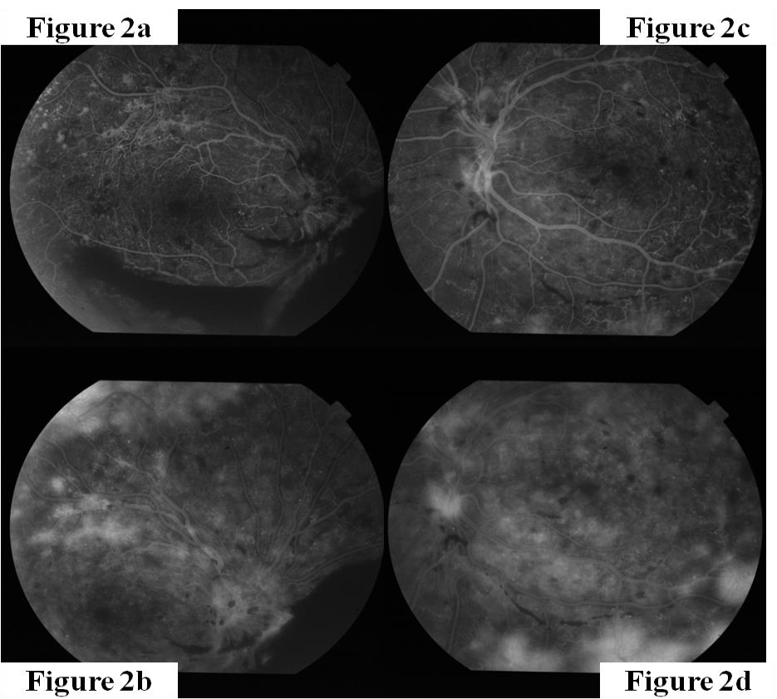
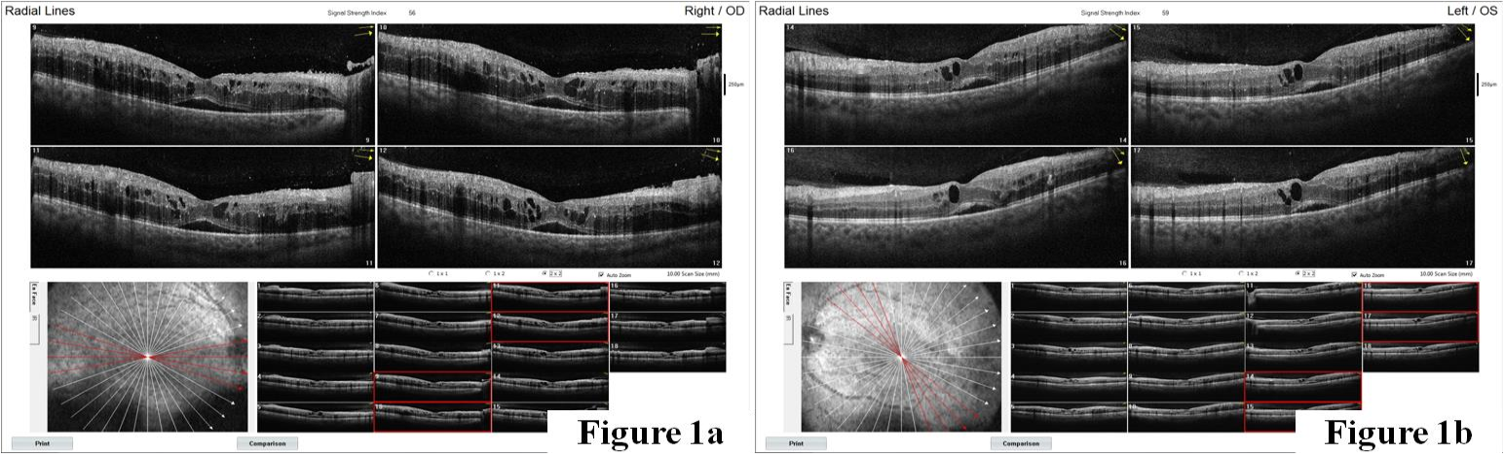
Patient was recommended to stay at prone position during the early postoperative period. Four weeks following the surgery, his BCVA was 0.9 (0.05 logmar : 83 letters in ETDRS) and his dilated fundus exam revealed the macula and retina totally silent except very few scattered microaneurisms on the temporalside of the macula. InOCT, macular thickness was better and minimal fluid was seen in the macular area (Figure 3). During the 13 months long postoperative follow-up, his visual acuity remained stable and he did not need any intravitreal injections or additional laser treatments

Figure 1a. Optical coherence tomography image of right eye. Figure 1b. Optical coherence tomography image of left eye

Figure 2. Fundus florescein angiography of bothy eyes showed retinal hemorrhage, venous beading and neovascularization. Fundus florescein angiography of the right eye (2a and 2b) and of the left eye (2c and 2d)

3
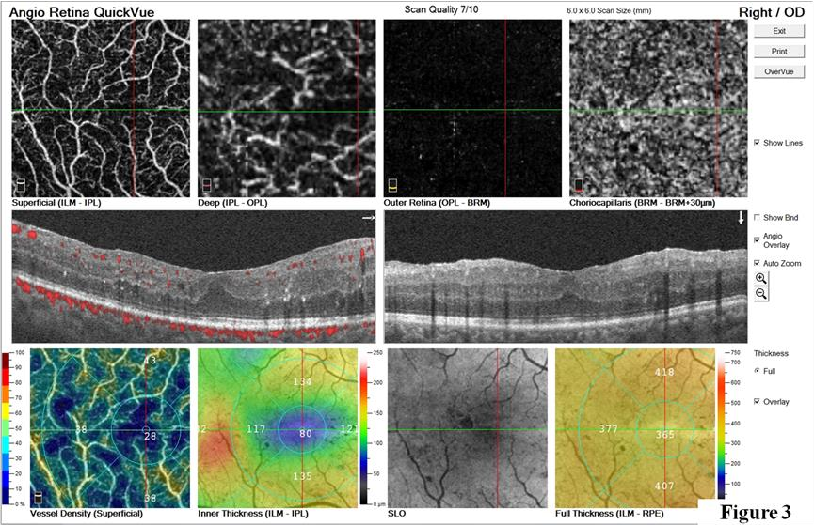

Figure 3. Optical coherence tomography image of right eye, postoperatively.

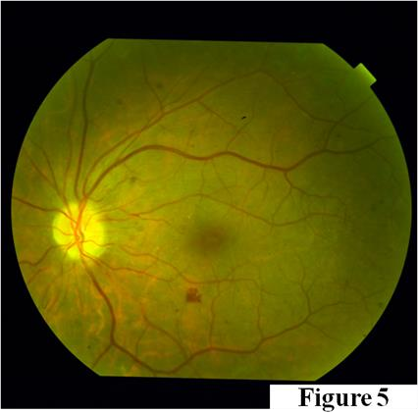
His left eye also was operated almost 2 months later than right with the same procedures because of the mild VH with early proliferations and preoperativetvisual acuity0.65(0.20logmar: 75letters inETDRS) improved to 0.85 (0.07 logmar : 81 letters in ETDRS) after 11 months of surgery. He had some microaneurisms around the temporal macular area without leakage to centrum. OCT was very silent with normal thickness.

Case 2 is a 42 years old male admitted to our hospital with a blurred vision in his left eye for four days. He was diagnosed as type1 DM 26 years ago. His HbA1c level was 7.6. His BCVA was 0.2 (0.70 log mar : 50 letters in EDTRS) inOD and 0.6(0.22 logmar: 74 letters inETDRS) in OS. His slit lamp examination and intraocular pressure were normal in both eyes. His dilated fundus exam revealed very limited hemorrhage in the right eye and VH in OS (Figure 4a and 4b). Neovascularisation of the disc and elsewhere were observed. Optic coherence tomography images could not be obtainedfromOS.His left eye underwent vitrectomy and intravitreal Ozurdex implant was injected at the end of the surgery. The surgery in the right eye started with25Gfour trocars withchandeliers andtotalvitrectomy, posterior hyaloid removal, ILM peeling with Trypan Blue and endophotocoagulation with scleral depression, fluid – gas exchanged were performed and dexamethasone implant was injected in the vitreous cavity. After two weeks, the same procedure was performed on his right eye. Three years postoperatively, BCVA was stable with 0.9 (0.05logmar : 83letters inETDRS) inthe right eye, 0.7(0.15logmar : 77 letters in ETDRS) in the left eye.
Funduscopic exam and OCT data were very silent with regular thickness and no more intravitreal injections or laser treatments were needed at this point (Figure 5). In the right eye, he had a very
subtle lens opacity which was followed regularly. Figure 4. Color fundus photography of both eyes. Color fundus photography of the right eye revealed limited vitreous hemorrhage (4a). Color fundus photography of the left eye revealed vitreous hemorrhage (4b).

Figure 5. Colour fundus photography of left eye, at postoper ative 6th month.

4
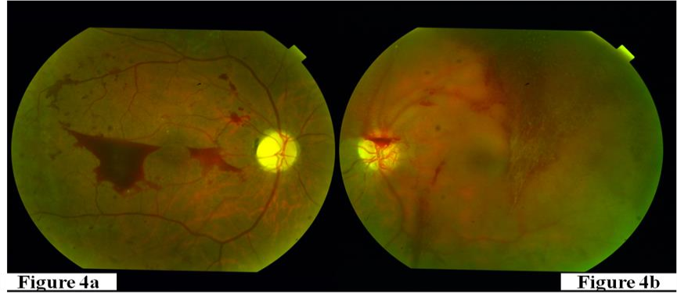

Figure 4. Color fundus photography of both eyes. Color fundus photography of the right eye revealed limited vitreous hemorrhage (4a). Color fundus photography of the left eye revealed vitreous hemorrhage (4b).

Discussion

Nearly one third of type 1 DM patients will develop vision threatening diabetic retinopathy during their lifetimes and will require aggressive conventional or surgical treatment to stabilize their vision.25 Since these patients have long life expectancy, therapeutic approaches should focus to increase their quality of life and provide a long-term solution in a cost-effective manner. Diabetic vitrectomy is generally scheduled approximately 3 months later in diabetic patients with VH to give a chance for spontaneous clearance.26 As VH is absorbed, these patients usually receive panretinal photocoagulation withintravitreal injections.27However, ina recent randomised clinical trial, patients who underwent intravitreal injections followed by panretinal photocoagulation showed more than twofold recurrence rate eventhoughthe meanfinal BCVA was similar compared to the early vitrectomy group.11 This brings up a question: what should be the algorithm and timing from conventional treatment tosurgical intervention and what is the best option for each patient?
The advantages of early vitrectomy was proposed since the beginning of 1980s.6-15 Shea et al.6 suggested performance of early vitrectomy before substantial visual loss or tractional retinal detachment development in proliferative DR patients with elevated neovascularization according to their study. Early vitrectomy yielded prompt recovery without increasing the complication rate and poor visual outcome regarding DRVS result.12-14 The number of patients with visual acuity better than 20/40 was significantly higher in the early vitrectomy group (25%) than the delayed vitrectomy group (15%). In addition, early vitrectomy gave higher chances to achieve 10/20or bettervisual acuity intheseeyes during 4 years follow up although endolaser was not part of the treatment protocol.14 Ramsay et al.7 founded statistically higher anatomic success rates, three times fold reading visual function. They argued that this success might be due to the following reasons: retina was thickerand elasticwhichallowed safe manipulations during surgery and decreased the rate of iatrogenic retinal breaks, fibrovascular membranes were less
complex permitting easier dissections and macula was more functional since permanent alterations were less likely to develop inthe initialphases. They alsoobserveddecreased risk of anterior segment neovascularization in the early vitrectomy group.7 Studies showed vitrectomy increased the oxygen levels significantly around the lens and the vitreous, decreased VEGF concentration and cytokines significantly around premacular area and had beneficial effects on retinal ischemia.28,29 That may explain why patients who underwent early vitrectomy developed less neovascularization.

Additionally, Ohanley et al.8 reported patients who did not undergo vitrectomy within 1 month developed late macular traction and could not reach 6/12 or better. They emphasized not just early but prompt vitrectomy was the reasonable approach to prevent formation of fibrous traction and eliminating the stimulus with the help of removing the scaffold.

Since thesestudies,the concept of pars plana vitrectomy has changed with advanced technological developments.30,31 Current sclerotomies are minimally invasive which allows transconjunctival sutureless up to 27 gauge vitrectomy. Surgical instruments are now more precise and have different types oftips suchas straight, curvy, blunt, taperedorsharpthat allow to dissect membranes more effectively and precise. Cutter rate can reach up to 16000 cuts/min from 20-27 gauge with various diameters, remove the vitreous rapidly and decrease the duration of surgery.16,30,31 Besides, endolaser is now an essential step of vitrectomy. It reduces the recurrence rate of VH from 48% to 7%.15 Panretinal photocoagulation may be applied to the most peripheral parts of retina with the help of wide illumination systems such as chandelier or curved illuminator probe itself withscleral depression. Different types of tips areavailable including straight or curves, whichprovide easier access to the peripheral retina.30,31 Endolaser burns are not interrupted by media opacities and they can be created at any condition in attached retina. They are more effective than transpupiller laser burns.32-34 According to our experiences

5

also, endolaser application with illuminated probes are very well controlled and the coagulation effects are more effective than transpupillary burns especially in the same power levels. These might be the causes of lower recurrence rates in VH patients who underwent vitrectomy in previous studies.9,11 Moreover, coagulation by endodiathermy may be applied to neovascularised areas to minimize the hemorrhage risk. Just before the conclusion of the surgery, we control if there is any hemorrhagic focus with transient hypotony and use endodiathermy to stop the potential hemorrhages, if there are any. In a recent study, immediate vitrectomy with endolaser decreased the spent time with vision loss and the need for additional panretinal photocoagulation treatment.9 Immediate vitrectomy improved the quality of life of the patients and shortened the period to return back to work in young population.9
Studies showed ILM peeling helps the macular edema to resolve since it may reduce the tangential traction and it contains inflammatory cells in inner surface.35-38 However, a metaanalysis showed vitrectomy with or without ILM peeling did not have any significant effect on postoperative BCVA.39 Besides, removing ILM is particularly controversial in nontractional diabetic macular edema patients and did not improve visual acuity significantly.39-41 The facts remain that, the need for intravitreal injections for DME following vitrectomy with or without ILM peeling should be studied. A Cochrane database reported the prevalence of diabetic macula edema up to 65%.42 Besides, panretinal photocoagulation may also cause changes in patients without clinically significant macular edema.43 We think it is reasonable and removed ILM and posterior hyaloid membrane in all eyes to have a quiet macula. Panretinal photocoagulation induces inflammation and macular thickening and patients received about 2000 laser spots intraoperatively. In our study, due to VH, we could not obtain OCT images in most of the patients. IntraoperativeOCT has also introduced which gives a chance to makeOCT guided ILM peeling decision during surgery.44 Currently, OCT guided ILM peeling is not used widely in clinical practice, so we were not able to use it in our study. In the future, we believe it is going to constitute a very important step of the surgery. Onthe other hand, we preferred to make intravitreal steroids instead of anti-VEGF injections to control the inflammation which was induced due to endolaser and surgical trauma as well. Intravitreal corticosteroids delay the progression of DR since they reduce cytokine production and VEGF expression which is the key agent for neovascularization development.17,20 Dexamethasone implants are slow releasing drugs and may maintain drug concentrations up to 6 months.17 They decrease the peripheral ischemia in patients with diabetic macular edema and recent studies showed they also improved the severity of the disease.20,45 Besides, dexamethasone seems to have a lower sideeffect profile, since it is less lipophilic and has a lesser tendency to accumulate in the trabecular meshwork and the lens.46 However, these implants are expensive. Patients who could not afford dexamethasone implants received intravitreal triamcinolone injections. During the follow-up, 20% of the patients needed intravitreal injections of dexamethasone implant with a mean number of one time a
year approximately. We think these corticosteroid injections decreased monthly anti-VEGF injection requirements.47-49
Rate of cataract development following diabetic vitrectomy is lower than patients who underwent surgery with other indications.50 Weobserved 6eyes whohad clinicallysignificant cataract and needed surgery. One possible cause may be the age of patients was relatively younger than the patients with other indications. These patients underwent early vitrectomy and surgery was relatively faster than in patients who had more complex fibrovascular and though membranes.7 We believe shorter duration of surgery should have an impact on low cataract rates.
On the other hand, diabetes is a chronic disease and type 1 DM patients area young, working populationwhosetreatment have significant economic impacts.23,24 Compared to deferral vitrectomy, early vitrectomyis consideredtobe extremelycost-effective.24 The number of visits during waiting clearance of VH was found to be 7.43 times greater than the cost to the immediate vitrectomy group.9 Prompt vitrectomy obviously decreases the number of additional visits and treatments.
The main advantages of the prompt vitrectomy surgery in type-1 diabetic cases with vitreous hemorrhage are to keep higher levels of visual acuity with a reasonable quality of life by a technique involving total vitrectomy with extensive panretinal endolaser combined with peeling of the ILM and conclusion of the surgery with long lasting steroid implant. In the long-term, obtaining higher quality of life and lowering the burden of disease are the main targets of the treatment modalities in those special cases.

Study Limitations
One of our limitations is the retrospective nature of this study and we did not have a control group.

Conclusion
In conclusion, prompt vitrectomy in type 1 DM patients is safe and effective which provides long-term visual stabilization with low complication rates. Long-term stabilization will yield a high quality of life in this population. Future randomized controlled studies with larger sample sizes are needed to reach more reliable outcomes.

Conflict of interests
The authors declare that there is no conflict ofinterests.

Data availability statement
The data that support the findings of this study areavailable from the corresponding author upon reasonable request.

Funding None.

Study association
This study is not associated with any thesis ordissertation work.

6
References and notes:

1. Cheung N, Mitchell P, Wong TY. Diabetic retinopathy. Lancet. 2010;376:124-36.
2. Fong DS, Aiello L, Gardner TW, King GL, Blankenship G, Cavallerano JD, Ferris 3rd FL, Klein R, American Diabetes Association. Retinopathy in diabetes. Diabetes Care. 2004;27:S84-7.
3. Kempen JH, O'Colmain BJ, Leske MC, Haffner SM, Klein R, Moss SE, Taylor HR, Hamman RF, Eye Diseases Prevalance Research Group. The prevalence of diabetic retinopathy among adults in the United States. Arch Ophthalmol. 2004;122:552-63.
4. Spraul CW, Grossniklaus HE. Vitreous Hemorrhage. Surv Ophthalmol. 1997;42:3-39.
5. Klein R, Klein BE, Moss SE, Davis MD, DeMets DL. The Wisconsin epidemiologic study of diabetic retinopathy. III. Prevalence and risk of diabetic retinopathy when age at diagnosis is 30 or more years. Arch Ophthalmol. 1984;102:527-32.
6. Shea M. Early vitrectomy in proliferative diabetic retinopathy. Arch Ophthalmol. 1983;101:1204-5.
7. Ramsay RC, Knobloch WH, Cantrill HL. Timing of vitrectomy for active proliferative diabetic retinopathy. Ophthalmology. 1986;93:283-9.
8. O'Hanley GP, Canny CL. Diabetic dense premacular hemorrhage. A possible indication for prompt vitrectomy. Ophthalmology. 1985;92:507-11.
9. Fassbender JM, Ozkok A, Canter H, Schaal S. A Comparison of Immediate and Delayed Vitrectomy for the Management of Vitreous Hemorrhage due to Proliferative Diabetic Retinopathy. Ophthalmic Surg Lasers Imaging Retina. 2016;47:35-41.
10. Chaudhry NA, Lim ES, Saito Y, Mieler WF, Liggett PE, FilatovV. Earlyvitrectomy andendolaserphotocoagulation in patients with type I diabetes with severe vitreous hemorrhage. Ophthalmology. 1995;102:1164-9.
11. Abd Elhamid AH, Mohamed A, Khattab AM. Intravitreal Aflibercept injection with Panretinal photocoagulation versus early Vitrectomy for diabetic vitreous hemorrhage: randomized clinical trial. BMC Ophthalmol. 2020;20:130.
12. Early vitrectomy for severe proliferative diabetic retinopathy in eyes with useful vision. Results of a randomized trial--Diabetic Retinopathy Vitrectomy Study Report 3. The Diabetic Retinopathy Vitrectomy Study Research Group. Ophthalmology. 1988;95:1307-20.
13. Early vitrectomy for severe proliferative diabetic retinopathy in eyes with useful vision. Clinical application of results of a randomized trial--Diabetic Retinopathy Vitrectomy Study Report 4. The Diabetic Retinopathy Vitrectomy Study Research Group. Ophthalmology. 1988;95:1321-34.
14. Early vitrectomy forsevere vitreous hemorrhage in diabetic retinopathy. Four-year results of a randomized trial: Diabetic Retinopathy Vitrectomy Study Report 5. Arch Ophthalmol. 1990;108:958-64.
15. Liggett PE, Lean JS, Barlow WE, Ryan SJ. Intraoperative argon endophotocoagulation for recurrent vitreous hemorrhage after vitrectomy for diabetic retinopathy. Am J Ophthalmol. 1987;103:146-9.
16. Lima LH, Deboer C, McCormick M, Kerns R, Bhadri P, Humayun MS. A new dual port cutter system for vitrectomy surgery. Retina. 2010;30:1515-9.
17. Boyer DS, Yoon YH, Belfort R, Jr, Bandello F, Maturi RK, Augustin AJ, Li XY, Cui H, Hashad Y, Whitcup SM, Ozurdex MEAD Study Group. Three-year, randomized, sham-controlled trial of dexamethasone intravitreal implant in patients with diabetic macular edema. Ophthalmology. 2014;121:1904-14.
18. Brown DM, Nguyen QD, Marcus DM, Boyer DS, Patel S, Feiner L, Schlottman PG, Rundle AC, Zhang J, Rubio RG, Adamis AP, Ehrlic JS, Hopkins JJ RIDE and RISE Research Group. Long-term outcomes of ranibizumab therapy for diabetic macular edema: the 36-month results from two phase III trials: RISE and RIDE. Ophthalmology. 2013;120:2013-22.
19. Chieh JJ, Roth DB, Liu M, Belmont J, Nelson M, Regilo C, Martidis A. Intravitreal triamcinolone acetonide for diabetic macular edema. Retina. 2005;25:828-34.
20. Iglicki M, Zur D, Busch C, Okada M, Loewenstein A. Progression of diabetic retinopathy severity after treatment with dexamethasone implant: a 24-month cohort study the 'DR-Pro-DEX Study'. Acta Diabetol. 2018;55:541-7.
21. Nguyen QD, Brown DM, Marcus DM, Boyer DS, Patel S, Feiner L, Gibson A, Sy J, Rundle, Hopkins JJ, Rubio RG, Ehrlich JS, RISE and RIDE Research Group. Ranibizumab for diabetic macular edema: results from 2 phase III randomized trials: RISE and RIDE. Ophthalmology. 2012;119:789-801.
22. Recchia FM, Scott IU, Brown GC, BrownMM, HoAC, IpMS. Small-gauge pars plana vitrectomy: a report by the American Academy of Ophthalmology. Ophthalmology. 2010;117:1851-7.
23. Lin J, Chang JS, Yannuzzi NA, Smiddy WE. Cost Evaluation of Early Vitrectomy versus Panretinal Photocoagulation and Intravitreal Ranibizumab for Proliferative Diabetic Retinopathy. Ophthalmology. 2018;125:1393-400.
24. Sharma S, Hollands H, Brown GC, Brown MM, Shah GK, Sharma SM. The cost-effectiveness of early vitrectomyfor the treatment of vitreous hemorrhage in diabetic retinopathy. Curr Opin Ophthalmol. 2001;12:230-4.
25. Roy MS, Klein R, O'Colmain BJ, Klein BE, Moss SE, Kempen JH. The prevalence of diabetic retinopathy among adult type 1 diabetic persons in the United States. Arch Ophthalmol. 2004;122:546-51.
26. Mohamed Q, Gillies MC, Wong TY. Management of diabetic retinopathy: a systematic review. Jama. 2007;298:902-16.
27. Zenoni S, Comi N, Fontana P. Individualised treatment of proliferative diabetic retinopathy: optimal surgical timing improves long-term outcomes. Epma j. 2010;1:78-81.
28. Holekamp NM, Shui YB, Beebe DC. Vitrectomy surgery increases oxygen exposure to the lens: a possible mechanism for nuclear cataract formation. Am J Ophthalmol. 2005;139:302-10.
29. Lee SS, Ghosn C, Yu Z, Zacharias LC, Kao H, Lanni C, Abdelfettah N, Kuppermann B, Csaky KG, D’Argenio DZ, Burke JA, Hughes PM, Robinson MR. Vitreous VEGF clearance is increased after vitrectomy. Invest Ophthalmol Vis Sci. 2010;51:2135-8.

7
30. Apostolopoulos N, Del prıore LV. The Future of Vitrectomy: An American Perspective. Turkiye Klinikleri Ophthalmology-Special Topics. 2017;10:209-16.
31. Mohamed S, Claes C, Tsang CW. Review of small gauge vitrectomy: progress and innovations. Journal of ophthalmology. 2017;2017.
32. Fong DS, Girach A, Boney A. Visual side effects of successful scatter laser photocoagulation surgery for proliferative diabetic retinopathy: a literature review. Retina. 2007;27:816-24.
33. Maeshima K, Utsugi-Sutoh N, Otani T, Kishi S. Progressive enlargement of scattered photocoagulation scars in diabetic retinopathy. Retina. 2004;24:507-11.
34. Shiraya T, Kato S, Araki F, Yamaguchi T, Kaiya T. Comparison of burn sizes resulting from photocoagulation using a transpupillary laser and an endolaser. Acta Ophthalmol. 2015;93:e595-6.
35. Gandorfer A, Messmer EM, Ulbig MW, Kampik A. Resolution of diabetic macular edema after surgical removal of the posterior hyaloid and the inner limiting membrane. Retina. 2000;20:126-33.
36. Kohno T, Sorgente N, Goodnight R, Ryan SJ. Alterations in the distribution of fibronectin and laminin in the diabetic human eye. Invest Ophthalmol Vis Sci. 1987;28:515-21.
37. Matsunaga N, Ozeki H, Hirabayashi Y, Shimada S, Ogura Y. Histopathologic evaluation of the internal limiting membrane surgically excised from eyes with diabetic maculopathy. Retina. 2005;25:311-6.
38. Tamura K, Yokoyama T, Ebihara N, Murakami A. Histopathologic analysis of the internal limiting membrane surgically peeled from eyes with diffuse diabetic macular edema. Jpn J Ophthalmol. 2012;56:280-7.
39. Rinaldi M, dell'Omo R, Morescalchi F, Semerraro F, Gambicorti E, Cacciatore F, Chiosi F, Costagliola C. ILM peeling in nontractional diabetic macular edema: review and metanalysis. Int Ophthalmol. 2018;38:2709-14.
40. Ghassemi F, Bazvand F, Roohipoor R, Yaseri M, Hassanpoor N, Zarei M. Outcomes of vitrectomy, membranectomy and internal limiting membrane peeling inpatients withrefractory diabeticmacular edemaand non-tractional epiretinal membrane. J Curr Ophthalmol. 2016;28:199-205.
41. Virgili G, Menchini F, Casazza G, Hogg R, Das RR, Wang X, MichelessiM. Optical coherence tomography (OCT) for detection of macular oedema in patients with diabetic retinopathy. Cochrane Database Syst Rev. 2015;1:Cd008081.
42. Soman M, Ganekal S, Nair U, Nair K. Effect of panretinal photocoagulation on macular morphology and thickness in eyes with proliferative diabetic retinopathy without
clinically significant macular edema. Clin Ophthalmol. 2012;6:2013-7.
43. Ung C, Miller JB. Intraoperative Optical Coherence Tomography in Vitreoretinal Surgery. Semin Ophthalmol. 2019;34:312-6.
44. Querques L, Parravano M, Sacconi R, Rabiolo A, Bandello F, Querques G. Ischemic index changes in diabetic retinopathy after intravitreal dexamethasone implant using ultra-widefield fluorescein angiography: a pilot study. Acta Diabetol. 2017;54:769-73.
45. Thakur A, Kadam R, Kompella UB. Trabecular meshwork and lens partitioning of corticosteroids: implications for elevated intraocular pressure and cataracts. Arch Ophthalmol. 2011;129:914-20.
46. Boyer DS, Faber D, Gupta S, Patel SS, Tabandeh H, Li XY, Liu CC, Lou J, Whitcup SM, Ozurdex CHAMPLAIN Study Group. Dexamethasone intravitreal implant for treatment of diabetic macular edema in vitrectomized patients. Retina. 2011;31:915-23.
47. Bastakis GG, Dimopoulos D, Stavrakakis A, Pappas G. Long-term efficacy and duration of action of dexamethasone implant, in vitrectomised and non-vitrectomised eyes with persistent diabetic macular oedema. Eye (Lond). 2019;33:411-8.
48. Schmidt-Erfurth U, Garcia-Arumi J, Bandello F, Berg K, Chakravarthy U, Gerendas BS, et al. Guidelines for the Management of Diabetic Macular Edema by the European Society of Retina Specialists (EURETINA). Ophthalmologica. 2017;237:185-222.
49. Smiddy WE, Feuer W. Incidence of cataract extraction after diabetic vitrectomy. Retina. 2004;24:574-81.

How to cite this article: Kaynak., Suleyman.Donmez, Oya., Prompt Vitrectomy in Patients with Type 1 Diabetes and Diabetic Retinopathy..Journal of Ophthalmology casses
& Hypotheses. 2023;4(01);1-8.

Copyright ©2023.All rights reserved.

8

