Volume 4, Number 1, 2023.9-12

Journal of Ophthalmology Cases & Hypotheses

ACUTE ZONAL OCCULT OUTER RETINOPATHY (AZOOR). DIFFICULTIES IN DIAGNOSIS
Introduction

Submission: 11-10-2022 Accepted: 05-02-2023 Published:10-04-2023

Dilara MELIKMAMEDOVA, MD HAT Medicine Clinic, Baku, Azerbaijan

Abstract

Purpose: The purpose of this article is to identify a way to differentiate acute zonal occult outer retinopathy (AZOOR) from the age-related macular degeneration (AMD).
Methods: A case study.
Results: Determination of morphofunctional changes in acute zonal occult outer retinopathy (AZOOR) that distinguish it from age-related macular degeneration (AMD).
Conclusion: If AZOOR is suspected, patients should definitely conduct electrophysiological studies. The appearance of pigment on the retina also seemed suspicious to us. This happens already in a far advanced process.

Keywords: Acute zonal occult outer retinopathy (AZOOR), age-related macular degeneration (AMD), electron-retinogram (ERG).
Acute zonal occult outer retinopathy (AZOOR) was first described by JD Gass in 1992. He described a disease characterized by sudden the appearance of subjective scotomas and photopsies due to the loss of areas of the outer part of the retina with normal fundus of the eye1. Based on electrophysiological studies, it was revealed that in this condition, the outer retina is first of all damaged2. Its electrophysiological abnormalities include reduced full‐field electroretinograms (ERGs), especially in the a‐wave, and reduced early receptor potentials (ERPs) during the acute and vision‐impaired phases of the disease3,4,5. Usually affects young predominantly Caucasian women who present with loss of central vision with or without photopsia. Its etiology remains uncertain.
Infectious, autoimmune, or inflammatory etiology must have been responsible in the onset of the disease. Death retinal photoreceptors can lead to a visual loss1. AZOOR may be misdiagnosed as a dry form of AMD. We would like to present a similar case.

Case report

A 73-year-old female presented with complaints of visual impairment. 8 years ago, the patient's vision suddenly deteriorated, she went to the ophthalmologist and was diagnosed with age-related macular degeneration (AMD) of the retina. She went tomany clinics. The treatment was carried out by taking antioxidant vitamins OMK-2 (Hyaluronat acid + Citicolin). There was no effect.
Best corrected visual acuity (BCVA) of the right eye (OD) is 20/50 and left eye is (OS) 20/50. Refraction: OD cylinder -0,25 axis 5˚; OS sphera -0,25, cylinder 0,25, axis 145˚. Tonometry: OD = 12 mm Hg, OS = 13 mm Hg.

Quick Response Code: Website:
https://ophthalmolcases.com/index.php/ hat

DOI:10.30546/2788-516X.2023.4.1.9
No cells were noted at the anterior chamber (AC) or vitreous. Fundus examination of the right eye revealed a large area of chorioretinal degeneration at the posterior pole and few spots of RPE hyperplasia. On the pathological zone, a pronounced "tessellated fundus” was noted. On fundus of the left eye revealed diffuse retinal pigment epithelium (RPE) atrophy (Figure 1,2).

OCT examinations revealedthat retina is thinned perifoveally. Internal layers of the retina are irregular. Ellipsoid zone is disrupted and tubulations can be observed in the outer layers of the retina. RPE is thin, with areas local atrophy and corresponding hypertransmission zones (Figure 3,4).

9
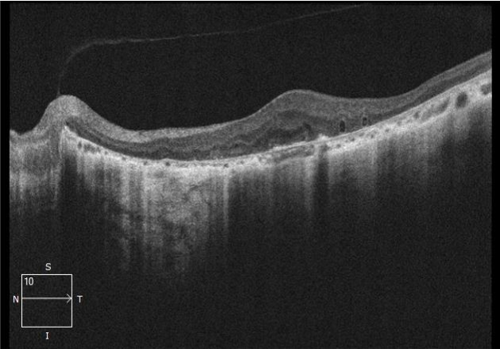
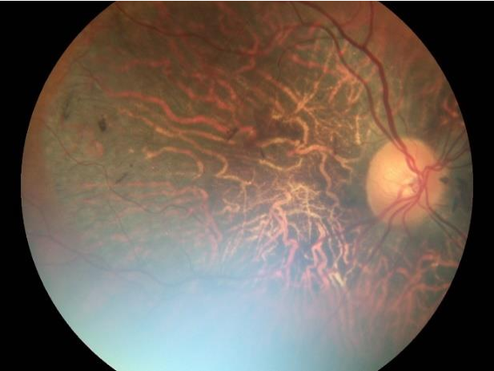

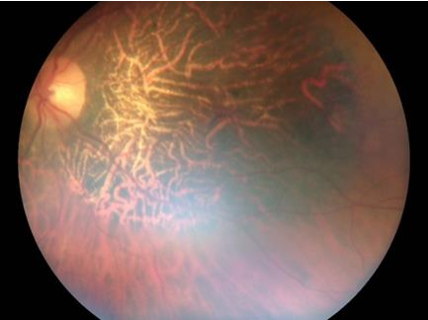
Figure 1. The fundus photo of the right eye. Fundus examination showed a diffuse retinal pigment epithelium (RPE) atrophy and few spots of RPE hyperplasia can be seen at the temporal and nasal periphery. Normal vitreous and optic disc
Visual fields of right and left eyes of a 73-year-old woman, showing remaining, markedly constrictedcentral visual fields, with complete loss of peripheral fields in both eyes (Fig. 5,6). According to her symptoms and examinations, AZOOR was diagnosed and was started on a dexamethasone intravenous for 5 days. At follow-up 5 days later, visual acuity of the right eye has improved slightly, subjective improvement is noticeable. Patient feels much better.
BCVA OD = 20/40. BCVA OS = 20/32.

Discussion

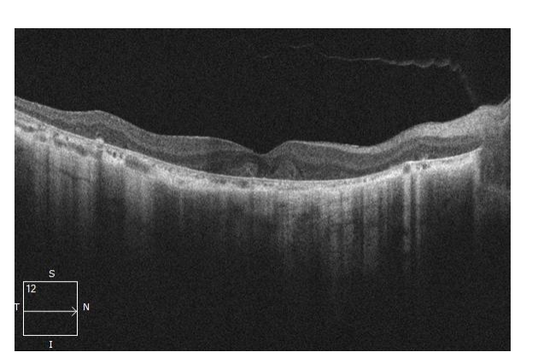
Figure 2. The fundus photo of the left eye. Fundus examination showed a diffuse retinal pigment epithelium (RPE) atrophy and normal vitreous and optic disc.
This case suggests that retinal changes and OCT data were similar to AMD dry form. Decreased vision with AZOOR occurs suddenly. This was observed ina patient 6 years agoand it was necessarytopay attentiontothis. Inaddition, this disease is accompanied by a narrowing of the field of view. Most importantly, inthiscase, thediseasereduces the localamplitude on ERG, and when the process worsens, the general ERG.If this disease is suspected, patients should definitely conduct electrophysiological studies.The appearance of pigment on the retina also seemed suspicious to us. This happens already in a far advanced process.Thus, one must be aware of this disease and, if necessary, conduct additional research.

Conflict of interests
The author declares that there is no conflict of interest.

Data availability statement
The data that support the findings of this study areavailable from the corresponding author upon reasonable request.

Funding None.

Figure 3. Right eye. The retina is thinned perifoveally. The inner layers of the retina are uneven. The ellipsoid zone is broken, and tubules can be observed in the outer layers of the retina. RPE is thin, with areas of local atrophy and corresponding areas of hypertransmission.
Study association
This study is not associated with any thesis or dissertation work.

10
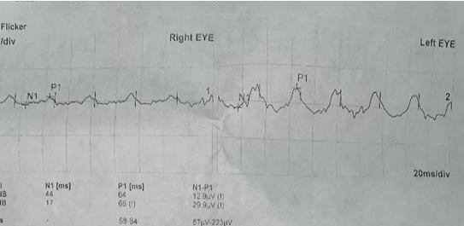
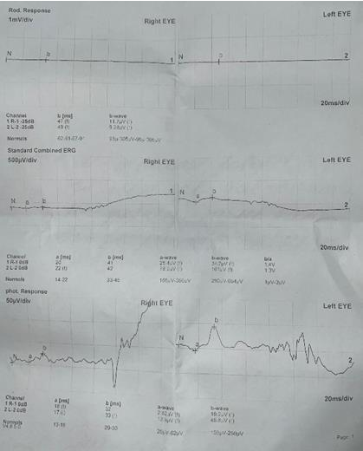
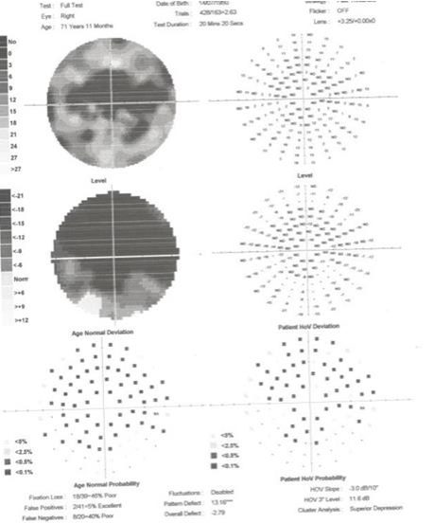
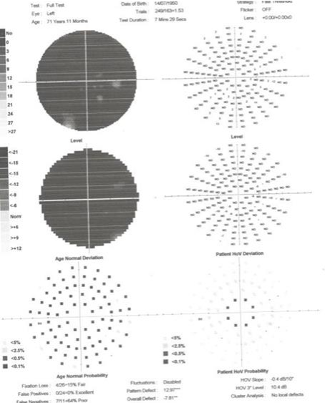

Figure 5. Visual fields of the patient, showing remaining, markedly constricted central visual fields, with complete loss of peripheral fields in both eyes.

Figure 6. Thestandard photopic and rhythmic electron-retinograms (ERG) are subnormal. In the outer layers of the retina observed pathological changes.

11
References and notes:

1. Gass, J.D. Acute zonal occult outer retinopathy. Donders Lecture: The Netherlands Ophthalmological Society, Maastricht, Holland, 19 June 1992. J. Clin. Neuro-Ophthalmol. 1993, 13, 79–97.
2. Özyol E, Özyol P. Acute zonal occult outer retinopathy: optical coherence tomography angiography findings and treatment response. GMS Ophthalmol Cases. 2022;12:Doc16. DOI: 10.3205/oc000203, URN: urn:nbn:de:0183-oc0002037.
3. Kuo Y.C., Chen N., Tsai R.K. Acute Zonal Occult Outer Retinopathy (AZOOR): a case report of vision improvement after intravitreal injection of Ozurdex. BMC Ophthalmol. 2017;17(236) doi: https://doi.org/10.1186/s12886-017-0638-5
4. Hajiyev R.V. Acute Zonal Occult Outer retinopathy (AZOOR) progression: 30- year follow-up of a clinical case. Ophthalmology Cases and Hypotheses. 2002;03(01):4-9. doi: 10.30546/2788-516X.2022.3.1.4
5. Fune H.F., Spaide R.F., Ryan E.H., et al. Acute Zonal Occult Outer Retinopathy in Patients With Multiple Evanescent White Dot Syndrome. Arch Ophthalmol. 2009;127(1):66-70. doi:10.1001/archophthalmol.2008.530

How to cite this article: Dilara Melikmamedova. Acute Zonal Occult Outer Retinopathy (AZOOR). Difficulties in diagnosis. Journal of Ophthalmology casses & Hypotheses. 2023;4(01);9-12.

Copyright ©2023.All rights reserved.

12

