Volume 4, Number 1, 2023.13-15

Journal of Ophthalmology Cases & Hypotheses

CREUTZFELDT-JAKOB DISEASE PRESENTING WITH VISUAL SIGNS: A CASE REPORT
Introduction

Submission: 30-10-2022 Accepted: 17-02-2023 Published:10-04-2023

Nilay AKAGUN, MD Liv Hospital, Ankara

Abstract

Creutzfeldt-Jakob disease (CJD) is a rare and progressive neurodegenerative disease. Heidenhain variant of CJD presents with isolated visual sypmtoms which persists without any cognitive decline for a few weeks. Therefore it often causes misdiagnosis or delay in diagnosis. We report a case of Creutzfeldt-Jakob disease (CJD) with visual disturbances as the initial manifestation. Blurred vision, macropsia and homonymous hemianopia were the first symptoms/signs of the disease. Patient was consulted to the neurology department and diagnosed with the Heidenhain variant of CJD based on the clinical course and confirmed by positive assays of the cerebrospinal fluid for the 14-3-3 protein. In addition, the diagnosis was confirmed by the findings of diffusion-weighted magnetic resonance imaging. Although there is no effective treatment in CJD, early diagnosis is significant.

Keywords:Creutzfeldt-Jakob disease, neurodegenerative disease, homonymous hemianopsia

Quick Response Code: Website:
https://ophthalmolcases.com/index.php/ hat

DOI:10.30546/2788-516X.2023.4.1.13
Creutzfeldt-Jakob disease (CJD) is a rare and progressive neurodegenerative disease characterized by spongiform changes in multiple
central nervous system (CNS) tissues1. CJD is a transmissible encephalopathy caused by prions which are proteinaceous infectious particles. It usually occurs in the 5th-7th decade. The incidence is reported as 1/1000000 per year. There is no significant sex predominance. Four different CJD subtypes have been described; sporadic, familial, iatrogenic and variant.
CJD presents with demantia, myoclonus and other neurological signs corresponding to the affected areas of the CNS. Brain cortex, cerebellum; corticospinal tract, spinal anterior horn cells and basal ganglia can be involved2,3.
The clinical course usually begin with behaivoral changes, speech and memory deterioration and visual disturbance. Visual symptoms are present at least 20% of patients. CJD is a rapidly progressive disease and leads to death in a few months. A subclass of patients withCJD present withisolated visual sypmtoms which persists without any cognitive decline forafewweeks. Thesecases areknownas Heidenhain variant of CJD.

Case report

A 64-year-old man visited our clinic and reported blurring of his vision bilaterally and macropsia. He had only hypertension in his medical history. His visual acuity was 20/20 OD and 20/20 OS, he had right homonymous hemianopsia (Figure 1, 2). The other results of ocular examination were normal.
Computed tomography (CT) and magnetic resonance imaging (MRI) tests of the brain were normal. He was consulted to neurology department for more detailed examination.
Blood investigations including hemography, random blood sugar, renal and liver function tests, thyroid profile, and serum vitamin B12 levels were normal. Paraneoplastic serum autoantibody testing results were normal or negative. Cerebrospinal fluid (CSF) analysis (protein, glucose, cytomegalic virus antigen, immunelectrophoresis) did not reveal any abnormality. Patient developed emotional changes and memory detoriation one week after the onset of visual symtoms.

13

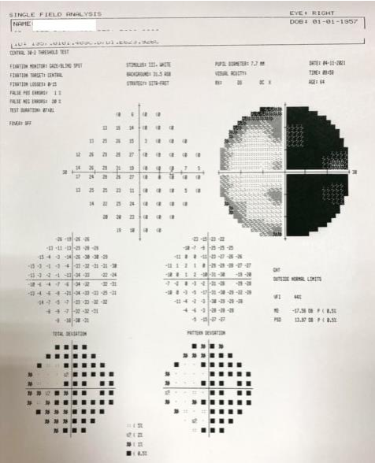
Discussion

The most common clinical manifestations of CJD are progressive cognitive decrease, dementia, myoclonus, and ataxia. Patients may initially complain of visual disturbances and then develop rapidly progressing dementia and death usually occurs within 12 months4,5.

Visual symptoms/signs of CJD include blurred vision, visual field defects, visual distortion, dyschromatopsia, visual hallucinations, palinopsia, micropsia, macropsia; visual agnosia, and rarely ocular motor symptoms. CJD affects vision in various ways6. The variations in the clinical manifestations were probably caused by the different locations of the accumulations of pathogenic prion protein in the CNS. It has been reported that, 3.7% of CJD patients had isolated visual symptoms at onset, and 77% of these patients initially visited an ophthalmologist7. In these cases, CJD was diagnosed by the ophthalmologist.
Figure 1. Perimetry of the right eye
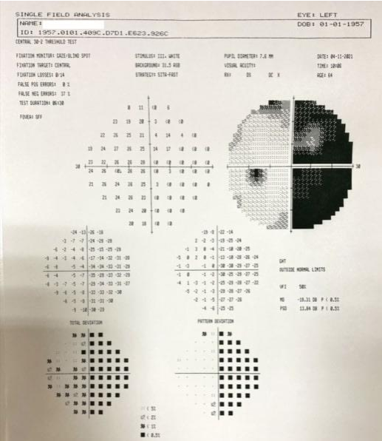
The CSF assay for the 14-3-3 proteinis useful for the diagnosis of CJD. The specificity of this finding may be as high as 95%, but the sensitivity varies from 45 to 85%. Our patient CSF assay for the 14-3-3 protein was positive.

EEG exhibits changes depending on the stage of the disease, ranging from nonspecific findings such as diffuse slowing and frontal rhythmic delta activity (FIRDA) in early stages of disease; typical periodic sharp wave complexes (PSWC) in middle and late stages to a reactive coma traces or even alpha coma in preterminal EEG recordings9,10. Our caseshowed as diffuse slowing and FIRDA. EEG testes couldn’t be repeated due to patients cognitive impairment.

Figure 2. Perimetry of the left eye

Gram staining of CSF was negative. CSF analyses were positive for surrogate marker of neurodegeneration, 14-3-3 protein. Electroencephalography (EEG) revealed diffuse slowing of the background and frontal intermittent rhythmic delta activity. Diffusion-weighted imaging (DWI) of the brain showed high signal intensity in the occipital cortex on the left side.
In view of the rapidly progressive dementia associated with visual signs and positive 14-3-3 CSF assay with high signals inMRI; a diagosis of probable Heidenhain variant of CJD was made. Ten days after his hospitalization, the patient progressed to severe dementia, depressive episodes and eating disorder. Percutaneous endoscopic gastrostomy (PEG) was placed and a palliative approach to his care was undertaken
Brain biopsy or an exam of brain tissue after death (autopsy) confirm the definite diagnosis of Creutzfeldt-Jakob disease (CJD). Histologicalanalysis for spongiform changes, neuronal cell loss, and gliosis, immunohistochemical tests and paraffin-embedded tissue blot analysis for detection of PrPSc is usually performed. However brain biopsy is not always an easy procedure to apply.

In view of the rapidly progressive dementia associated with visual signs and positive 14-3-3 CSF assay with high signals in DWI; diagnosis of probable Heidenhain variant of CJD was made. The Heidenhain variant of CJD must be considered in all patients who present with isolated visual complaints. This rare group can cause diagnostic difficulties.

Although there is no effective treatment, an early diagnosis is desirable for avoiding the fear of infection. Insuspected cases, it is important to consult the neurology department quickly for early and exact diagnosis of CJD.

14

Conclusion

Heidenhein variant of Creutzfeldt-Jakob disease usually presents with visual syptoms. Ophthalmologists should be aware that visual disturbance even with normal neuroimagining, may be the first indication of CJD.

Conflict of interests
The authors declare that there is no conflict of interests.
Data availability statement
The data that support the findings of this study are available from the corresponding author upon reasonable request.

Funding None.

Study association
This study is not associated with any thesis ordissertation
work.

References and notes:

1. Sakuma T, Watanabe S, Ouchi A, Sakanishi Y, Mizota A, Ebihara N: Three cases of Creutzfeldt-Jakob disease with visual disturbances as initial manifestation. Case Rep Ophthalmol. 2019;10:349-56
2. Vargas ME, Kupersmith MJ, Savıno PJ, Petito, F, Frohman, LP, Warren, FA. Homonymous field defect as the first manifestation of Creutzfeldt-Jakob disease. Am J Ophthalmol. 1995;119(4):497–504
3. Foundas M, Donaldson MD, McAllister IL, Bridges LR. Vision loss due to coincident ocular and central causes in a patient with Heidenhain variant Creutzfeldt-Jakob disease. Age and Ageing. 2008;37(2):231–2
4. Lueck CJ, McIlwaine GG, Zeidler M. Creutzfeldt-Jakob disease and the eye. II. Ophthalmic and neuro-ophthalmic features. Eye. 2000;14(3):291-301
5. Proulx AA, Strong MJ, Nicolle DA. Creutzfeldt-Jakob disease presenting with visual manifestations. Can J Ophthalmol. 2008;43(5):591–5
6. Akcali A, Saygili O, Karaoglan I. Muhtemel sporadik Creutzfeldt-Jakob hastalığı Heidenhain varyantının tanısında EEG. Nöropsikiyatri Arşivi. 2011;48:71-4
7. Inanc Y, Arlier Z, Inanc Y, Geyik S, Giray S, Kocaturk O. Creutzfeldt-Jakob disease presented with diziness, weakness and neuropscychiatric symptoms: Two case reports. Gaziantep Med J. 2015;21(2):142-6
8. Eren F, Ekmekci AH, Ozturk S. Sporadic Creutzfeldt-Jakob disease in the differential diagnosis of psychiatric disorders: Two case reports. Med Bull Haseki. 2018;6:252-5
9. Aykac O et al. Sporadic Creutzfeldt-Jacob Disease: Analysis of 16 Patients. Epilepsi. 2016;22(2):46-50
10. Eren F, Güler S, Gül G, Dirican AC, Atakli D, Soysal
A. Clinical, electrophysiological, radiological features and prognosis of Creutzfeldt -Jakob disease. Epilepsi. 2020; 26(3):169-7

How to cite this article: Nilay Akagun. Creutzfeldt-Jakob disease presenting with visual signs: A Case Report. Journal of Ophthalmology casses & Hypotheses. 2023;4(01);13-15.

Copyright ©2023.All rights reserved.

15

