UDC 617.72
Journal of Ophthalmology Cases & Hypotheses

CLINICAL CASE OF ABRUPT DISAPPERANCE OF CHEMOSIS AFTER INTRAVENOUS USE OF CORTICOSTEROIDS

Hajiyev R.V. MD PhD
(Corresponding Author) HAT Medicine Clinic, Baku, Azerbaijan (rasim.gadjiev@gmail.com)

Abstract
Chemosis is a condition characterized by conjunctival edema resulting from an inflammatory response. It can occur due to various underlying pathologies, including allegies, infections, trauma, or systemic diseases. Here, we present a case of chemosis in a 45-year-old male patient and discuss the diagnostic evaluation, management strategies, and patient outcomes. This case report aims to increase awareness of chemosis as a clinical entity and provide insights into effective treatment options.

Keywords: chemosis , microbiota.

Access this article online
Quick Response Code: | Website:
 | https://ophthalmolcases.com/in
 | dex.php/ hat
 | DOI:
 | 10.30546/2788-
 | 516X.2023.4.2.2

Introduction

Conjunctivitis is the most widespread eye disease and the most frequent reason for seeking ophthalmological treatment.
Depending on the type of conjunctivitis, patients are treated with antibiotics, glucocorticoids, and other medications.
However, there can be cases of tolerance to the treatment, accompanied by chemosis. In some instances, this is observed

Submission: 22-03-2023
Accepted: 14-05-2023
Published: 15-12-2023

in leukaemia (1). Chemosis occurs frequently after direct surgical or accidental trauma (2). However, in some patients swelling of the conjunctiva may persist for over 6 months with no obvious cause. In some idiopathic cases, tissue inflammation or lymphangiectasia may give rise to irreversible chronic chemosis (3).
There is an article describing a patient with chronic unilateral chemosis, likely due to treatment with amlodipine besylate. Amlodipine besylate is a calcium channel blocker (CCB), one of the most commonly used classes of antihypertensive agents (4).

Case report

A 45-year-old man presented to our clinic with a 4- month history of redness in his right eye. He complained of slight pain and foreign body sensation. Before referral to us, the patient had received topical antibiotics and corticosteroids, but there was no effect. According to the patient, the redness had occurred suddenly 4 months ago after previous back pain. He also suffered from chronic prostatitis and periodic high blood pressure. No other medical history was present, and he did not take any medications. After reddening of the eye, the back pain disappeared.
Examination of the right eye revealed severe hyperaemia and oedema of the bulbar conjunctiva. There was mild ptosis, and the oedema was so pronounced that when the eyelids closed, the conjunctiva remained visible. In addition, chemosis was present (Figure 1).
The patient’s best-corrected visual acuity was 20/20 in both eyes. The anterior segment of the eye was not changed, and the cornea and lens were transparent. The posterior segment of the eye was also without pathology. Haematological analyses, such as complete blood cell count (CBC) and blood smear results, were within normal limits.

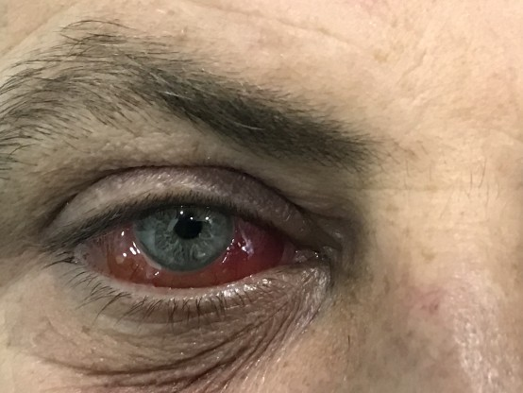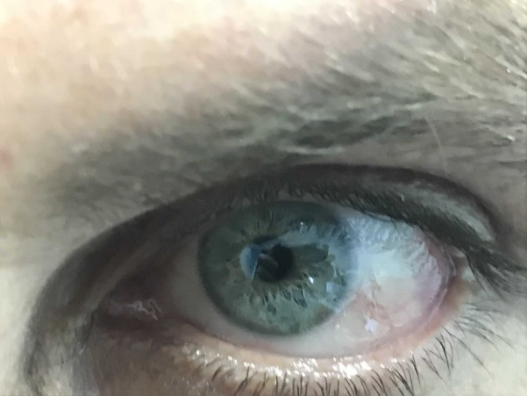

Figure 1. Right eye of the patient with chemosis. Before treatment.

The patient was started on dexamethasone eye drops with frequent instillation (6 times a day). On ophthalmological evaluation one week later, there was no improvement. After that, all eye drops were discontinued. Three intravenous dexamethasone injections were encouraged. After two days, the patient's hyperaemia and chemosis completely resolved. No further injection was needed (Figure 2).
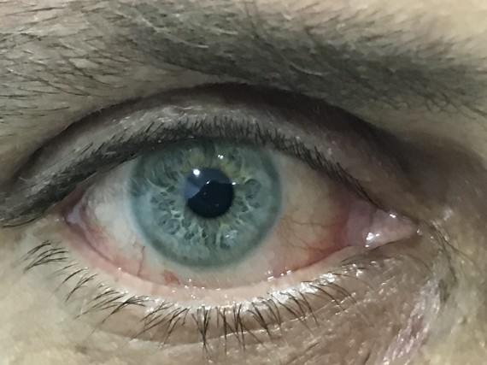
Figure. 2. Right eye of patient after two intravenous dexamethasone injection.

One week later, the patient returned, complaining about his other eye. Examination revealed swelling of the lateral bulbar conjunctiva of the left eye (Figure 3). However, the swelling was not as obvious as it had been in the right eye. The right eye appeared completely normal. Three intravenous injections of dexamethasone were again prescribed. Two days later, the oedema had completely improved.
Figure 3. Left eye of the patient. A slight conjunctival edema at the temporal side.

Discussion

Chemosis is a non-specific symptom that can have several different causes. It is related to
allergies. Sometimes, a viral, trauma or bacterial infection can cause it (4), but there was no known history of allergic reaction, bacterial or viral infection, angioedema, or trauma in this patient. Sudden onset of chemosis occurred in this patient after he experienced back pain. Once chemosis began, the back pain stopped immediately. Can there be a link between the disappearance of back pain (chronic prostatitis) and the occurrence of chemosis? Modern medicine does not have an answer to this question. Kerimoglu et.al presented a clinical case of unilateral chemosis, acute myopia, and choroidal detachment after treatment with tamsulosin in a patient who underwent vesicular diverticulectomy procedure one month ago (6).
Tamsulosin is a subtype-selective α1A and
α1D adrenoceptor antagonist, which improves maximal urine flow by relaxing the prostate and bladder smooth muscles (7). Its well-known ocular side-effect is intraoperative floppy iris syndrome (8). In this example, we also see that the dysfunction of the urogenital system led to the development of chemosis.
Conditions linked to back pain can vary, and for many diseases that cause it, anti-inflammatory drugs such as corticosteroids and nonsteroidal anti- inflammatory drugs (NSAIDs) are used. It is notable that neither the use of antibiotics, which the patient was taking before coming to us, nor the use of topical corticosteroids in high doses led to a decrease in the chemosis. Apparently, there was no local inflammation.
We diagnosed this case as idiopathic orbital inflammatory syndrome (IOIS). Kalin et al. (3) presented a series of seven cases of chronic localized conjunctival chemosis. Each patient had a localized

area of dependent conjunctival edema for >or= 6 months. Evaluation of each patient included clinical examination, laboratory studies, and neuroimaging to attempt to elucidate the pathogenesis of the chemosis. Conjunctival biopsy was performed in six of the seven patients. In all of the patients studied, clinical examination uncovered no definitive signs of local inflammation. Laboratory evaluation was normal, and neuroimaging failed to confirm obstruction of venous or lymphatic drainage. Conjunctival biopsies showed chronic tissue inflammation or lymphangiectasia. The diagnosis of chronic localized conjunctival chemosis (CLCC) can be made if localized conjunctival edema persists for 6 months.
A similar case was described by Vrcek J et al. A 59-year-old woman was diagnosed with IOIS. She had a history of mastectomy and exhibited hypertension. Moreover, she had been treated for a long time without success in other departments. Soon (within 24 hours) after she received oral prednisone, all her symptoms disappeared (9). Thus, we see that only the systemic use of hormones resulted in a quick recovery.
Why is this happening? Why is the topical application of corticosteroids ineffective? Only systemic use leads to recovery. Let us examine how corticosteroids work. To exert an effect, steroids bind to glucocorticoid receptors, which causes a conformational change in the receptor and blocks the cell membrane. As a result, the antigen-antibody complex moves away from the membrane. Thus, the cells "throw off" these complexes and begin to recover.
Where are the locations of microbes (bacteria) in the body? They are normally only on mucous membranes in contact with the external environment, namely, on the conjunctiva and on the mucous membranes of the gastrointestinal tract, urinary tract, nose and ears.
Which microbial complexes associated with cells are affected by corticosteroids? If these drugs acted on the conjunctiva of the eye, then local instillation of dexamethasone would help, but it did not.
Therefore, corticosteroids act on other mucous membranes. Thus, the gastrointestinal, genitourinary system or other systems may play a role in the development of İOİS.

Conclusion
IOIS is caused by a variety of ocular and systemic diseases.
In some IOIS cases, only the systemic use of corticosteroids leads to rapid recovery. Topical application of corticosteroids in our patient had no effect. However, this does not exclude the fact that for other causes of chemosis, the topical administration of corticosteroids may help. It is suggested that corticosteroids do not affect the microbial population and antibodies of the conjunctival mucous membrane but, rather, the antigen- antibody complexes of other mucous membranes.

Conflict of interests
The author declares that there is no conflict of interests.

Data availability statement
The data that support the findings of this study areavailable from the corresponding author upon reasonable request.

Funding
None.

Study association
This study is not associated with any thesis ordissertation work.

References

- Gandhi A.,Das S. Conjunctival chemosis or not? Indian J Ophthalmol. 2018 Oct; 66(10): 1394. doi: 10.4103/ijo.IJO_456_18
- Enzer YR, Shorr N. Medical and surgical management of chemosis after blepharoplasty Ophthalmic Plast Reconstr Surg. 1994 Mar;10(1):57- 63
- Kalin NS, Orlin SE, Wulc AE, Heffler KF, Frayer WC, Sulewski ME, Mittra RA, Cavanagh HD.
Chronic localized conjunctival
chemosis. Cornea. 1996;15(3):295–300. doi: 10.1097/00003226-199605000-00011.
- Makani H, Bangalore S, Romero J, Wever-Pinzon O, Messerli FH. Effect of renin-angiotensin system blockade on calcium channel blocker-associated peripheral edema. Am J Med. 2011;124(2):128–135. doi: 10.1016/j.amjmed.2010.08.007
5Minckler MR1, Newell C, Drummond B.Chemosis from trauma.West J Emerg Med. 2014 Jul;15(4):357-8. doi: 10.5811/westjem.2014.3.21550
- Kerimoglu H., Zengin N., Ozturk B., Gunduz K. Unilateral chemosis, acute onset myopia and choroidal detachment following the use of tamsulosin Acta Ophthalmologica Volume 88, Issue 2
- Dunn CJ, Matheson A, Faulds DM (2002): Tamsulosin: a review of its pharmacology and therapeutic efficacy in the management of lower urinary tract symptoms. Drugs Aging 19: 135–161
- Keklikci U, Isen K, Unlu K, Celik Y, Karahan M. Incidence, clinical findings and management of intraoperative floppy iris syndrome associated with

tamsulosin. Acta Ophthalmol. 2009 May;87(3):306-9. doi: 10.1111/j.1755-3768.2008.01246.x.
- Vrcek J, Gummelt KL, Diagnosis and treatment of a red, swollen eye Proc (Bayl Univ Med Cent). 2012 Oct; 25(4): 378– 380

Copyright ©2023. All rights reserved.

