Submission: 16-01-2024

Accepted: 23-03-2024

Published: 17-05-2024

***Journal of Ophthalmology Cases & Hypotheses***

**Ocular Syphilis Masquerading the Arteritic Ischemic Optic Neuropathy:**

**A Case Presentation**

**Mustafa Kayabaşı, MD**

Department of Ophthalmology, Mus State Hospital, Mus, Turkey

**Seher Köksaldı,** **MD**

Department of Ophthalmology, Mus State Hospital, Mus, Turkey

**Meltem Söylev Bajin, MD**

Department of Ophthalmology, Dokuz Eylul University, Izmir, Turkey

**Ali Osman Saatci, MD, Prof.**

Professor, Department of Ophthalmology, Dokuz Eylul University, Izmir, Turkey osman.saatci@gmail.com

**Abstract**

**Purpose:** To report a case presenting with the clinical findings insinuating the arteritic ischemic anterior optic neuropathy who received the diagnosis of ocular syphilis.

**Method:** Case presentation.

**Case Presentation:** An 86-year-old woman presented with sudden painless vision loss in her only good right eye (OD). Her medical history was unremarkable except the left eye (OS) glaucoma. Her best corrected visual acuity (BCVA) was counting fingers at 1 meter in OD, hand motion in OS, and color vision was 0/21 bilaterally with the Ishihara pseudoisochromatic plates. Slit-lamp examination was unremarkable for both eyes. Right optic disc edema and peripapillary retinal hemorrhage was observed together with a left pale optic disc upon dilated fundoscopy. As the inflammatory blood markers were elevated, prompt pulse corticosteroid treatment (1000 mg/day) was commenced and intravitreal 4 mg triamcinolone acetonide injection was performed with the presumption of right arteritic ischemic optic neuropathy. At the third day of the treatment, serologic tests revealed the presence of syphilis. Pulse corticosteroid treatment was discontinued, and 2 gr/day intravenous ceftriaxone treatment was administered for 14 days. Cranial neuroimaging revealed the signal enhancement of the right optic nerve at the retrobulbar level. Even though the patient reported a subjective increase in her vision, her BCVA remained stable at the first month follow-up.

**Conclusion:** The present case emphasizes the importance of a high clinical suspicion for syphilis even in cases with optic neuropathy.

***Key Words:*** *Arteritic ischemic optic neuropathy, multimodal imaging, ocular syphilis*



**Access this article online**

|  |  |
| --- | --- |
| **Quick Response Code:** | **Website:** |
|  | https://ophthalmolcases.com/in |
| dex.php/ hat |
| **DOI: 10.30546/2788-516X.2024.015.0901** |
|  |
|  |

**Introduction**

Syphilis, caused by the spirochete *Treponema pallidum*, is an infectious systemic disorder. While commonly recognized among the important causes of sexually transmitted infections, it can also be transmitted from mother to baby during pregnancy or delivery, as well as through blood transfusions.1 Syphilis affects between 2.5 and 8.7 cases per 100.000 individuals annually.2, 3

Syphilis progresses through four distinct disease stages: primary, secondary, latent, and tertiary. It can impact nearly any organ or system in the body, including the skin, eyes, cardiovascular system, musculoskeletal system, and nervous system.4 Eye involvement generally occurs during the secondary or latent stages of the disease; while it may be encountered in all stages, ocular involvement occurs in approximately 10% of all syphilis cases.5 Syphilis has the potential to impact various compartments of the eye, including the sclera-episclera,6 cornea,7 iris-ciliary body,8 pars plana,9 vitreous,10 retinal vasculature,11 retina,12 choroid,13 and optic nerve.14

Here, we describe a case of ocular syphilis mimicking an arteritic ischemic optic neuropathy (ON) and emphasize the importance for clinicians to consider syphilis as a potential factor in the differential diagnosis of ON.

**Case Presentation**

An 86-year-old woman was referred to our clinic with sudden painless vision loss in her right eye for a day. She had reduced vision in her left eye for several years. Her medical history was unremarkable for any chronic systemic diseases. Still, she had been prescribed topical antiglaucomatous medication for both eyes five years ago, but she didn't adhere to the recommended treatment. She has also undergone right uneventful cataract surgery a week before the admission to our clinic.

Upon ophthalmological examination, her best corrected visual acuity (BCVA) was counting fingers at 1 meter in OD, and hand motion in OS. No anisocoria was present and both pupils were slightly responsive to the light. Miosis was observed bilaterally with accommodation. Her color vision was 0/21 bilaterally with the Ishihara pseudoisochromatic plates. Visual field test could not be performed due to the decreased visual acuity in both eyes. Slit-lamp examination revealed clear cornea and posterior chamber intraocular lens in the right eye, while grade 3 nuclear sclerosis and pseudo exfoliation were present in the left eye. No anterior chamber reaction was noted for either eye. Intraocular pressures (IOP) were 16 mmHg in OD and 18 mmHg in OS with the Goldmann applanation tonometry. Dilated fundoscopy revealed optic disc edema together with a retinal hemorrhage located nasal to optic disc in the right eye, while left optic disc was pallid. Cup/disc ratios were 0.3 in OD and 0.8 in OS. Transfoveal optical coherence tomography (OCT) (Heidelberg Spectralis, Heidelberg Engineering, Heidelberg, Germany) sections showed no significant pathological changes bilaterally except for the punctate hyperreflective dots at the inner choroidal level below the retinal pigment epithelium (RPE) (Figure 1A, B). Global thickening was present in the right eye together with a left near total atrophy of peripapillary retinal nerve fiber layer (Figure 1C, D).

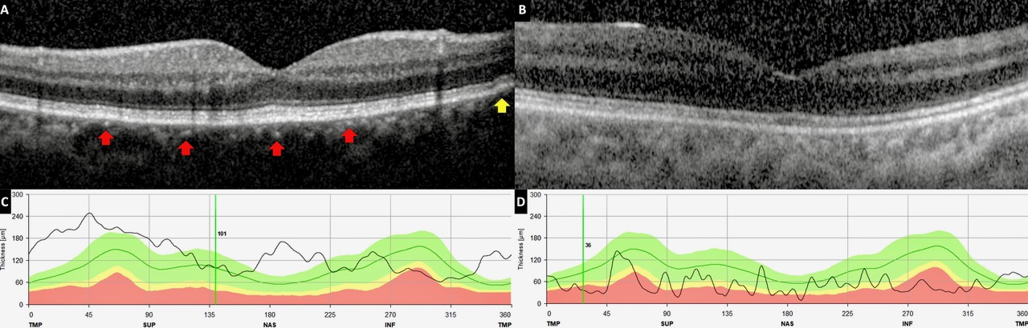

***Figure 1:*** *Optical coherence tomographic sections at admission depicting punctate inner choroidal hyperreflective dots (red arrows) together with the disorganization of the outer retinal layers at the papillomacular region (yellow arrow) in the right eye (A) and normal left eye (B). Retinal nerve fiber layer thickness measurements revealing global thickening in the right eye (C) and near total atrophy in the left eye (D).*

Fundus autofluorescence imaging (Heidelberg Spectralis, Heidelberg Engineering, Heidelberg, Germany) was unremarkable for both eyes (Figure 2A, B).

Early and late phases of fluorescein angiogram (Heidelberg Spectralis, Heidelberg Engineering, Heidelberg, Germany) depicted leakage from the macula and optic nerve head both in the right eye, left angiogram was unremarkable except the late disc staining (Figure 2C-F).

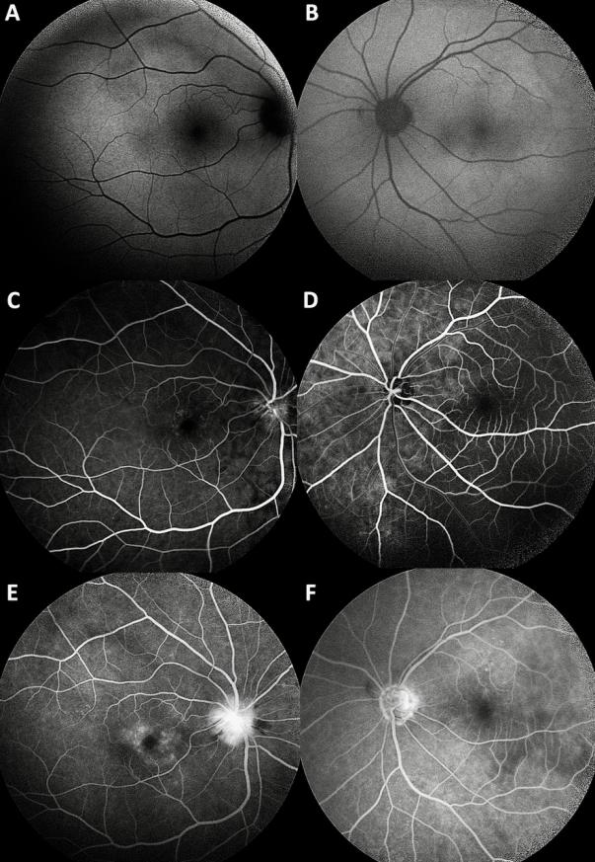

***Figure 2:*** *Fundus autofluorescence images were unremarkable for both eyes (A; right eye, B; left eye). Early and late phase fluorescein angiographic images showing leakage from the macula and optic nerve head both in the right eye (C and E); late disc staining in the left eye (D and F).*

A thorough systemic investigation was carried out, including complete blood count, routine biochemistry, sedimentation rate, C-reactive protein level, full infectious panel, and a rheumatological panel as the clinical presentation was consistent with bilateral ON. Due to high levels of sedimentation rate (60 mm) and C-reactive protein level (102 mg/L), a diagnosis of right arteritic ischemic ON was established and the patient was hospitalized immediately. As she had experienced vision loss in her good eye, 1000 mg/day intravenous pulse corticosteroid and a right intravitreal 4 mg triamcinolone acetonide were administered immediately while waiting the results of the infectious and rheumatological panels.

On the third day of treatment, analysis of the infectious panel yielded a positive result for the non-specific anti-treponemal test of the venereal disease research laboratory (VDRL). Rapid plasma reagin (RPR) tested negative. She tested negative for other infectious agents including human immunodeficiency virus. Upon consultation with the Department of Infectious Diseases, the pulse corticosteroid treatment was discontinued, and a regimen of 2 grams of intravenous ceftriaxone sodium administered twice daily as the patient was considered to have tertiary syphilis. An intravitreal injection of 2.25 mg/0.1 cc ceftazidime was also given. Intravenous crystalline penicillin G could not be given due to supply problems of the drug at the time of diagnosis in Turkey.

Orbital and cranial magnetic resonance imaging (MRI) revealed non-specific chronic and ischemic changes in the brain together with a short segment T2 signal enhancement of the right optic nerve at the retrobulbar level.

The patient was treated with 2 gr/day intravenous ceftriaxone for 14 days. The change of the fundoscopic appearance with the treatment is shown in Figure 3.

\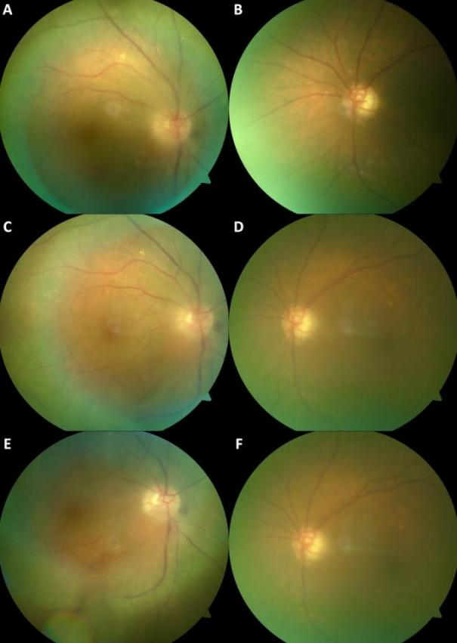

***Figure 3:*** *Fundoscopic appearance of both eyes on the 4th (A and B), 8th (C and D) and 14th (E and F) days of the systemic antibiotic treatment.*

One month after the completion of the treatment, her BCVA was still counting fingers at 1 meter in OD, and hand motion in OS, even though she reported a subjective increase in her vision. Slit-lamp examination was unremarkable for both eyes. Complete resolution of optic disc edema and regressed retinal hemorrhage was observed in the right eye (Figure 4A). The punctate hyperreflective dots at the inner choroidal level were relatively lessened on the right transfoveal spectral-domain OCT (Figure 4B).

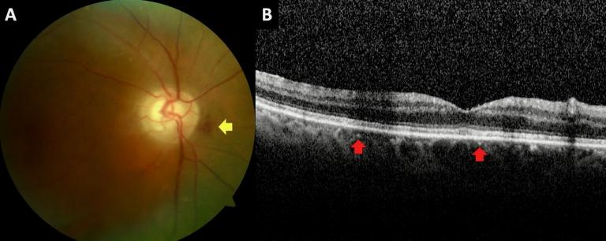

***Figure 4:*** *Color fundus picture (A) depicting complete resolution of the optic disc edema and regressed retinal hemorrhage (yellow arrow) and transfoveal optical coherence tomographic section (B) delineating the lessened punctate hyperreflective dots (red arrows) at the inner choroidal level in the right eye at the first month visit.*

**Discussion**

Syphilis poses a significant public health concern and is markedly on rise.15, 16 Recently, Köksaldı et al.17 published a retrospective analysis of 10 cases who had serologically confirmed ocular syphilis in the past three years. All of the cases had received the diagnosis based on the presenting ocular findings.

Ocular involvement can affect all segments and layers of the eyeball. Optic nerve involvement was reported in 12-78% of ocular syphilis cases and can manifest in various forms, including the inflammatory optic disc oedema, optic neuritis, optic disc gumma formation, neuroretinitis, perineuritis, optic chiasmal syndrome or optic atrophy accompanying uveitis.1, 18-21

Syphilitic ON cases have been reported by several authors in recent years. A 65-year-old male who presented with a horizontal diplopia and pale optic discs was described by Kowalski et al.22 in whom the diagnosis was bilateral syphilitic ON. Apinyawasisuk et al.23 reported seven syphilitic ON cases within a two-year period at their clinic. We have also reported a 60-year-old male who presented with a one year history of bilateral progressive visual loss and received the diagnosis of syphilitic ON.14

Ocular syphilis exhibits various OCT features including tongue-like projections between the nerve fiber layer and inner plexiform layer, rounded spots within the nerve fiber layer and ganglion cell layer, disruption or loss of the ellipsoid zone, hyperreflective dots across retinal and choroidal layers, vitreous hyperreflectivity, and mottling of the RPE alongside outer retinal discoloration.24, 25 The hyperreflective dot-like lesions at the inner choroidal and outer retinal layers are thought to represent the inflammatory foci in the choroid vasculature since the circulating *Treponema pallidum* spirochaetes enter the outer retina through the choroidal circulation.26 The presence of these lesions on OCT supported the diagnosis of syphilis in the present case.

Ocular syphilis is considered as a part of the spectrum of neurosyphilis. Even though cerebrospinal fluid examination is generally recommended in ocular syphilis cases, central nervous system involvement might be investigated using cranial MRI and computed tomography imaging.18, 26 In the latest guideline for the treatment of sexually transmitted diseases, which was published in 2021 by The United States Center for Disease Control and Prevention, it was recommended that among the individuals with isolated ocular symptoms (i.e., no cranial nerve dysfunction or other neurological abnormalities), confirmed ocular abnormalities on examination, and for reactive syphilis serology, a cerebrospinal fluid examination was not necessary before the treatment.27

The diagnosis of syphilis is based on the relevant clinical findings and appropriate serological examinations. In addition to commonly utilized non-treponemal tests like VDRL and RPR, treponemal tests such as fluorescent treponemal antibody absorption (FTA-ABS) and treponema pallidum particle agglutination (TP-PA) are also employed. The presence of any type of ocular involvement together with positive serological test results indicates the diagnosis of ocular syphilis.28

Treatment of ocular syphilis cases should be administered adhering to neurosyphilis protocol. The administration of 18–24 MU of intravenous crystalline penicillin G treatment per day for 10-14 days is the recommended treatment protocol for these cases.27 We were not able to treat our patient in accordance with this protocol due to supply issues of the drug in Turkey at the time of diagnosis.

**Conclusion**

Syphilis may present with a wide spectrum of manifestations and thus is often referred to as the ‘great imitator’. It is imperative to maintain a high level of suspicion for ocular syphilis in the differential diagnosis of ON, despite there may be no direct history or systemic finding.

**Ethical Declaration**

Written informed consent was obtained from the patient.

**Acknowledgements**

None.

**Funding**

None.

**References**

1. Klein A, Fischer N, Goldstein M, Shulman S, Habot-Wilner Z. The great imitator on the rise: ocular and optic nerve manifestations in patients with newly diagnosed syphilis. Acta Ophthalmol. 2019;97(4):e641-e7.

2. Centers for Disease Control and Prevention. Sexually Transmitted Diseases Surveillance 2003. Atlanta, GA: U.S. Department of Health and Human Services; 2004.

3. Tucker JD, Li JZ, Robbins GK, Davis BT, Lobo AM, Kunkel J, et al. Ocular syphilis among HIV-infected patients: a systematic analysis of the literature. Sex Transm Infect. 2011;87(1):4-8.

4. Chao JR, Khurana RN, Fawzi AA, Reddy HS, Rao NA. Syphilis: reemergence of an old adversary. Ophthalmology. 2006;113(11):2074-9.

5. Tran TH, Cassoux N, Bodaghi B, Fardeau C, Caumes E, Lehoang P. Syphilitic uveitis in patients infected with human immunodeficiency virus. Graefes Arch Clin Exp Ophthalmol. 2005;243(9):863-9.

6. Wilhelmus KR, Yokoyama CM. Syphilitic episcleritis and scleritis. Am J Ophthalmol. 1987;104(6):595-

7. Orsoni JG, Zavota L, Manzotti F, Gonzales S. Syphilitic interstitial keratitis: treatment with immunosuppressive drug combination therapy. Cornea. 2004;23(5):530-2.

8. Schulman JA, Peyman GA. Syphilitic gummatous iridocyclitis. Ann Ophthalmol. 1989;21(9):333-6.

9. Babu BM, Rathinam SR. Intermediate uveitis. Indian J Ophthalmol. 2010;58(1):21-7.

10. Kuo IC, Kapusta MA, Rao NA. Vitritis as the primary manifestation of ocular syphilis in patients with HIV infection. Am J Ophthalmol. 1998;125(3):306-11.

11. Yokoi M, Kase M. Retinal vasculitis due to secondary syphilis. Jpn J Ophthalmol. 2004;48(1):65-7.

12. Katarzyna P, Jerzy N, Zofia M. Syphilitic bilateral neuroretinitis--a case report. Klin Oczna. 2012;114(1):50-2.

13. Gass JD, Braunstein RA, Chenoweth RG. Acute syphilitic posterior placoid chorioretinitis. Ophthalmology. 1990;97(10):1288-97.

14. Kayabaşı M, Köksaldı S, Saatci AO, Bajin MS. Presentation of Ocular Syphilis with Bilateral Optic Neuropathy. Neuro-Ophthalmology. 2023;47(5-6):274-80.

15. Queiroz RP, Smit DP, Peters RPH, Vasconcelos-Santos DV. Double Trouble: Challenges in the Diagnosis and Management of Ocular Syphilis in HIV-infected Individuals. Ocul Immunol Inflamm. 2020;28(7):1040-8.

16. Rasool N, Stefater JA, Eliott D, Cestari DM. Isolated presumed optic nerve gumma, a rare presentation of neurosyphilis. Am J Ophthalmol Case Rep. 2017;6:7-10.

17. Köksaldı S, Nazlı A, Kaya M, Saatci AO. Never forget ocular syphilis: A case series from a single tertiary centre. Int J STD AIDS. 2023;34(11):817-22.

18. Smith GT, Goldmeier D, Migdal C. Neurosyphilis with optic neuritis: an update. Postgrad Med J. 2006;82(963):36-9.

19. McLeish WM, Pulido JS, Holland S, Culbertson WW, Winward K. The ocular manifestations of syphilis in the human immunodeficiency virus type 1-infected host. Ophthalmology. 1990;97(2):196-203.

20. Hausman L. The Surgical Treatment of Syphilitic Optic Atrophy due to Chiasmal Arachnoiditis*. American Journal of Ophthalmology. 1941;24(2):119-32.

21. Karti O, Top Karti D, Ozkan Ozdemir H, Eskut N, Zengin MO, Kusbeci T, et al. Coexistence of Papillitis and Posterior Placoid Chorioretinopathy as the Presenting Symptoms of Syphilis-Human Immunodeficiency Virus Coinfection. Neuroophthalmology. 2019;43(3):196-200.

22. Kowalski T, Fuzzard D, Williams I, Darby J, Mack HG. Bilateral Syphilitic Optic Neuropathy with Secondary Autoimmune Optic Neuropathy and Poor Visual Outcome. Case Rep Ophthalmol. 2019;10(1):81-8.

23. Apinyawasisuk S, Poonyathalang A, Preechawat P, Vanikieti K. Syphilitic Optic Neuropathy: Re-emerging Cases Over a 2-Year Period. Neuroophthalmology. 2016;40(2):69-73.

24. Vaze A, De Angelis RE, Simoes M, Arantes TE, Moreto R, Oliver GF, et al. Optical Coherence Tomography Findings in Ocular Syphilis Involving the Posterior Segment of the Eye. Ocul Immunol Inflamm. 2022;30(6):1464-70.

25. Saleh MG, Campbell JP, Yang P, Lin P. Ultra-Wide-Field Fundus Autofluorescence and Spectral-Domain Optical Coherence Tomography Findings in Syphilitic Outer Retinitis. Ophthalmic Surg Lasers Imaging Retina. 2017;48(3):208-15.

26. Mandelcorn ED. Infectious causes of posterior uveitis. Can J Ophthalmol. 2013;48(1):31-9.

27. Workowski KA, Bachmann LH, Chan PA, Johnston CM, Muzny CA, Park I, et al. Sexually Transmitted Infections Treatment Guidelines, 2021. MMWR Recomm Rep. 2021;70(4):1-187.

28. Larsen SA, Steiner BM, Rudolph AH. Laboratory diagnosis and interpretation of tests for syphilis. Clin Microbiol Rev. 1995;8(1):1-21.

## Copyright ©2024. All rights reserved.