Submission: 01-02-2024

Accepted: 23-03-2024

Published: 17-05-2024

***Journal of Ophthalmology Cases & Hypotheses***

**Anterior uveitis and severe keratoconjunctivitis sicca in a patient with steroid-induced ocular hypertension - Case Report**

**Fidan A. Aghayeva, MD**(Corresponding Author)

Technical University of Munich, Munich, Germany

Chiemsee Eye Clinic, Prien on Chiemsee, Germany

dr.aghayeva@gmail.com

**Ines Lanzl, Professor, MD**

Technical University of Munich, Munich, Germany

Chiemsee Eye Clinic, Prien on Chiemsee, Germany

**ABSTRACT**

Severe dry eye syndrome and anterior uveitis are known as adverse effects of different intraocular pressure (IOP) lowering drops. We report a case of acute anterior uveitis and severe keratoconjunctivitis sicca associated with combined IOP-lowering therapy including GANFORT*®* and SIMBRINZA*®* in a patient with steroid-induced ocular hypertension. 360-degree selective laser trabeculoplasty (SLT) was performed in both eyes as an IOP-lowering treatment. The transition from combined IOP-lowering therapy to monotherapy and significant reduction of ocular side effects combined with improved ocular surface as well as patient’s quality of life. The appropriate treatment regimen to reduce elevated IOP should be individualized, considering multiple topical adverse effects related to glaucoma treatment. SLT is a proven clinically effective procedure and a valuable potential alternative as primary or adjunct treatment that should be definitely considered in patients with ocular hypertension and severe intolerance to topical medications.

**Keywords:** *dry eye,**intraocular pressure, keratoconjunctivitis sicca, ocular hypertension, uveitis*

|  |  |
| --- | --- |
| **Quick Response Code:** | **Website:** |
|  | https://ophthalmolcases.com/in |
| dex.php/ hat |
| **DOI:10.30546/2788-516X.2024.019.0657** |
|  |



**Access this article online**

**Access this article online**

**Access this article online**

**Access this article online**

**INTRODUCTION**

Elevated intraocular pressure (IOP) still remains the main risk factor for the development of glaucoma [1]. Thus, lowering IOP is the sole currently available prevention and treatment of glaucoma, and could be achieved through medications, laser treatment or surgery [2]. Available topical preserved and preservative-free IOP-lowering drops have several ocular and periocular adverse effects, including ocular surface disease/dry eye symptoms with superficial punctate keratitis, corneal erosion, conjunctival allergy, and conjunctival injection; contact dermatitis, skin/eyelash/iris hyperpigmentation, eyelash bristling/lengthening, prostaglandin analog periorbitopathy with upper eyelid deepening, mucous membrane pemphigoid, skin hypertrichosis and, skin depigmentation; corneal thinning; anterior uveitis, etc. [3-11]. Another alternative clinically and cost-effective treatment option to reduce and avoid the above mentioned adverse effects and to improve patients’ compliance and quality of life is selective laser trabeculoplasty (SLT) [12].  According to the updated glaucoma management for glaucoma treatment of the American Academy of Ophthalmology, the European Glaucoma Society, and National Institute for Health and Care Excellence after publication of the 3-year results of the LIGHT trial SLT can be considered as initial or as first-line treatment for ocular hypertension (OHT) and open angle glaucoma [13]. The aim of this report is to present a case of acute anterior uveitis and severe keratoconjunctivitis sicca associated with combined IOP-lowering therapy in a patient with steroid induced OHT and uncontrolled high IOP.

**CASE REPORT**

A 82-year old woman was admitted to our clinic with a severe redness, itching, burning, photophobia, tearing, and pain in both eyes. Her medical history showed arterial hypertension and significanttrauma by car accident with post-traumatic stress disorder 4 years prior and initial administration of intensive steroid therapy with switch to oral steroids (prednisolone 5 mg qd)*.* Other used systemic medications included benzodiazepine tranquilizer Alprazolam, and antihypertensive drugs Valsartan and Amlodipin; ocular medications – combined IOP-lowering therapy of GANFORT*®* (AbbVie LTD) and SIMBRINZA*®* (Alcon); multiple tear substitutes: Vitavision, Hylo Gel and Cationorm eye drops. The blood laboratory testing did not reveal any abnormal findings.

We performed a detailed ophthalmic examination including visual acuity testing, refractometry, tonometry (Goldmann applanation tonometry), pachymetry, automated visual field examination using the Medmont M700 Automated Perimeter (MAP, Australia), fundoscopy, and analysis of the optic disc using optical coherence tomography (Optopol, Copernicus REVO OCT). Her distance corrected visual acuity by logMAR was 0,50 for right eye and 0,50 for left eye; IOP was 28 mmHg and 26 mmHg; central corneal thickness amounted to 521 μm and 530 μm, in the right and left eye, respectively. Biomicroscopy revealed severely red eyes with swollen eyelids, mixed (conjunctival + pericorneal) hyperaemia, congestion, chemosis, mucous secretion, subtarsal giant papillae, corneal fluorescein staining Grade 1 (CFS, Oxford Grade Scale) [14], keratic endothelial precipitates mostly in the lower part of the cornea, a few anterior chamber cells, flare/Tyndal +1 and pseudophakic lens status of the eyes (Fig. 1, Fig. 2).

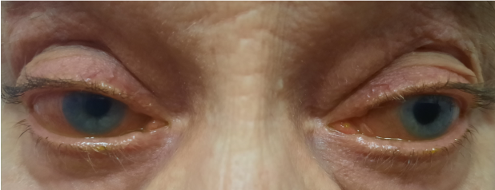

***Figure 1.*** *Baseline binocular eye status.*

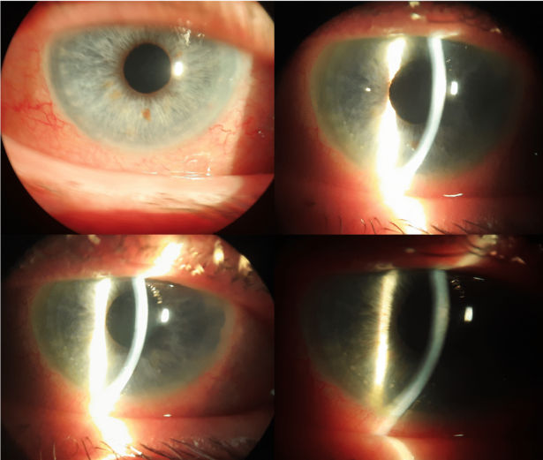

***Figure 2.*** *Biomicroscopy at the baseline.*

Perimetry showed several visual field defects in both eyes that could be explained by loss of fixation, false negative replies and known myopia (Fig. 3).

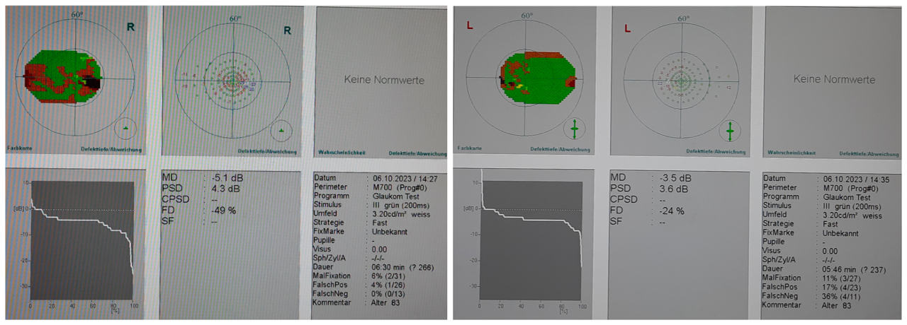



***Figure 3.*** *Perimetry of the both eyes.*

Fundoscopy identified myopic fundus with oblique small optic discs and dry macular degeneration with drusen (Fig. 4, Fig. 5).

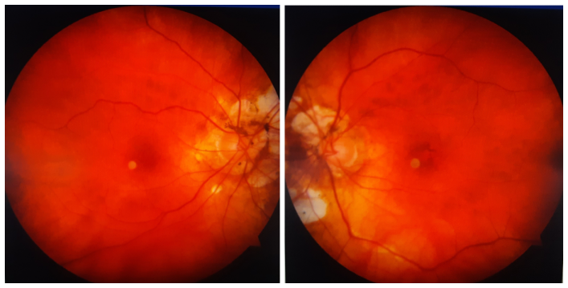***Figure 4.*** *Fundus of the both eyes.*

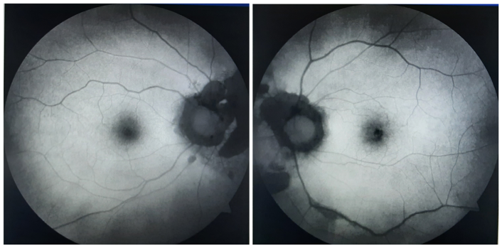***Figure 5.*** *Fundus Autofluorescence of the both eyes.*

Optic disc OCT findings were typical for myopic discs (Fig. 6).

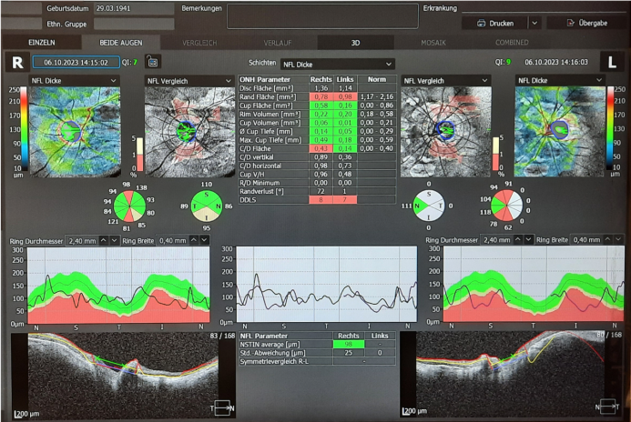***Figure 6.*** *Optic nerve head OCT of the both eyes.*

We diagnosed a steroid-induced ocular hypertension in the absence of glaucomatous optic disc damage [15] with a severe dry eye syndrome and acute anterior uveitis induced by IOP-lowering drops in a myopic pseudophakic patient and decided to reduce the topical antihypertensive therapy by performing SLT with a 3600 modality. First of all, we decided to discontinue SIMBRINZA*®* eye drops. SLT was performed in both eyes by using topical anaesthetic drops and a gonioscopic lens with coupling medium. Laser treatment was delivered at 360° of the trabecular meshwork with 130 nonoverlapping spots (spot size 400 microns, 25 per quadrant; energy 1.5 mJ) and with a just visible tissue reaction or small microbubbles.

The follow-up was 12 months. IOP measurements were performed on the first day, 1 week, 2 weeks, and every 3 months after laser procedure. IOP was reduced to 20 mmHg and 19 mmHg on the first day, and to 18 mmHg and 16 mmHg at 1 and 2 weeks after SLT, no visiblekeratic precipitates were documented. At 2 weeks IOP-lowering therapy was reduced from GANFORT*®* toMONOPROST*®* (Thea Pharmaceuticals Ltd)*,* Thealoz Duo preservative free dry eye drops were prescribed as a tear substitute. IOP still remained under control and amounted to be 17 mmHg and 18 mmHg, 18 mmHg and 15 mmHg; 17 mmHg and 19 mmHg; 16 mmHg and 18 mmHg at 3-, 6-, 9- and 12 months follow-up, respectively. Biomicroscopy of both eyes with clinically significant reduction of all above mentioned ocular symptoms’ severity, improvement of ocular surface and CFS Grade 0 at the last follow-up is presented in Fig. 7, Fig. 8.

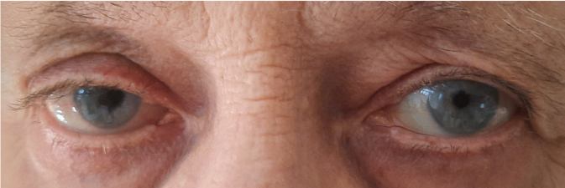

***Figure 7.*** *Binocular eye status at the last follow-up.*

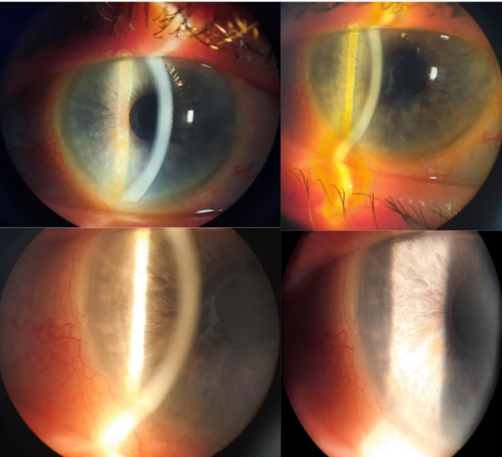

***Figure 8.*** *Biomicroscopy at the last follow-up.*

**DISCUSSION**

An acute anterior uveitis and severe keratoconjunctivitis diagnosed by our patient were adverse effects of previously prescribed combined IOP-lowering therapy including 4 different agents. Despite of almost maximal topical antihypertensive therapy the IOP in both eyes was uncontrolled, which could be explained with development of severe dry eye symptoms and following patient’s incompliance. Anterior uveitis secondary to brimonidine containing eye drops administration was reported by several authors [9-11, 16-18]. A large retrospective descriptive case series of brimonidine-associated uveitis included 16 patients (26 eyes) with a median follow-up time 15 months and was published in BMC Ophthalmology in 2020 [18]. This phenomenon should not be misinterpreted in such patients and differentiated from primary anterior uveitis, especially in our case with steroid-induced OHT. If not recognized correctly over-treatment with topical steroids could lead to aggravated steroid response and further IOP elevation and complicate the already challenging case. Keratoconjunctivitis sicca is a very common side effect of most preserved and even preservative-free antihypertensive eye drops [4,5,7], and thus, could be associated with both medications in our case. Therefore, we decided to stop SIMBRINZA*®* eye drops, as a first step of therapeutic modification after performing the SLT procedure, which resulted in the disappearance of keratic precipitates 2 weeks after discontinuation of use. Further stable bilateral control of IOP after SLT motivated us to switch combined therapy with GANFORT*®* to monotherapy with MONOPROST*®* and the pressure was well controlled during the 12 months follow-up.

Each patient with elevated IOP must be treated individually and closely monitored. Multiple treatment related adverse effects should be considered and ameliorated by prescription of different IOP-lowering drops. SLT is a proven clinically effective procedure and a valuable potential alternative primary or an adjunct treatment in patients with ocular hypertension and severe intolerance to topical medications.

### Conflict of interests

The author declares that there is no conflict of interests.

### Data availability statement

The data that support the findings of this study are available from the corresponding author upon reasonable request.

### Funding

None.

### Study association

This study is not associated with any thesis or dissertation work.

**REFERENCES:**

1. Gordon MO, Beiser JA, Brandt JD, et al. The Ocular Hypertension Treatment Study: Baseline Factors That Predict the Onset of Primary Open-Angle Glaucoma. Arch Ophthalmol. 2002;120(6):714–720. doi:10.1001/archopht.120.6.714
2. Heijl A, Leske MC, Bengtsson B, Hyman L, Bengtsson B, Hussein M; Early Manifest Glaucoma Trial Group. Reduction of intraocular pressure and glaucoma progression: results from the Early Manifest Glaucoma Trial. Arch Ophthalmol. 2002;120(10):1268-79. doi: 10.1001/archopht.120.10.1268.
3. Eraslan N, Celikay O. Effects of topical prostaglandin therapy on corneal layers thickness in primary open-angle glaucoma patients using anterior segment optical coherence tomography. Int Ophthalmol. 2023;43(9):3175-3184. doi: 10.1007/s10792-023-02717-y.
4. Inoue K. Managing adverse effects of glaucoma medications. Clin Ophthalmol. 2014;8:903-13. doi: 10.2147/OPTH.S44708.
5. Lanzl I, Kaercher T. Konservierte Augentropfen und Adhärenz in der augenärztlichen Praxis [Preservative-containing eye drops and adherence in ophthalmological practice]. Ophthalmologe. 2012;109(11):1087-92. German. doi: 10.1007/s00347-012-2641-9.
6. Patchinsky A, Petitpain N, Gillet P, Angioi-Duprez K, Schmutz JL, Bursztejn AC. Dermatological adverse effects of anti-glaucoma eye drops: a review. J Eur Acad Dermatol Venereol. 2022;36(5):661-670. doi: 10.1111/jdv.17928.
7. Saade CE, Lari HB, Berezina TL, Fechtner RD, Khouri AS. Topical glaucoma therapy and ocular surface disease: a prospective, controlled cohort study. Can J Ophthalmol. 2015;50(2):132-6. doi: 10.1016/j.jcjo.2014.11.006.
8. Sano I, Takahashi H, Inoda S, Sakamoto S, Arai Y, Takahashi Y, Ohkubo A, Kawashima H, Mayama C. Shortening of Interpupillary Distance after Instillation of Topical Prostaglandin Analog Eye Drops. Am J Ophthalmol. 2019; 206:11-16. doi: 10.1016/j.ajo.2019.03.013.
9. Goyal R, Ram AR. Brimonidine tartarate 0.2% (Alphagan) associated granulomatous anterior uveitis. Eye Lond Engl. 2000;14(Pt 6):908–10.
10. Moorthy RS, Moorthy MS, Cunningham ET. Drug-induced uveitis. Curr Opin Ophthalmol. 2018;29:588–603.
11. Nguyen EV, Azar D, Papalkar D, McCluskey P. Brimonidine-induced anterior uveitis and conjunctivitis: clinical and histologic features. J Glaucoma. 2008;17(1):40-2. doi: 10.1097/IJG.0b013e3181132188.
12. Garg A, Gazzard G. Selective laser trabeculoplasty: past, present, and future. Eye (Lond). 2018; 32(5):863-876. doi: 10.1038/eye.2017.273.
13. Gazzard G, Konstantakopoulou E, Garway-Heath D, Adeleke M, Vickerstaff V, Ambler G, Hunter R, Bunce C, Nathwani N, Barton K; LiGHT Trial Study Group. Laser in Glaucoma and Ocular Hypertension (LiGHT) Trial: Six-Year Results of Primary Selective Laser Trabeculoplasty versus Eye Drops for the Treatment of Glaucoma and Ocular Hypertension. Ophthalmology. 2023;130(2):139-151. doi: 10.1016/j.ophtha.2022.09.009.
14. Bron AJ, Evans VE, Smith JA. Grading of corneal and conjunctival staining in the context of other dry eye tests. Cornea 2003; 22(7):640-50.
15. Kasimov EM, Aghayeva FA. Steroid induced ocular hypertension and steroid induced glaucoma. Azerbaijan Medical Journal 2013; 2: 126-130.
16. Boualila L, Bouirig K, El Hamidi S, Boutimzine N, Cherkaoui LO. Brimonidine induced bilateral hypertensive anterior uveitis: Case report and review of the literature. J Fr Ophtalmol. 2023 May;46(5):e143-e145. doi: 10.1016/j.jfo.2022.10.014.
17. Carrasco MA, Schlaen BA, Zárate JO. Brimonidine-timolol fixed combination induced granulomatous inflammation of the eye. Int Ophthalmol. 2013;33: 557–60.
18. Hopf S, Mercieca K, Pfeiffer N, Prokosch-Willing V. Brimonidine-associated uveitis - a descriptive case series. BMC Ophthalmol. 2020 Dec 17;20(1):489. doi: 10.1186/s12886-020-01762-w.

## Copyright ©2024. All rights reserved.